The Book of Acts
Follow the apostles’ examples
Anchor command. “Repent and be baptized every one of you in the name of Jesus Christ for the forgiveness of your sins, and you will receive the gift of the Holy Spirit.” Acts 2:38
Anchor story. Saul (later called Paul) meets Jesus on his way to persecute Christians. Acts 9
Anchor verse. “When they had prayed, the place where they had gathered together was shaken, and they were all filled with the Holy Spirit and began to speak the word of God with boldness.” Acts 4: 31
Learning goal. Find how the apostles and believers in the first churches witnessed for Jesus.
Growth goal. Believers carefully follow the example of the apostles.
Skill goal. Testify for Jesus accurately in the power of the Holy Spirit.
Outcome goal. Many believers testify effectively for Jesus in the power of the Holy Spirit.

Basic Study

Dear Lord, help us to learn and follow the apostles’ example in the power of your Holy Spirit.
Learn from Saul’s conversion (before he was renamed Paul)…
- Why was Saul traveling to Damascus? Acts 9:1-2
- What happened to Saul on the way? 3-8
- What did God enable Ananias to do for Saul? 9-18
- Why yes was Ananias reluctant at first to go to Saul? 10-15
- How soon was Saul baptized after Ananias came? 18
- Why were people amazed by Saul? 19-22
- How did Saul escape from the Jews who tried to put him to death? 23-25
- What did the churches throughout Judea and Galilee and Samaria enjoys after that? 31
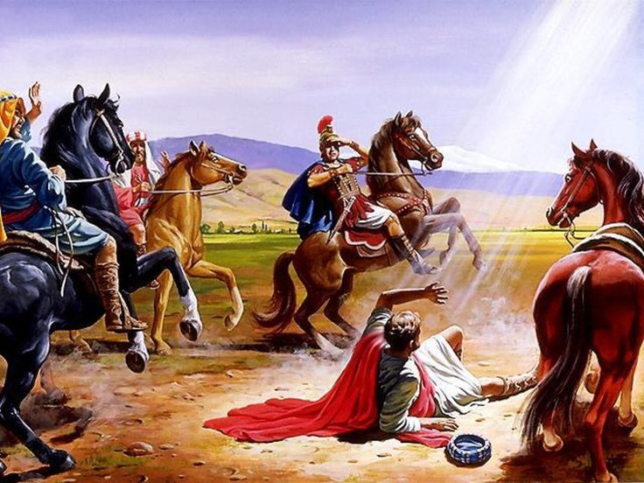
Saul fallen from his horse at the appearance of Jesus
During the week go and visit people the same way the apostles did, proclaiming Christ.
During worship…
- Tell the story of Paul’s conversion, and ask the same questions as above. Urge believers to discuss the answers.
- Ask the children to present what they have prepared.
- Memorize John 14:15.

Advanced Study
- Wise shepherds and the helpers whom they train do God’s work the way the apostles and other champions did it, as recorded in the Book of Acts.
Pray now that the Holy Spirit will illuminate your mind and heart from the Acts.
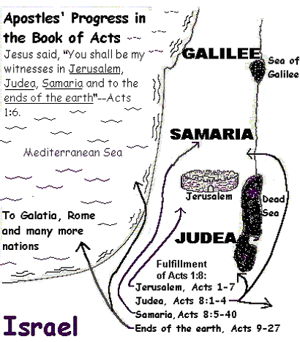
- Preparatory reading. If you have not yet done the study number A1a, The Apostles and Other Champions in the Book of Acts, then, please, do so before reading this more advanced study.
- Recommended Bible reading. Please read this week Acts chapters 13 through 28.
- Background of the book of Acts.
Acts was written by a medical doctor named Luke. He interviewed many people, and he recorded the activities of the first apostles. He began with an account of Christ ascending up into glory. Then, he described the arrival of the Holy Spirit at the Jewish feast of Pentecost, the Spirit who dwells in the hearts of Christian believers. The Holy Spirit gave the apostles power to witness for Christ in different places. He does the same for us, today.
- Luke accompanied the apostle Paul on some of his trips and recorded his work. The first chapters of Acts tell about the earliest days of the first Christian congregation. The first few chapters focus mainly on Peter’s ministry. Later chapters record the ministry of Paul as he and his co-workers started congregations in the ancient Roman Empire.
- You will understand the book of Acts better if you can visualize what the new congregations were like:
- They met as small groups in believers’ homes. Most congregations had no buildings for almost three hundred years.
- They were led by shepherding elders who had no formal, theological training. Today, some congregations call such leaders ‘lay’ pastors or, since they were always more than one, co-pastors. Some were paid, others were not. In those years, they had no professional clergy as in modern tradition. Jesus’ brother, James, became the main elder in Jerusalem and Timothy in Ephesus. Today many congregations would call such a leader ‘pastor’ or ‘senior pastor’.
- They often prayed for the sick.
- They baptized new believers at once, and they broke bread to eat the Lord’s Supper in their regular meetings.
- Their meetings helped people to know each other and to help each other. Everyone was able to participate in various ways.
- They did not yet have the New Testament, so they mostly taught each other from the Old Testament.
- In each city, they would form clusters of house congregations or cells.
- Sometimes, false teachers would tell non-Jewish believers that they had to obey Jewish traditions and Old Testament laws.
- Non-believing Jews would sometimes severely persecute the Christians. Since those days, those who die for Christ are called Martyrs and are the most privileged of God’s people (Rev. 20:4-6).
- Of course, the congregations were not perfect. They had many problems and made mistakes common to new congregations.

- Stories in Acts that are easy to dramatize, and to read dramatically
- Jesus ascended to glory, Acts 1:4-11.
- Peter and John healed the crippled man, Acts chapters3 & 4.
- God punished Ananias and Sapphira for lying, Acts 5:1-13.
- The authorities arrested the apostles and Gamaliel defended them, Acts 5:14-42
- Simon the magician tried to buy the Holy Spirit’s power, Acts 8:5-25
- Philip witnessed to the Ethiopian in the desert, Acts 8:26-40
- Saul the persecutor was transformed on the road to Damascus, Acts 9:1-31.
- Peter raised Dorcas from death through the power of Christ, Acts 9:36-43.
- Peter and helpers from Joppa won the first Gentiles to Christ, Acts chapter 10.
- King Herod imprisoned Peter but an angel frees him, Acts chapter 12.
- Paul and Silas witnessed to the Philippian jailer and his family, Acts 16:16-40.
- Paul and his co-workers survived a riot in Ephesus, Acts 19:23-41.
- Paul survived a shipwreck and a poisonous snake, Acts chapters 27, 28 & 29.
- Great Truths in the Book of Acts
One of the greatest lessons from Acts is that everywhere the apostles went making disciples, the way Jesus said to do so, congregations multiplied.
Congregations also multiply today, when believers go to neglected peoples and make disciples, the way Jesus said. If the people do not respond to the Good News, Jesus told us to “shake the dust” from our feet and go where people listen and believer (Luke 10:11).
How should we make disciples the way Jesus said, so that congregations multiply? We must do the things that the apostles did, which you will find in many chapters of the book of Acts.
- What the Apostles Did in Jerusalem
They prayed. Acts chapter 1. Pray like the apostles and the first followers of Jesus did. Pray that God will give to you his promised power from the Holy Spirit, so that you can witness for Christ.
They received power. Acts 2:1-36. You can proclaim Jesus with the same power from the Holy Spirit as Peter did, announcing the essential truths of the Good News:
- Jesus Christ died on a cross as a sacrifice to God.
- Christ rose from death and gives life to believers. This was the main point of the apostles’ witness throughout the Book of Acts.
- God promises forgiveness and eternal life to all who repent and believe. The apostles told people to repent, that is, to have a change of heart, not simply to make a superficial ‘decision.’
They obeyed Jesus. Acts 2:37-40. Teach new believers to obey all the basic commands of Jesus, like the 3,000 new believers in Jerusalem immediately did, following the coming of the Holy Spirit.
They healed the sick. Acts chapter 3. Pray in Jesus’ name for God to heal the sick, like Peter and John did.
They were bold. Acts chapter 4. Speak about Jesus, to people and to government authorities, with boldness like Peter and John did.
They maintained discipline. Acts 5:1-16. Maintain holiness and honesty in the congregation, like Peter did. God will support you as he did Peter in the case of Ananias and Sapphira who lied to the believers and to God.
They interceded. Acts 5:17-41. Pray fervently for your shepherds and for those who are persecuted, as believers prayed for Peter when hostile authorities imprisoned him.
They worshipped in homes. Acts 5:42. Gather regularly in homes to worship, to break bread and to apply God’s Word.
They had compassion. Acts 6:1-7. Serve the needy like the first deacons did in the congregation at Jerusalem.
They had courage. Acts 6:8 – 7:60. Accept persecution and suffering with the grace that God gives to believers, like Stephen did.
- What the Apostles Did in Judea and Samaria
They spread the Good News. Acts chapter 8. Witness for Christ in nearby regions, both to people of your own culture and to those of other cultures, like the believers from Jerusalem did in Judea and in Samaria.
- What the Apostles Did as They Took God’s Word to Distant Lands
- They transformed lives. Acts chapter 9. Trust God to change the hearts of those who persecute us, like He did to Saul of Tarsus on the road to Damascus.
- They showed respect for other cultures. Acts 10 – 11:26. Give up your own cultural traditions with God’s help, when you work in other cultures, like Peter and the believers from Joppa did, when they started the congregation in Cornelius’ house at Caesarea.
- Congregations co-operated with each other. Acts 11:27-30. Believers of one congregation should help those of another congregation in times of need, like the believers in the newer congregations did for the poor believers in Jerusalem.
- They sought protection from God. Acts chapter 12. Pray and trust God’s angels to care for you in times of danger, as you work where people are hostile towards Christ, like the angel did for Peter when Herod imprisoned him.
- They commissioned apostles. Acts 13:1-3 and chapter 14. Let the Holy Spirit choose ‘sent ones’ who will work as a team, not alone. Pray for them and lay hands on them. Send them to start congregations in neglected places, like the congregation in Antioch did with Paul and Barnabas.
- They started congregations, Acts 13:4 through 14: 24. Proclaim Christ, gather the newly baptized believers together in obedient congregations, and prepare their local leaders immediately.
- They reported back. Acts 24:25-28. Let your ‘sent ones’ report back to their sending congregation what God is doing, so they, too, can share in the blessing and can evaluate their work.
- They practiced reconciliation. Acts chapter 15. Gather leaders from nearby congregations to resolve any congregational dispute, as the elders in Jerusalem did for the believers in Antioch.
- They evangelized families. Acts chapter 16. Go at once to the family and close friends of new believers, like Paul and Silas did with Lydia and with the Philippian jailer.
- They adapted to other cultures. Acts chapter 17. Adapt the way you present the message to the people’s culture and mentality, like Paul did in Thessalonica, Beria and Athens.
- They often supported themselves. Acts 18:1-4. Support yourselves as you serve Christ, like Paul did when he joined Aquila and Priscilla to make tents to earn their living.
- They sought responsive people. Acts 18:5-23. Leave those who reject Christ and go to people who are willing to believe, like Paul did repeatedly in Greece.
- The mentored novice leaders. Acts 18:24-28. Instruct new leaders privately, ‘behind the scenes’, not publicly or in academic institutions, like Priscilla and Aquila did for Apollos at Ephesus.
- They reproduced congregations. Acts chapter 19. Continue work in a new region until the new congregations are multiplying, like Paul did in Ephesus, in spite of rejection by some and a riot.
- They strengthened leaders. Acts chapter 20. Continue to encourage the shepherds of new congregations, instructing them, and preparing them to ward off ‘wolves’, that is, false teachers, like Paul did for the Ephesian elders.
- They defended the faith. Acts chapters 21 through 26. When you are brought before authorities, speak about Christ boldly, trusting the Holy Spirit to give to you the right words to say, as Paul did before the Jewish rulers, King Agrippa and others.
- They persevered. Acts chapters 27 through 29. Keep persevering and trusting God wherever He takes you, like Paul did when, as a prisoner, the ship was wrecked on its way to Rome. There he continued to proclaim Christ, and the Good News spread among many people.

- Guidelines for Different Workers in the Book of Acts
Guidelines for evangelists
- Study Acts 10; 16:13-15, 29-40, 18:8.
- Communicate the gospel within other cultures by working through existing webs of relationships and through local leaders.
- Work mainly through heads of households.
- When possible, get the cooperation of community leaders.
- Respect both their culture and their authority.
- Pray for the Holy Spirit’s power, and for the healing of sick and demonized people.
- Make definite plans to communicate the Good News through family heads and other leaders.
- Write these plans in your notebook, and discuss your plans with your co-workers next time you meet.
Guidelines for Shepherds
- Study Acts 1:1-8; 2:37-40; 20:7, 17-38
- Depend on the power of the Holy Spirit to change lives and give birth to new congregations.
- Do not work alone, rather train and work with other shepherding elders, as you care for God’s people.
- Apply God’s Word to yourself and to your people.
- Baptise new believers without delay and teach them first to obey the commands of Jesus.
- Celebrate the Lord’s Supper regularly.
- Maintain order, watch over the flock, correct the unruly and ward off ‘wolves’, false teachers who attack the flock with division and false doctrine.
- Correct without condemning (compare Matt. 18:15-20; Gal. 6:1; 1 Cor. 5). Do not tell an offending believer that he is not saved. Rather, remind him that, since he is a child of God, he should behave like one (Eph. 4:1).
- Mentor new pastoral trainees constantly, so that they can help serve your congregation and to start new ones.

Guidelines for congregations to prepare and send workers
to start new congregations
- Study Acts 13:1-5.
- Form a temporary task group, like the congregation of Antioch did with Paul, Barnabas and John Mark, and send it to start new congregations in neglected places.
- Choose those who have learned to make disciples and are gifted to go. Make serious prayer and lay hands on them.
- In Ephesians 4:11-12, God promises to give to every congregation gifted ‘sent ones’.
- These ‘apostles’ normally lead teams that start new congregations in other regions.
- Those whom you send may correctly be called ‘apostles’ in the sense that Barnabas, Luke and other ‘sent ones’ who were not of the original twelve apostles who had known Jesus.
- Send them out from the mother congregation with the power of the Holy Spirit.
- Pray for guidance as you make plans to form a task group to go to a neglected region where there are not many Christians.
Guidelines for those who travel to start congregations
in neglected regions
- Study Acts 2:37-47 and 13:6 – 14:7.
- Penetrate both small towns and cities. Go where the people are willing to listen and to believe. Let the gospel flow from the towns to the cities and from the cities to the towns, either way. Go with the flow! Do not think that the Holy Spirit is like a river that flows only one way.
- Instruct new believers at once to obey the basic commands of Jesus, as the apostles did in Acts 2. The 3,000 new believers in the first congregation at Jerusalem were obeying all of Jesus’ commands in their most basic form:
- Repent, believe, and receive the Holy Spirit.
- Baptize.
- Break bread (Lord’s Supper).
- Love (fellowship).
- Pray.
- Give.
- Make disciples.
- Give new congregations much loving care while they are ‘baby’ congregations. During their time of immaturity, they need much help and counsel from other congregations.
- Maintain strong relations between congregations. A group of believers that is small enough to practice the New Testament “one-another” relations, is too few to have all the spiritual gifts promised in Scripture. All the spiritual gifts are needed to sustain healthy congregational body life. Believers must practice ‘body life’ between congregations as well as within them, as the congregations did in the book of Acts.
- Ask for many volunteers, self-supporting workers to serve the congregation (Acts 18:1-3). Operate a small business as Aquila and his wife did, or any other vocation that allows you to meet and talk with the common people, to tell about the gospel, and to gather believers into obedient congregations.
- Deal with serious disagreements in new congregations by visits from leaders of other congregations, as in Acts 15:1-31.
- Make definite plans to gather disciples who obey the commands of Jesus, and to prepare their local leaders.
Guidelines for those who train new shepherds
- Study Acts 14:21-23 and 18:24-28.
- Keep visiting and sending others to visit new congregations until their local leaders are appointed, as Paul did (Acts 20:13-36; Titus 1:5; 2 Tim. 2:2).
- Instruct new leaders privately, ‘behind the scenes’, as Aquila and Priscilla did for Apollos.
- Make definite plans to train new leaders on the job.

The Pentecostal Experience Enables Believers to Obey Jesus

This little story comes from Shepherds’Storybook which is free
from www.Paul-Timothy.net
Learner is a new shepherd. Mr. Wise mentors him, and had been explaining from the Bible what a congregation really is. He tells Learner, “The first Christians obeyed Jesus’ general commands that sum up all that he commanded commands from the very beginning. This obedience to Jesus is the foundation for new congregations.”
Learner asks Mr. Wise, “What are Jesus’ general commands?”
Wise replies, “Jesus commanded many things, but seven general commands include everything else that He commanded. We can find these seven basic commands in Acts chapter two. The 3,000 new believers in the first New Testament congregation were obeying them all before the end of chapter 2.”
Learner quickly reads Acts 2:37-47 and finds that the new believers began at once to obey Jesus’ seven basic commands:
They repented, believed and received the Holy Spirit.
They confirmed this conversion with baptism and continued to live the new, holy life that baptism initiates (Romans 6:1-14).
They studied, taught and obeyed the Word of God, which helped them to make disciples.
They loved God, fellow believers and people in need, in practical ways. Their love was seen in their fellowship and in the way they helped people in need. Jesus taught that we must love even our enemies, which means to forgive them.
They broke bread, that is, they celebrated the Lord’s Supper.
They prayed regularly using Jesus’ name.
They gave sacrificially.
[Find in Acts 2:37-38 the answers to what Mr. Wise asked Learner:
“How soon were new believers baptized and added to the congregation?”
Where did they break bread to celebrate the Lord’s Supper?
How did they show, in a very practical ways, their love for each other?
What did the Lord do for the new, obedient congregation to make it grow?]
Learner exclaimed joyfully. “Now I understand what a congregation is! It is people who gather and obey Jesus. The first Christians honoured Christ. They remembered what He taught, and they obeyed His words with fervour and joy. My family is going to honour Jesus like those first Christians did.”
“Good,” Mr. Wise answered. “With the power of the Holy Spirit, they obeyed the seven basic commands of Christ from the beginning. To this day, God’s blessing and joy come to congregations that obey Christ, because they love Him.”

Practical Work
- Help your congregation memorize the seven basic commands of Christ, listed above, under #8, Guidelines for those who travel to start congregations in neglected regions.
- Ask a talented believer to help write a short song about Jesus’ seven basic commands.
Let the believers learn the song.
- Help your congregation to obey Christ out of love because of what He has done for us, not out of fear.
- Ask all the believers to obey Jesus’ basic commands before any man-made rules or traditions from other congregations.

