God Brings Something Good from Bad Things
Dear Lord, please use this study to show the children how you make all things work together for good to those who believe.
Choose any or all of these children's learning activities.
- Let an older child or adult tell or read about Paul being shipwrecked, Acts 27:13-28:10.
This story shows how God uses his people to bring good news and blessing to the world, even when bad things happen.
Ask the children these questions:
- How did Paul know that the people in the ship would not die in the storm?
[Answer: see Acts 27:23-25]
- What was God’s plan for Paul? [27:24]
- Why did the people of Malta think Paul was a god? [28:5-6]
- How did the people of Malta thank Paul for bringing healing to their island? [28:10]
- How did God use something bad that happened to Paul to bring good to others?
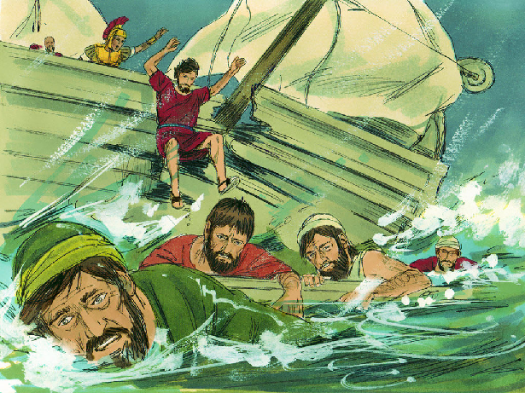
As their ship was breaking apart, Paul promised that everyone would be kept safe.
- Dramatize parts of the story of Paul's shipwreck.
- Arrange with the leader of the main congregational worship for the children to present this brief drama with the help of some adults.
- If you do not have enough children for all the parts, then ask neighbours’ children to help. This is a good way to help them discover Christ.
- Children do not need to memorize each word of the dialogue; just make sure that each child knows the general idea of what to say.
- Older children help younger ones to prepare
- Older children or adults play these parts:
Narrator. Summarize the story and help the children remember what to say.
Paul
Publius, who invited Paul to his home
Younger children play these parts:
Captain (of the ship)
Sailors (on the ship)
Folk from Malta, around the fire)
Narrator: Read or tell by memory the first part of the story, Acts 27:13-30. Say,
“Hear what the sailors shout.”
Sailors (Some shout) “I'm afraid of this storm!”
(Others shout) “We will all die!”
Narrator “Hear what Paul shouts.”
Paul (Shout) “Sailors, don’t leave the ship!
We will all survive because my God has work for me to do.”
Narrator Tell the second part of the story, Acts 27:31-44. Then say,
“Hear what the captain shouts.”
Captain (Shout) “We are sinking! Grab a plank! Swim to shore.”
Narrator Tell the third part of the story, Acts 28:1-6. Say,
“Hear what the people shout.”
People (Some shout) “Look, a poisonous snake bit him!”
(Others shout) “He shook it into the fire!”
(Others shout) “His hand didn't swell up at all!”
Publius, “I am amazed that the poisonous snake did not hurt you.
Your God is strong. Please come to my house.”
Narrator Tell the fourth part of the story, Acts 28:7-10. Say,
“Hear what the people of Malta shout.”
People (Some shout) “His god healed our leader's father!”
(Others shout) “Please come and pray for my sick mother.”
(Others shout) “Come pray for my brother.”
Narrator Thank the children, and thank the adults for listening.
- Ask for other examples of how God uses painful things to bring good.
Let the children or adults tell examples.
- Arrange with the main worship leader for the children to present the drama to the adults during the worship time.
- Ask the adults the questions that are listed under #1 above.
- Present the poem and anything else that the children have prepared.
- Memorize together Romans 8:28:
“We know that God causes all things to work together for good to those who love God, to those who are called according to His purpose.”
- Draw a simple picture of a snake falling into a fire, and let the children copy it.
- Let older children help the younger.
- Some children might like to colour the picture found at the end of this lesson.
- Let the children show their pictures to the adults at the next worship time and explain that this illustrates God defeating Satan.
- Poem. Let three children recite these verses from Psalm 69:
Save me, O God, for the waters have come up to my neck. I sink in the miry depths, where there is no foothold. I have come into the deep waters; the floods engulf me. I am worn out calling for help; my throat is parched.
Zeal for your house consumes me, and the insults of those who insult you fall on me. They put gall in my food and gave me vinegar for my thirst.
Do not hide your face from your servant; answer me quickly, for I am in trouble. May your salvation, O God, protect me.
- Let older children write a poem, song or short story, or give a testimony about what they have seen happen, that shows how God brings good out of bad circumstances.
- Let an older child pray:
“Dear God, we trust you to bring something good from the bad things that happen to us and to others. Help us to keep serving you joyfully even when we have bad times. In Jesus’ name. Amen”

