The Greatest Life Ever Lived
Jesus’ Life, Death and Resurrection
Anchor command. “Let us run with endurance the race that is set before us, looking to Jesus.” Hebrews 12:1-2
Anchor story. Jesus’ trial, death and resurrection, Mark chapters 15 and 16
Anchor verse. “If we have been united with him in a death like his, we shall certainly be united with him in a resurrection like his.” Romans 6:4-5
Learning goal. Know and appreciate the final key events in Jesus’ earthly life.
Growth goal. Grasp the eternal importance of believing these pivotal events.
Skill goal. Recount Jesus’ saving work in the power of the Holy Spirit.
Outcome goal. Believers testify to others about the saving death and resurrection of Jesus.
Basic Study
Heavenly Father, Let your flock and me learn about the wonderful life that Jesus lived on earth, so that we can thank you together for all that He did for us.
- Learn from the account of Jesus’ trial, death and resurrection
from Mark chapters 15 and 16.

What people delivered Jesus over to the Roman governor to be crucified? Mark 15:1

Why he was Governor Pilate amazed at Jesus’ response? 15:2-5

Who was the first man to realize that Jesus would die in his place? 15 6-15

What did the soldiers do to make fun of Christ? 15:17-19

Who were crucified along with Jesus? 15:27

What came over the whole land for several hours? 15:33

What did the Centurion cry out when Jesus died? 15:37-39

Jesus was buried and lay in the repose of death throughout the Sabbath day of rest; then women came to the tomb to anoint his body. What did they see that startled them? 16:1-8

To whom did the risen Christ appear first? 16: 9-11
- Teach your flock the Good News about Jesus, in a way that they can pass on the message to others, in turn.

- During the week you and your coworkers visit folk who do not yet know Christ, recounting to them Jesus’ trial, death and resurrection.
- During worship…

Relate the account of Jesus’ trial, death and burial. Ask some of the questions, above, and let the people discuss the answers.

Ask the children to present what they have prepared.

Memorize together Hebrews 1:1-2.
Advanced Study

Before Jesus came into the world, the Old Testament prophets made more than 300 predictions about the one whom the Jews called the Messiah or Christ.

Find what each of these seven prophets said about the promised Messiah (Christ) who was to come into the world:
- Abraham (Genesis 22:18)
- Moses (Deuteronomy 18:18–19)
- Isaiah (Isaiah 53:7–8)
- David (Psalm 2:7)
- David (Psalm 16:8–11)
- Nathan (2 Samuel 7:16)
- John the baptizer (Luke 3:15–17)

When the Messiah came into the world, many eye witnesses saw and heard all that he did, and some of them wrote those things in the books called the New Testament. The apostles of Jesus told seven things about Him that they considered to be most important:
- When Jesus was on earth, he showed who he was by what he did for people.
Find what Jesus did in these Bible texts:
For blind folks (Matthew 9:27–31)
For a man with a demon (Matthew 9:32–33)
A child who died (Luke 8:49–55)
- Jesus taught people about the holiness of God, how to have faith, and how to lead a holy and joyful life. He taught by using stories about simple things, like a man sowing seeds. Find in these texts:
The kinds of people whom God will bless (Matthew 5:1–16).
How Jesus’ followers are to lead their lives (John 14:1–17).
What the future of the world will be (Matthew 21–31).
- Jesus died when his enemies had him nailed to a wooden cross. Find in these texts:
Who wanted to kill Jesus (Luke 23:12–21)
How Jesus was executed (Luke 23:32–34)
How Jesus died (Luke 23:44–53)
- Three days later, God raised Jesus back to life.
As Jesus said before he died (Mark 9:31–32)
As reported by angels from heaven (Matthew 28:1–10)
As Jesus explained after rising from death (Revelation 1:17–18)
- Jesus appeared to many people who knew him and became his witnesses. Find:
How Jesus proved that he was alive (Luke 24:36–43)
What Jesus talked about (Acts 1:1–3) [“Talked about”??? unclear]
To whom he appeared (1 Corinthians 15:3–8
- Jesus promised to forgive everyone who turns to him. Find in these texts what the risen Christ said:
About forgiveness (Luke 24:44–48)
About God’s Holy Spirit (Acts 1:4–8)
About how to become Jesus’ followers (Matthew 28:16–20)
- God took Jesus up into heaven till he comes back. Find in these texts:
What angels said to Jesus’ followers (Acts 1:9–11)
What Jesus said to his enemies (Mark 14:60–62)
What Jesus will say to those who serve others (Matthew 25:31–34)

Plan with your co-workers additional activities for the coming week.
- Practice telling from memory the main things about Jesus. Then go tell them to people in their homes. Show the pictures as you tell the story.
- Plan to hold a training seminar at which you will instruct believers in how to tell the story of Jesus using pictures, songs, poems, in ways that fit the culture.

Plan with your co-workers additional, optional activities for the upcoming worship.
- Dramatize one or more of the events in Jesus’ life that you have studied.
- Ask folks to tell what they know about…
What the prophets foretold about Jesus.
What Jesus did for people.
What Jesus taught about how we should live, and the future of the world.
How Jesus died and rose from the dead.
To whom Jesus appeared after rising from the dead.
What the risen Christ promised to do for believers who repent and follow Him.
How Jesus finally left this earth.
- Have the children present the drama, poem and questions that they have prepared.
- To present the Lord’s Table, read Hebrews 7:7–12. Explain that Jesus entered into His Father’s presence, not with the blood of animals as the Old Testament High Priest entered into the Most Holy Place, but with His own blood.
- Let the folks gather in little groups to pray for each other and ask God to take the story about Jesus to all their families and friends and to other ethnic groups near and far.

Those who teach children should read study #38 for children.

Find or create tools that help believers to recount the Gospel of Jesus to others.

Employ written or pictorial media, if your community accepts these. Here are some examples.

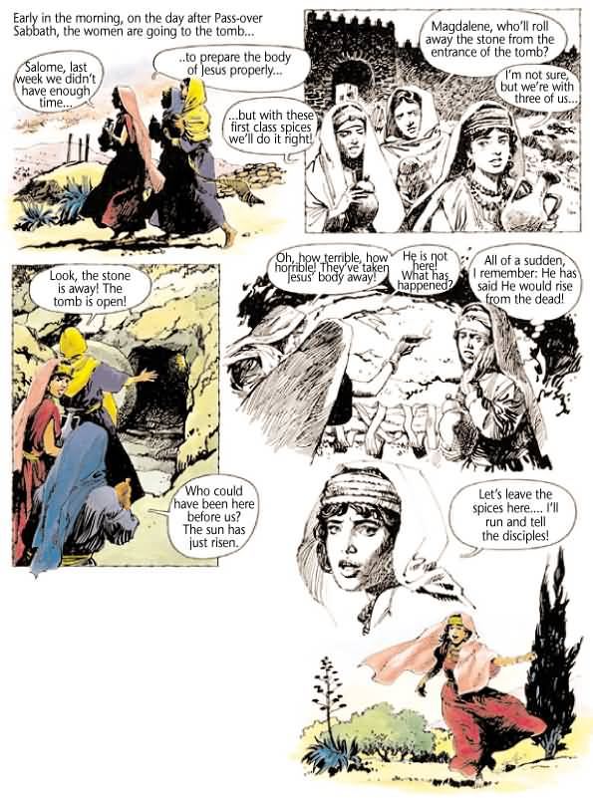
Available in 17 languages from www.gospelcomics.com

