Jesus Called His First Followers

Teach Children the Joy of Following Jesus.
Choose learning activities that fit the children’s ages and needs.
Dear Lord, please help the children to tell others about your life from the Gospels.
- Teach the story of Jesus calling His disciples.
Read Matthew 4:18-22. It tells how Jesus chose disciples to carry on his ministry and spread the Good News about Him.
Let an older child read or tell the story from memory. Then pose these queries:
[The answers appear after each query]:
- What were Peter and Andrew doing before Jesus called them? [See verse 18]
- What did Jesus promise to make of them, if they would follow him? [19]
- How soon did the two men follow Jesus? [20]
- Which other two men were also fishermen? [21]
- Whom did they leave behind in their boat when they followed Jesus at once? [22]

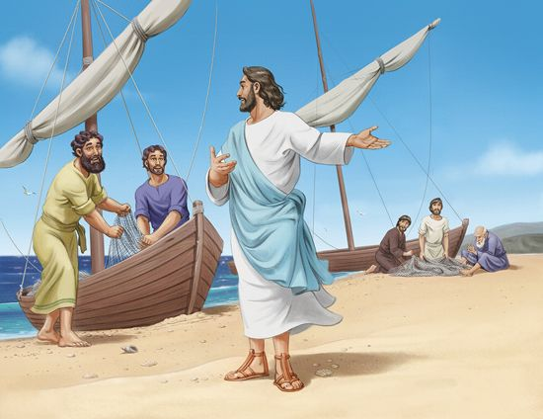
Jesus called fishermen as his first followers.
- Memorize the names of the twelve apostles found in Matthew 10:2-4.
“Simon, who is called Peter, and Andrew his brother; James the son of Zebedee, and John his brother; Philip and Bartholomew; Thomas and Matthew the tax collector; James the son of Alphaeus, and Thaddaeus; Simon the Zealot, and Judas Iscariot, who betrayed hime.”
Matthew 10:2-4
- Dramatize parts of the story of Jesus calling his disciples.
Arrange with the adult worship leader to have the children present this drama.
Let the older children help the younger ones to prepare.
Older children or adults play these parts:
Jesus
Simon (later named Peter),
Andrew
Narrator (Summarize the story and help the children to remember what to say and do.)
Younger children play these parts:
James
John
Zebedee (father of James and John)
Other fishermen (Use basins or stools turned upside-down for boats, and string for nets).
Narrator. Tell the story or part of it. Then say, “Hear what Simon says to Andrew.”
Simon. (Sitting by a ‘boat) “Andrew, look! That is Jesus of Nazareth. He heals people! I like what he teaches, but he is too good and important to notice us.”
Andrew. “Yes, Simon. Jesus is such a good teacher that he does not need our help.”
Jesus. “Simon and Andrew! Come and follow me. You will help me fish for men!”
Simon and Andrew.
Jump up. Drop your nets and run to Jesus.
Jesus. “John and James! You also, come and follow me!”
John and James.
Jump up and run to Jesus.
Zebedee. “They left me, their father, to do all the work!
Well, I guess it is for the good!”
Other fishermen.
Sit on the floor when the drama starts.
When Zebedee speaks, stand and point at John and James.
(Some say) “Those foolish men!”
(Others say) “They left their boats!”
(Others say) “They are leaving a good job to follow that teacher!”
Narrator. When the drama is over, thank everyone who helped with it.
- If the children dramatize this story for the adults, then let them also pose to the adults the queries listed above under #1.
- Draw a picture of a fish and let the children copy it.
The children may like to colour the picture on the last page of this lesson.

Little children might like to draw a fish.

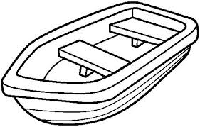

Big children might like to draw a fishing boat.

Let the children show their pictures to the adults during the worship time and explain that this illustrates how God gives us a new job of fishing for men.
- Let the children tell other examples of how believers fish for men, by helping people to follow Jesus.
- Let five children each recite a verse from Romans 8: 35-39.
- Let older children write a poem or song using Jesus’ words in the story, Matthew 4:18-22.
- Memorize John 15:16:
“You did not choose me but I chose you, and appointed you that you would go and bear fruit, and that your fruit would remain, so that whatever you ask of the Father in my name He may give to you.
- Let an older child pray:
“Father God, thank you for choosing us to be your disciples. We want to be obedient to you and to bear fruit as you told us to do. Help us to answer your call quickly and to learn to fish for men.”

