Job, Song of Solomon, Ecclesiastes,
Psalms, and Proverbs

Wisdom and Poetry
Anchor command. “Make your ear attentive to wisdom, Incline your heart to understanding.” Proverbs 2:2
Anchor story. King Solomon prays for wisdom, and God gives it to him. 1 Kings, chapter 3.
Anchor verse. “How sweet are your words to my taste! Yes, sweeter than honey to my mouth!” Psalm 119:103
Learning goal. Be familiar with the main topics of the wisdom books of the Old Testament.
Growth goal. Appreciate the beauty and practical advice found in the wisdom literature.
Skill goal. Teach the wisdom of the Old Testament in a way that people respond from the heart.
Outcome goal. Believers practice the important precepts of the wisdom literature.

Basic Study
Dear Lord, help us to use the beautiful poetry that you inspired Hebrew speaking Israelites to write many centuries ago, to instruct, exhort and praise you.
Learn from 1 Kings chapter 3…
- Solomon had become King, and in a dream God told him to ask whatever he wanted, and God would give it to him (1 Kings 3:5). What did Solomon ask for? Verse 9
- What is God’s response? 11-13
- What was the argument that two women asked King Solomon to settle? 10-23
- How did King Solomon discern which women was telling the truth? 24-28
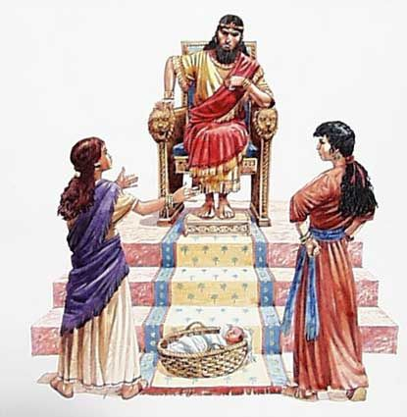
God gave to Solomon wisdom to rule
During the week read from the wisdom books of the Old Testament, and keep track of the precious truths that you learn.
During worship
- Tell the story of King Solomon’s prayer for wisdom, from 1 Kings chapter 3.
- Ask the same questions as above, and urge believers to discuss the answers.
- Explain the main topics of the different poetical books.
- Let the children present what they have prepared.

Advanced Study
- Learn to appreciate the unique beauty and power of ancient Hebrew Poetry.
- Poetry of many cultures rhymes; the words at the end of phrases sound alike. It also has meter; the number and position of accented syllables in the phrases follow a pattern. Such poetry is hard to translate. God intended for people to read His Word in all languages and thus used another style of poetry.
- The poets of ancient Israel used a form of beauty and balance that fits all languages and cultures. Rather than harmonizing the mere form of words and stressed syllables, God inspired poets to balance the meanings of their thoughts. They balanced their verses by expressing a thought in two or more different ways.
Go to the ant, O sluggard, Observe her ways and be wise. (Proverbs 6:6)
- Find an idea that Proverbs 16:11 balances in parallel phrases.
- Find the idea that Proverbs 13:1 balances in contrasting phrases.
- Books of Drama: Job and Song of Solomon
- Job records intense, penetrating conversations between men who differed sharply in their opinions about God and His justice. In Job chapter 11, Zophar, a friend of Job, made the common error of assuming that people suffer because of their sin, what Hindus call ‘karma.’
Find in Job 11:11-15 of what Zophar accused Job.
Find in Job 12:1-3 what Job thought about Zophar’s advice.
- Song of Solomon expresses the passion of young lovers, echoed by a chorus. It illustrates reciprocal love between God and believers, and between our Lord Jesus Christ and His bride, His followers.
- Psalms: hymns that ancient Israelites sang:
- Almost all Christian congregations use the Psalms in worship.
- King David, his worship leader, Asaph, and other composers expressed to God their deepest feelings of praise, pleading, anger, gratitude, complaints, hope, despair, and thanks.
- Find what 2 Samuel 23:1 called David at the end of his life.
- Proverbs: sayings of wisdom:
- They were written by David’s son, King Solomon, and other wise men.
- Find in Proverbs chapter 5 …
What an adulteress’ speech is like [verses 3-4],
Where her feet lead to [verses 5-6],
Why husbands should be faithful to their wives [verses 15-23].
- Many of the Proverbs give instruction for young people.
“My son, give attention to my words;
Incline your ear to my sayings.
Do not let them depart from your sight;
Keep them in your heart.
For they are life to those who find them
And health to all their body.
Watch over your heart with diligence,
For from it flow the springs of life.” (Proverbs 4:20-23)
- The sluggard says, "There is a lion in the road! A lion is in the town square! As the door turns on its hinges, so does the sluggard on his bed. (Proverbs 26:13-14)
- Find in Proverbs 31:10-31 several things that a virtuous woman does.
- Ecclesiastes: Pessimistic complaints of an aged man about the state of things in this world:
- An elderly writer, possibly Solomon, reminisced about the futility of life on earth (‘under the sun’). He had tried every pleasure but finally found it all to be vanity (‘chasing after the wind’).
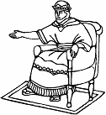

Additional activities to do during the week
- Visit and help parents to apply Proverbs 13:24, 19:18; 22:6; 23:13.
- Help their children to apply Proverbs 1:8-9.

Plan with co-workers additional activities for the next worship.
- Select verses from Psalms that focus attention on God and praise Him.
- Explain the unique method and beauty of Old Testament poetry and read some examples.
- Explain some of the proverbs from the book of Proverbs.
- Let believers who have been blessed by reading the poetical books tell about it.
- Form groups of two and three people to pray for one another and to review helpful verses of Hebrew poetry.
- To introduce the Lord’s Supper, read Psalm 133 and explain that when we break bread in remembrance of Jesus’ sacrificial death, we experience the deep unity between believers.
- Memorize together Psalm 145:1-2.

