God Always Kept His Promises

The Historical Books of the Old Testament
Anchor command. “Put your trust in the Lord your God and you will be established. Put your trust in His prophets and succeed.” 2 Chronicles 20:20
Anchor story. Gideon. Judges chapters 6 - 7.
Anchor verse. “Not one of the good promises which the Lord had made to the house of Israel failed; all came to pass.” Joshua 21:45
Learning goal. Find examples of God keeping his promises.
Growth goal. Trust in God’s promises.
Skill goal. Encourage others to trust God’s promises.
Outcome goal. Believers act vigorously in response to God’s promises, knowing that they will be rewarded in glory.
Lord God, you have been faithful to your people through all ages past. Let my flock and me learn to trust you, today, and our children trust you, after us.
Basic Study
Learn from the story of Gideon…
- Why did God punish the sons of Israel in Gideon’s time? Judges 6-1
- The Angel of the Lord appeared to Gideon and assured him that the Lord was with him to deliver Israel from the Midianites. Gideon gathered an army of over 22,000 men.
What did God tell Gideon to do to reduce the number of soldiers? 7:2-3
- How did God reduce the 10,000 who remained to on a 300? 7:4-7
- What strategy did Gideon use to drive away the huge army of the Midianites? 7:16-22
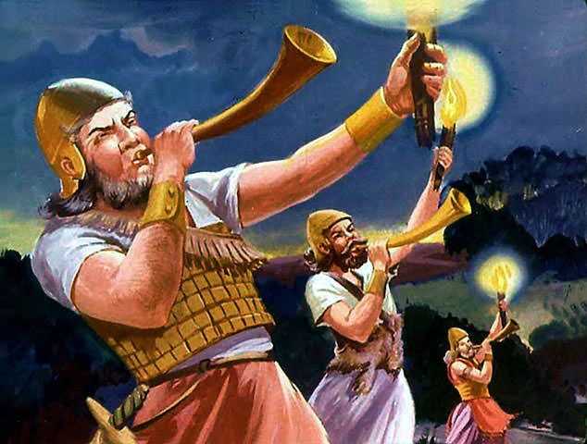
Gideon’s brave men prepare to attack
During the week visit believers who have weak faith, and urge them to trust God’s promises.
During worship
- Relate the story of Gideon and ask the same questions as above. Urge the believers to discuss the answers.
- Ask the children to present what they have prepared.
- Memorize together Joshua 1:7. Only be strong and very courageous; be careful to do according to all the law which Moses My servant commanded you; do not turn from it to the right or to the left, so that you may have success wherever you go. Joshua 1:7
Advanced Study

Learn about the many promises of God that have been fulfilled.
- Promises that a Messiah (Christ) would come.
The numbers in the list below indicate about how many years the events in those books happened before Messiah Jesus was born. See a well-known verse in each book Read how the New Testament refers to all of the historical books.

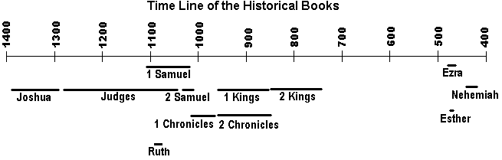
- 1406–1383. Joshua led the Israelites as they conquered Canaan. See 1:7. They had victory over enemies only when they obeyed the Lord completely.
Find in Hebrews 11:31 how the New Testament cites the story of Rahab from Joshua 6:22-25.
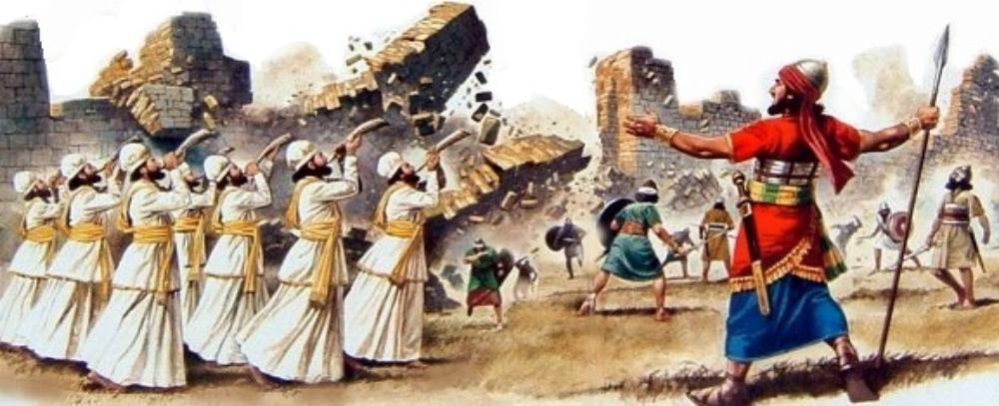
The walls of Jericho start to crumble. See Joshua 6:15–20
- 1386–1045. Judges were local leaders, heroes, and liberators during 300 years of Israelite disobedience to God. See Judges 16:6.
Find in Hebrews 11:33 mention of Samson from Judges 14:5-6.
- 1100. Ruth, a foreigner who obeyed the LORD of Israel, married Boaz and became an ancestor of King David and of Messiah Jesus. See Ruth 1:16.
Find in Matthew 1:5 the names of Boaz and Ruth.
- 1100–1010. 1 Samuel recounts the leadership of the prophet Samuel, the reign and fall of King Saul, and the rise of David. See 15:22.
Find in Acts 13:22 the words of the LORD about David from 1 Samuel 13:14.
- 1010–970 2 Samuel recounts King David’s many triumphs, his sins and failures, and his political troubles. See 2 Samuel 7:9.
Find in 2 Corinthians 6:18 applies to us Christians the promise God made to David’s descendants in 2 Samuel 7:8 & 14.
- 1011–970. 1 Chronicles recounts the reign of King David. See 1 Chronicles 4:10.
Find in Hebrew 1:5 applied to Jesus the promise made to David in 1 Chronicles 17:11 & 13.
- 970–538. 2 Chronicles recounts the reigns of the kings of Israel and Judah from Solomon’s coronation through the fall of Judah till Persian King Cyrus’ decree to rebuild the temple of Jerusalem in 538. See 2 Chronicles 13:10.
Find in Matthew 23:35 the words of Jesus recalling 2 Chronicles 24:20 & 21.
- 970–853. 1 Kings recounts the reign of King Solomon, the division of the nation into two kingdoms, Israel in the north and Judah in the south, and the career of the prophet Elijah. See 1 Kings 3:9.
Find in Romans 11:3 & 4 quotations from 1 Kings 19:10, 14 & 18.
- 853–561. 2 Kings recounts the career of the prophet Elisha and the reigns of righteous and wicked kings of Israel and Judah. See 2 Kings 19:15. Israel’s population was deported to Assyria in about 722 and Judah to Babylonia in about 561.
Find in Luke 4:27 mention of the Syrian who was healed when he obeyed Elisha as reported in 2 Kings 5:1–27.
- 538–516 & 458–457. Ezra recounts the promised return from captivity to Judah, a first contingent led by Zerubbabel and a second by Ezra. See Ezra 3:11.
Find in Luke 21:24 how Jesus used the words of Ezra 9:7 to tell of coming punishment because of unbelief.
- 483–473. Esther recounts how Queen Esther, a Jewish wife of the king of Babylon, interceded with him to save captive Jews from extermination by their enemies.
See in Esther 4:14. Matthew 6:23 how foolish king Herod used words from Esther 5:3 & 6.
- 444–425. Nehemiah recounts another return of captives to Jerusalem led by Nehemiah, with orders from Babylonian king Artaxerxes I to rebuild the city walls. See Nehemiah 8:10.
Find in John 6:31 Jesus applying to himself the words of Nehemiah 9:15.
Events and Judges, during the Period of the Judges,  from the Book of Judges | Years
Israel served Cushan-Rishathaim, 3:7-8 | 8
Peace following Othniel’s deliverance of Israel, 3:7-11 | 40
Israel served Moab, 3:12 | 18
Peace followed Ehud’s deliverance of Israel, 3:12-30 | 80
Shamgar delivered Israel from the Philistines, 3:31 | 1
Israel served Canaan, 4:1-3 | 20
Peace followed deliverance by Deborah and Barak, 4:1—5:3 | 40
Abimelech, King of Israel, 9:1-57 | 3
Tola’s career, 10:1-2 | 23
Jair’s career, 10,3-5 | 22
Israelites serve Ammon and Philistia, 10:8-10 | 18
Jephthah’s career, 10:8—12:7 | 6
Ibzan’s career, 12:8-10 | 7
Elon’s career, 12:11-12 | 10
Abdon’s career, 12:13-15 | 8
Israel serves Philistia, 13,1 | 40
Samson’s career, 13:1—16:31 | 20
From Nelson’s Complete Book of Bible Maps and Charts.
Copyright © 1993 Thomas Nelson

Plan with your co-workers additional activities for the coming week.
- Help your trainees to find and learn the names and main topics of the historical books in their Bibles.
- Find out in the historical books about the biblical heroes, including Joshua, Ruth, Gideon, Samson, David, Samuel, Elijah, Elisha, and Nehemiah. Tell some of those stories when you visit members of your flock.

Plan with your co-workers additional, optional activities for the up-coming worship.
- Recount from the Bible or act out one of the stories that you prepared in Part 2.
- Have the children present the things that they have prepared.
- To introduce the Lord’s Table read 1 Samuel 15:22. Explain that the animal sacrifices of the Old Testament foretold the sacrifice of Christ. Like the Lord’s Supper, they had no value if the people performed them simply as a ritual without faith and repentant hearts.
- Form small groups of two and three to pray for the sick, for nearby people groups that need Christ and for the congregation’s leaders.

