Moses and the Old Testament Law

Pentateuch part 3: Exodus, God gives Moses the Law
Anchor command. “Hear, O Israel! The Lord is our God, the Lord is one! You shall love the Lord your God with all your heart and with all your soul and with all your might.” Deuteronomy 6:4-5
Anchor story. Moses received the Ten Commandments on Mt. Sinai. Deuteronomy 5:1-21.
Anchor verse. “The Law was given through Moses; grace and truth were realized through Jesus Christ.” John 1:17
Learning goal. Know the basis of the Old Covenant that God made with the nation of Israel.
Growth goal. Appreciate how God’s Law prepared the nation of Israel for the coming of Messiah.
Skill goal. Explain the Old Testament law in a way that people do not embrace it as a system for today.
Outcome goal. Believers discern which parts of the Law applied only to the nation of Israel before Christ came, and which parts apply today to us who follow the New Testament.

Dear Lord, help us understand the present purpose of your commands to ancient Israel.

Basic Study
The Ten Commandments (abbreviated)
- Have no other Gods but Me.  - Have no idols.  - Do not take the name of God in vain.  - Set apart the seventh day to rest.  - Honour your father and mother.  - Do not murder.  - Do not commit adultery.  - Do not steal.  - Do not give false testimony.  - Do not covet other people’s property | 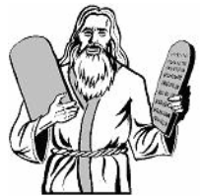  God inscribed the Ten Commandments  for Israel on tablets of stone
Background
After escaping from slavery in Egypt, God gave the Israelites the Torah, the Old Testament Law for the nation of Israel, through Moses. The Ten Commandments where the foundation of the Old Testament Law.
God told Moses to have the people wash their garments, consecrate themselves and approach Mount Sinai. They were not to touch the mountain, or they would be put to death. Moses went up the mountain, which was quaking in smoking, with a loud sound like a trumpet.
God himself wrote the Ten Commandments on two stone tablets. When Moses did not come back down right away, the people thought he had perished, and asked his brother Aaron to make them a god that would lead them to the Promised Land. The people gave Aaron jewelry of gold, and he fashioned it into a molten calf.
When Moses came down with the two tablets he saw the calf and the revelry of the people, he foolishly threw the tablets down and they shattered. God told Moses that he would destroy the people, but Moses interceded for them; God spared them and later replaced the tablets. Some of the people opposed Moses, and 3000 men died a violent conflict.
The entire story can be found in Exodus chapters 19 and 20, chapter 32, and Deuteronomy 5.
Find in Deuteronomy 5:1-3…
- With whom God made his covenant in the form of the Ten Commandments. 5:1-3
- Why the people were afraid. 5:4-5
- The evil that God warn against in the first of the Ten Commandments. 5:6-10
- All of the Ten Commandments are repeated as commands in the New Testament except that of the seventh day of rest (Sabbath).
Find in Acts 20:7 on what day of the week, also called “the Lord’s day,” the disciples celebrated the Lord’s Supper.
During the week.
If any believers are confused by the Old Testament laws, visit them and explain the truths given in this study. Explain that Christian believers now live under the New Covenant of grace. The minor details of Christians’ lives are not controlled by written laws; the Holy Spirit guides Christians through the law of liberty as we obey the law of love.
During worship
- Tell the story of how God gave the 10 commandments, and ask the above questions. Urge the believers to discuss the answers.
- Ask the children to present what they have prepared.
- Memorize together John 1:17: “The Law was given through Moses but grace and truth came through Jesus Christ.”
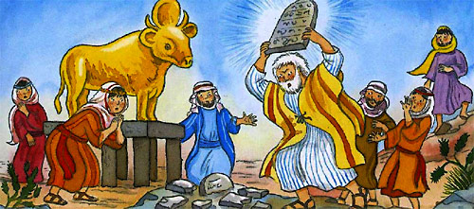
Moses broke the stone tablets, when he found the Israelites violating its laws.

Advanced Study
- Find basic truths about the Old Testament Law…
- Read Exodus 19 to find how God prepared the people to receive His Ten Commandments, which were the heart and foundation of the Old Testament Law.
- Find in Exodus 20:1-17 the complete text of the Ten Commandments, which the Old Testament also called simply the Law or the Covenant.
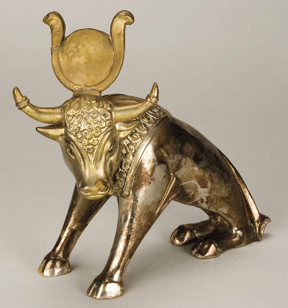
A real, ancient, ‘golden calf’
- Historical facts about the Old Testament Law:
- Galatians 3:23-25 clarifies God’s purpose for giving Israel the law:
But before faith came, we (Israelites) were kept in custody under the law, being shut up to the faith which was later to be revealed. Therefore the Law has become our tutor to lead us to Christ, so that we may be justified by faith. But now that faith has come, we are no longer under a tutor.
- God gave the Ten Commandments to the ancient Israelites soon after He had miraculously led them out of slavery in Egypt by making a path through the Red Sea. They were to obey Him because of that great miracle of mercy (Exodus 20:2).
- The ancient Law contained 612 laws including the basic Ten. God no longer requires His people to obey many of those laws, such as worshipping only in Jerusalem, slaying people who worked on the seventh day, not cultivating the soil during Sabbath years, offering animal sacrifices. Very few of the Old Testament laws are required by the New Testament. The primary law of both Testaments is the law of love (Deuteronomy 6:4-5). The Apostle Paul scolded those that required believers to obey special days and to eat only approved food (Galatians 3:1-3; 4:9-11; Colossians 2:16-17).
- Moses followed the advice of his father-in-law Jethro and named elders to judge God’s people (Exodus 18:24-25). These judges had to know God’s laws (Exodus 19:7). When the wandering Israelites were camping near a mountain later called Sinai, God told them that they were not to climb that mountain or they would die (Exodus 19:2-5). Only Moses was allowed to go up. God came down onto that mountain with great thunder, lightning and much smoke; the mountain quaked violently (Exodus 19:16-20). There, God gave the Ten Commandments to Moses, engraved on tablets of stone (Exodus 24:12).
- The New Testament repeats nine of the Ten Commandments as requirements for Christian believers. It does not require Christians to set apart the seventh day of the week as a day of rest. Some early Christian congregations would gather on the ‘first day of the week’ (Acts 20:7). God has not changed the Sabbath to another day. Rather, He has changed the Covenant that defined the kind of rest that He provides for His people (Hebrews 4:3-12). Some churches still require total rest on the Sabbath.
- The seventh day rest required by the Old Covenant, like many Old Testament laws, focused on the old, temporary and material creation, because God rested on the seventh day after He finished creating the world (Exodus 20:11).
- The first day of the week, on which Jesus rose from the dead, focuses on the new, spiritual creation of the New Covenant that replaced the old. Christians become part of this new, eternal creation when they are born anew by the Holy Spirit (Jeremiah 31:31-34; 2 Cor. 5:17).
- God has replaced the Old Testament law with the New Testament covenant of grace.
- Since Jesus introduced the New Covenant by His blood, the New Testament reveals a new kind of law for believers to follow. It is called the law of Liberty (James 2:13), the law of faith (Romans 3:27-28), the Law of Love (Galatians 5:14) and the Law of the Spirit; (Romans 8:2-4). The more glorious and eternal ‘ministry of the Spirit’ replaced the old ‘ministry of death,’ which was the old law that ‘faded away’ (2 Corinthians 3:7-11).
- The Old Testament law brought death, because nobody could keep all of its commands. Its purpose was threefold:
  - It defined civil and military rules for ancient Israel, so that the elders could judge wisely;
  - It brought knowledge of sin (Romans 3:19-20);
  - It served as a ‘tutor’ and ‘shadow’ of better things to come, to lead sinners to Christ who cancelled our debt to the decree that caused our death, by ‘nailing it to the cross’ (Galatians 3:24-25; Colossians 2:14-17).
- Plan what believers will do next week to help each other be guided by the Holy Spirit rather than by the ‘letter of the law’.
- If believers feel bound to follow the Old Testament rules, then pray for their liberation from the bondage of the law. Help them to memorize Romans 6:14, “Sin is no longer your master, for you are no longer subject to the law, which enslaves you to sin. Instead, you are free by God's grace.”
- If believers still want to follow old rules instead of obeying the commands of Jesus in love, then read to them Colossians 2:16-17: “Do not let anyone condemn you for what you eat or drink, or for not celebrating certain holy days or new-moon ceremonies or Sabbaths. For these rules were only shadows of the real thing, Christ himself.”
- Plan together with co-workers the activities for the next worship.
- Explain the historical facts about the Old Testament Law (#2, above).
- Explain how God replaced the Old law with the New covenant of grace (#3, above).
- Explain the plans you made with co-workers to visit people who struggle with the old law.
- To introduce the Lord’s Supper, read Colossians 2:13-14. Explain that Jesus’ blood freed us from the curse of the law of death, and that the Lord’s Supper celebrates His blood sacrifice.
- Pray and help one another in groups of two or three. Confirm plans to help people who struggle with keeping old laws that God no longer requires for New Testament believers.
Those who teach children should read study #32 for children.

