God Gave Good Laws to His People Israel
Lord, help the children see that you gave your ancient Law to prepare your people for something better.
Choose activities that fit the children’s needs and ages.
- Moses received Ten Commands.
- Have an older child or a teacher read or relate how God gave Moses the Ten Commands for the nation of Israel:
- Tell how God prepared the people to receive His law, Exodus 19:9–13.
- Tell what God did on Mount Sinai, Exodus 19:16–25.
- Explain briefly each command, Exodus 20:1–21.
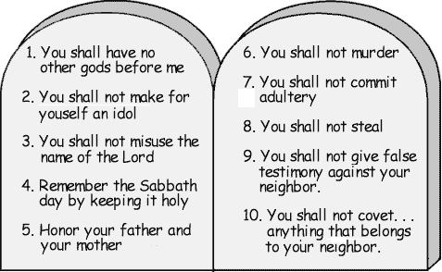
- Ask these questions. [Verses with the answers appear after each question.]
- What was the mountain like when the people went there to meet God? [Exodus 19:18.]
- What would have happened, if the people had touched the mountain? [Exodus 19:24.]
- How did the people feel when they saw the mountain in smoke? [Exodus 20:18.]
- What were the Ten Commands that God gave to Moses? [Let the children name as many as they can remember.]
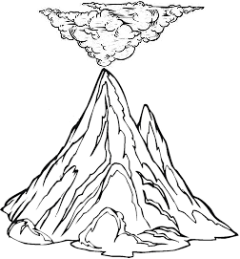
- Let the children copy the picture of Mt. Sinai smoking.
Or let them colour the picture on the last page of this lesson. Let them show their pictures to the adults during worship time and explain that it illustrates God’s holiness. Older children may want to write the commands.
- Explain Galatians 5:18 “If you are led by the Spirit, you are not under law.”
- Since Jesus died and rose from the dead, and sent the Holy Spirit to live in us, we are no longer under the ancient law of the Old Covenant. Romans 6:14 assures us, “You are not under law, but under grace.”
- Jesus fulfilled the old Law given to the nation of Israel, Matthew 5:17.
- We are saved by God’s grace, not by keeping the ancient law but by the transforming work of His Holy Spirit, Ephesians 2:8–10.
- Under the New Covenant we obey Jesus’ commands out of love, not out of fear.
He said, “If you love me, obey my commands”, John 14:15.
- Jesus commanded many things. We can summarize his commands in the seven general commands that the first believers obeyed, Acts 2:37–47:
- Repent, believe and be filled with the Holy Spirit
- Baptized new believers
- Love and forgive
- Celebrate the Lord’s Supper
- Pray
- Give
- Make disciples
- Dramatize the story of Moses and the Ten Commands.
Arrange to present this also during worship. Use your teaching time with the children to prepare these five roles:
1) Narrator: summarize the story and remind the children of what to say.
2) Voice of God.
3) Moses.
4) Paul.
5) Israelites (young children).
Narrator: “The new nation of Israel, many thousands of people, were wandering in the desert without laws. God prepared them to receive His holy Law. Listen to what God said to their leader Moses.”
Voice of God: Read Exodus 19:9–11 in a loud voice.
Narrator: “Hear what the people of Israel said.”
Israelites: Some shout, “Look at the smoke on the mountain!”
Some shout, “Look at the lightning.”
Some shout, “The thunder frightens me!”
Some shout, “We cannot go near God or we will die!”
Narrator: Read Exodus 19:16–20. Then say,
“Listen to what God said to Moses.”
Voice of God: Read loudly the words of God in Exodus 19:21.
Narrator: Explain that God told Moses to come up on the mountain to receive the Law for the people. Then say,
“Listen to what God said to Moses at the top of the mountain.”
Moses: Climb up on a chair and say,
“We will obey these laws so you will bless us.”
Narrator: “Galatians 5:18 says, ‘If you are led by the Spirit, you are not under law’.
Hear what the Apostle Paul said, after God made the New Covenant.”
Paul: “Jesus died to save us. We are not under the law. We obey Jesus out of love.”
Israelites: Some shout: “Then we can break God’s Law now!”
Others shout: “We can do whatever we want!”
Others shout “Let us sin, so God can show us more forgiveness and love!”
Paul: “No! No! No! God is holy! We obey Jesus out of love. He commands us to love God and each other. His Holy Spirit puts love in our hearts. If we love, we will not murder or steal or worship idols. We will do what pleases God.”
Israelites: Others shout: “Will God appear on a mountain with smoke and lightning?”
Others shout: “He’s too far away and too holy”.
Others shout: “We cannot get near Him!”
Others shout “I am afraid to talk to him!”
Paul: “No! No! No! Under the New Covenant, God is no longer far from us. He lives in us. We talk to him like a father. We do not fear to talk to him now.”
Narrator: When the drama is over thank the children.
Ask them if they have questions for the adults to answer.
- If the children present the drama to the adults, then let them ask the adults the questions under #3 above.
- Ask the children:
“What is the difference between the Old Law and the way we obey Jesus now?”
(Let them cite examples.)
- Memorize Matthew 7:12:
“In everything … treat people the same way you want them to treat you, for this is the Law and the Prophets.”
- Let three children each recite one of these verses from Psalm 19:7, 10 & 11:
The law of the LORD is perfect, reviving the soul.
The statutes of the LORD are trustworthy, making wise the simple.
They are more precious than gold, than much pure gold;
they are sweeter than honey, than honey from the comb.
By them is your servant warned;
in keeping them there is great reward.
- Let and older child read this prayer:
“Lord, you are Holy. You hate our sin. Thank you for showing us our sin so that we could repent and find forgiveness in Jesus. We want to obey you not because the Law forces us to, but because we love you.”

More detailed drama to act out, about God giving the Ten Commandments, 5 minutes:
http://biblestoryskits.com/005-god-gives-the-ten-commandments-on-mt-sinai/

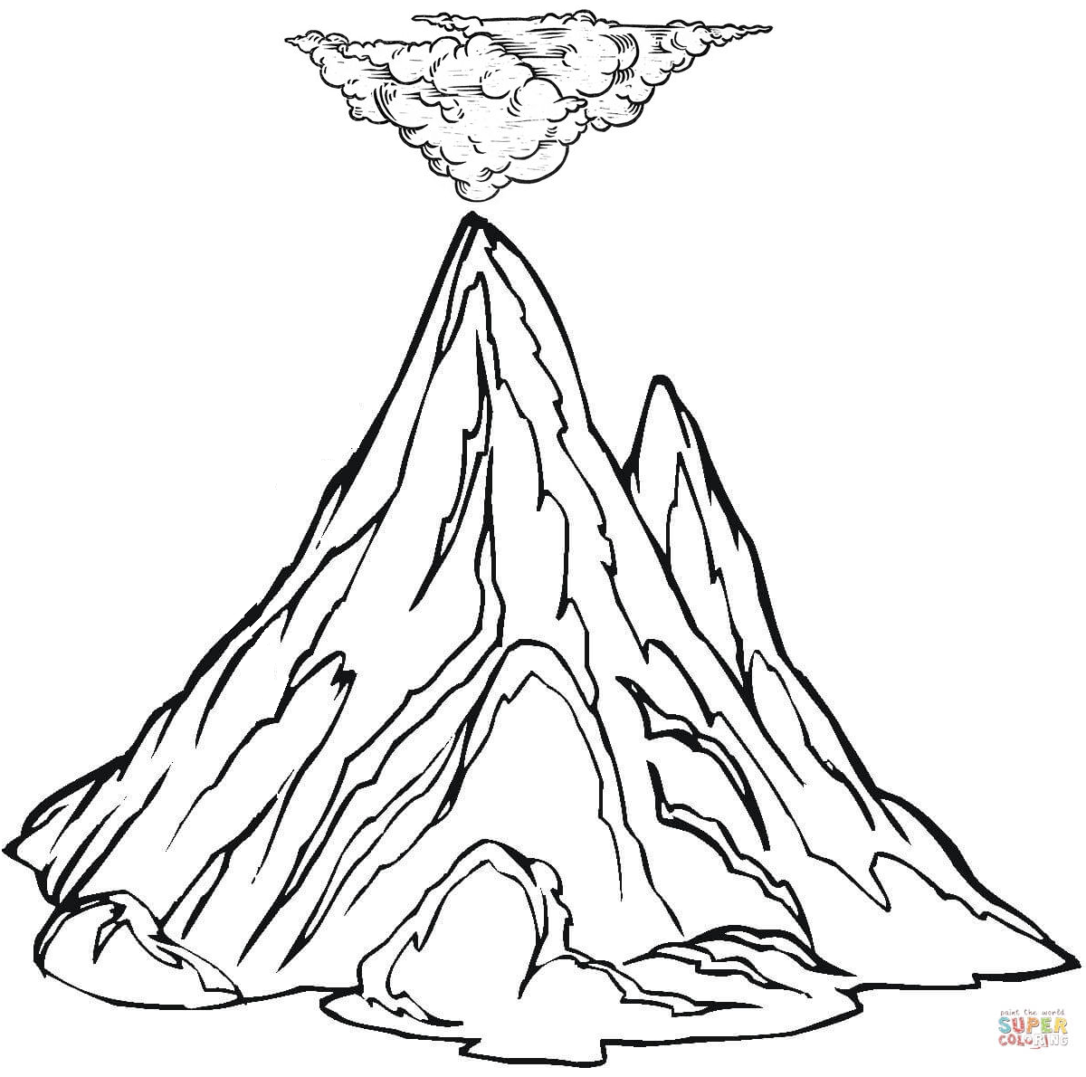

Mount Sinai with smoke at its top

