God Freed his People from Slavery

**Anchor command.** “For freedom Christ has set us free; stand firm therefore, and do not submit again to a yoke of slavery.” *Galatians 5:1*

**Anchor story**. God rescues the Israelites from Pharaoh’s army, by opening a path for them through the Red Sea. *Exodus 14*:5-41

**Anchor verse.** “Moses stretched out his hand over the sea; and the Lord swept the sea back by a strong east wind all night and turned the sea into dry land, so the waters were divided.” *Exodus 4: 21*

**Learning goal**. Understand how God prepared both Egyptians and Israelites, to free his people Israel from slavery in Egypt.

**Growth goal**. Appreciate the great miracle of the Exodus whereby God brought his people out of Egypt to become the nation of Israel.

**Skill goal.** Relate the account of the Exodus accurately.

**Outcome goal.** Many believers communicate the vast importance of the Exodus, to prepare God’s people in the Old Testament to be a special, holy nation.

Basic Study

Dear Lord, give us the courage, faith and obedience that Moses had, when you used him to free your people from Egypt’s king Pharaoh and his army. We trust you to do great miracles also today, to bring nations into your Kingdom, heal and transform lives in the Name of Jesus.

**Learn from Exodus chapter 14** how God brought his people out of slavery to become a powerful and holy nation.

**Background**

400 years earlier Jacob and his twelve sons settled in Egypt because of the famine in their own land. They multiplied to over 2 million people, counting women and children, and Pharaoh, the King of Egypt made them slaves.

Pharaoh feared they would join his enemies and commanded that all Israelite boy babies be drowned in the Nile River. Pharaoh’s daughter found baby Moses hidden in a basket and raised him as her own son. God prepared Moses to lead his people, and sent him to Pharaoh to demand that he free them. Pharaoh hardened his heart, and God sent ten plagues on Egypt to make Pharaoh relent. The final plague was the death of the firstborn of every Egyptian family, and Pharaoh let Moses lead the Israelites out of Egypt. However Pharaoh changed his mind, and sent his army to pursue and kill the fleeing Israelites.

* What did Pharaoh do to stop the Israelites from leaving? *Exodus 14:5-9?*
* What complaint did the Israelites make against Moses? 14:*10-12*
* What did the Lord tell Moses to do? 14:16
* How were the sons of Israel enabled to cross the sea on dry land? 21-22
* What happened to the Egyptian army? *23-28*
* What did the Israelites do then? *29-31*

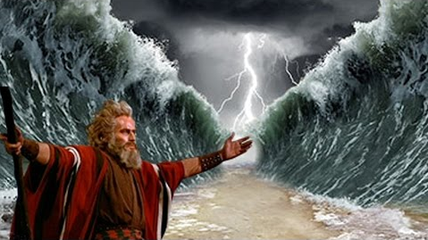  
*Moses obeyed God, and led his nation across a sea on dry land.*

**During the week** you and your co-workers visit anyone who might be enslaved in some way, by bad habits or circumstances, and do what you came to free them, just as God used Moses to free the Israelites from slavery.

**During worship…**

* Relate the account of the Exodus, the Israel’s plight from Egypt. Ask the same questions as above and urge the believers to discuss the answers.
* Ask the children to present what they have prepared.
* Let the men memorize Exodus 15:18-19, the women, verses 20-21.

Advanced Study

1. **Learn from Exodus and related passages…**

* In **chapter 1** a bad king tried to kill baby boys. What similar events followed Jesus’ birth (Matthew 2:13-16)?
* Find in **2:1-10**who saved baby Moses.
* Find in **2:11-15** why Moses later fled to Midian and what happened to him there.
* Find in **chapter 3** what God told Moses to do, speaking from a flaming bush.
* Find in **chapter 5** the conflict between Moses and king Pharaoh, and between Moses and his own people.

*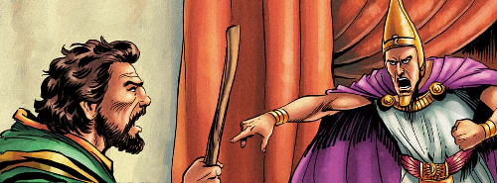  
When Moses spoke from the LORD, the King of Egypt hardened his heart against Israel’s God.*

* Find in Exodus **chapters 6–11** ten plagues that God sent to force Egypt’s king to free God’s people, and how the last plague was the worst of all.
* Find in Exodus **chapter 12** what feast God established, and why God’s people painted blood on their door posts.
* Find in **Matthew 16:17-28** what feast Jesus was celebrating when He established the Lord’s Supper.
* Find in Exodus **chapter 14** how God’s people escaped from Egypt’s army.

**The greatest Old Testament miracle** was God’s making a path for the Israelites through the Red Sea, to escape death. God based His Old Covenant with Israel on this great event, which happened about 1,500 years before Christ was born.

God’s people left the Nile River delta in Egypt, crossed the Red Sea and trod to Mount Sinai, where God gave Moses their ancient Law. Some traditions put Mount Sinai at site #1 in the map, below, but archaeologists have found discarded pottery and jewellery at site #2, indicating an ancient camp of many people.

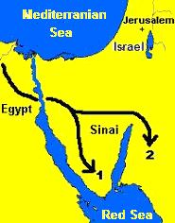

*The Israelites’ route from Egypt*

* Find in **Exodus chapter 16** why people complained and what two things God gave them to eat.
* Find in Exodus chapter **17:1-13**:

Why people complained again and what God provided for them.

Why Aaron and Hur had to hold up Moses’ arms.

* Find in Exodus **chapter 18** how Moses organized the people.

1. **Plan with your co-workers additional, optional activities to do during the week.**

* Start congregations and cells, by applying Jethro’s advice of naming capable shepherds.
* Train novice shepherds to teach this study from Exodus to their flocks.
* Ask these leaders to visit people who have needs or are sick, to counsel and pray for them.

1. **Plan with your co-workers additional, optional activities for the next worship time.**

* Recount or act out some of the events you studied in part 1.
* **Explain** why Jews painted their doorposts with blood. Explain how the Passover Feast corresponds to the Lord’s Supper.
* **Explain** that the bad king Pharaoh is a biblical picture of Satan.

Like Satan, Pharaoh had great power and kept people in slavery.

Just as God freed the Israelites from Pharaoh and his great army, so Jesus frees people from Satan and his army of evil spirits.

* Pray for people who need Christ to free them from sin and spirits.
* Let the children present the things that they have prepared.
* To introduce the Lord’s Supper read Exodus 12:3 and explain:

(1) Israelites ate a Lamb to celebrate the Passover feast.

(2) God’s angel passed over Egypt and slew the oldest child in each house, but spared the sons in homes where blood of the lamb was painted by the door.

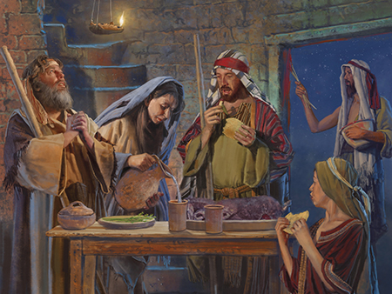  
*The Israelites slew a lamb and applied its blood to their doorposts.*

(3) Jesus is the Lamb of God that takes away the sins of the world.

(4) Since Jesus came and died, the Lord’s Supper is our Passover Feast.

**Let believers give testimonials** of how the Lord’s Supper has helped them to remember and appreciate Jesus’ sacrificial death.

* **Form** **groups** of two and three people to pray for one another and discuss how they can help other people to be freed from Satan’s slavery.