Jacob Saw into Heaven
Dear Lord, please, help the children appreciate the adventures and lessons of the ancient Patriarchs of the Old Testament.
Choose any of these children's learning activities that fit their ages.
- Jacob dreamed of a ladder reaching to heaven, and angels going up and down it,
Genesis 28:12.
- Let an older child or teacher read the story of Jacob’s Ladder, Genesis 28:10-22.
It tells how God revealed himself to Jacob, one of the fathers of the Israelite nation.
- After telling the story, ask these questions. [Answers appear after each question.]
- What did Jacob use for a pillow while resting during his journey? [See verse 11]
- What did Jacob dream about? [12]
- What did the Lord promise about the number of Jacob’s descendants? [14]
- Who did the Lord say would be a blessing to all families of the earth? [14]
- What did the Lord assure Jacob about his travel? [15]
- Why was Jacob afraid when he awoke? [16-17]
- To whom did Jacob promise to give a tenth of all that God gave to him? [20-22]
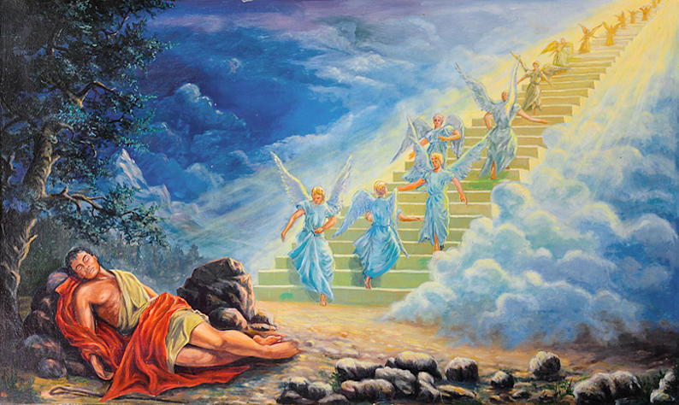
Jacob’s dream of a ladder with angels coming down it.
- Dramatize parts of the story of Jacob’s vision, Genesis 28:10-22.
- Arrange with the worship leader for the children to present this brief drama.
- Use your teaching time with the children to prepare the drama.
- You do not have to use all the parts.
- Let the older children help the younger ones to prepare.
- Let older children or adults play the parts of:
Jacob. Prepare a stone, preferably flat, and a small bottle.
Voice of God.
Narrator. Summarize the story and help the children recall what to say and do.
- Let younger children play the parts of Angels, with a chair or something that represents a ladder.
Narrator: Tell the story from Genesis 28:10-22. Then say,
“Hear what Jacob says.”
Jacob: “It is night. I have travelled a long way. I must sleep.”
Lie down with the stone under your head. Then say,
Angels: Place the ‘ladder’ near Jacob and step up and down on it.
Voice of God: “Jacob, I am the Lord God of your father Isaac and grandfather Abraham.”
Speak each of these promises promise loudly, slowly and clearly:
”I will give you many descendants.”
”I will bless all the world through them.”
”I will take care of you.”
Angels: Leave and take the ladder.
Jacob: Wake up, stand up and say,
“What a powerful dream! This is an awesome place: God is here!
I will leave a memorial stone here, and anoint it with oil.”
Pick up the stone pillow and set it where everyone can see it. Pretend to pour oil on it from the bottle. Say,
“If the Lord protects me as I travel, then He will be my God.
I will serve him.”
Narrator: Thank everyone who helped with the drama.
- Questions.
If the children dramatize this story for the adults, then let them also ask the adults the questions that are listed above under #1.
- Ask the children to give other examples of ways that God reveals himself to people?
- Draw a picture of a ladder and let the children copy it.
They can show their pictures to the adults during worship time and explain that the ladder to heaven illustrates how God is all around us even when we cannot see Him.
Or let the children copy or colour the picture on the last page of this lesson.
- Memorize Ephesians 5:20:
“Always give thanks to God, the Father, for everything, in the name of our Lord Jesus Christ.”
- Let older children write a poem or song about how God is always present with those who trust Him to watch over them.
- Let four children each recite one of the verses from Psalm 139:7-10 —
Where can I go from Your Spirit?
Or where can I flee from your presence?
If I ascend to heaven, you are there;
If I make my bed in the grave, behold, you are there.
If I take the wings of the dawn,
If I dwell in the remotest part of the sea,
Even there your hand will lead me,
And your right hand will lay hold of me.
- Let one of the older children read this prayer:
“Father, we thank you for revealing yourself to Jacob. We know that you are with us all the time, just as you were with Jacob. Help us to trust you like he did. Thank you for blessing me and everyone else through Jacob’s descendent, Jesus.”

Download a drama script to act out, about how God chose Jacob to be Messiah’s ancestor:
http://biblestoryskits.com/010-god-chooses-jacob-to-be-messiahs-ancestor-3/

