The Authority of the Word of God
Anchor command. “Prove yourselves doers of the word, and not merely hearers who delude themselves.” James 1:22
Anchor promise: “Everyone who hears these words of Mine and acts on them, may be compared to a wise man. Matthew 7:24-25
Anchor story. King Josiah’s obedience to God’s Word, 2 Chronicles 34
Anchor verse. “Josiah … made all who were present in Israel serve the LORD their God. All his days they did not turn away from following the LORD.”2 Chron. 34:33
Learning goals. Respect, honour and obey God’s holy Word.
Growth goals. Read and meditate on God’s word daily, including with one’s family.
Gain a profound appreciation for the infinite value of Scripture.
Find how joyful learning God’s word can be.
Skill goal. Become able to teach and apply God’s word skilfully.
Outcome goal. All believers in one’s church come to love and obey God’s word.
Basic Study
- Learn from Josiah how to respond to God’s Word.
- Prayer: “Holy Spirit, illuminate our minds to learn and obey your Word with all our hearts. Help us make it clear to others, so they can share in our joy.”
- Read 2 Chronicles 34 and find in it:
- How Josiah broke with some human religious traditions, in order to obey God.
(Answer: See verses 3-7. Josiah rejected the people’s idols. We, too, must shepherd God’s flock in the way that God requires, not according to human traditions.)
- Find how hard Josiah’s people worked to find the Word of God.
(Answer: See verses 8-15. The Word of God had been lost in the neglected temple.)
- Find the authority that God’s Word had for Josiah, and what he did.
(Answer: See verses 30-33. We receive God’s revelation with faith and obey it.)
- Find how Josiah sought God’s help as he studied the Scriptures.
(Answer: See v. 21-28. The Holy Spirit dwells in us believers and guides us into truth, John 16:13. We ask Him to illuminate us as we study God’s Word, Eph. 1:15-18.)
- Plan with coworkers activities to do during the week.
- With your co-workers, help families to study the Word of God carefully during the week.
- Find how you can support translation and literacy in your area.
- Announce to the believers what you and they will be doing during the week.
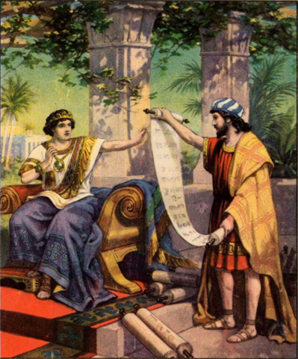
King Josiah listens to the Law of the LORD

5. Plan with coworkers the upcoming worship time.
- Praise God for the truth revealed in His Word.
- Ask for testimonies and reports of how the Holy Spirit used the Bible last week to help people find joy and holiness.
- Prepare helpers to tell or act out the story of King Josiah in 2 Chronicles 34.
- Ask all to listen to find how the God’s Word changed the lives of the Israelites.
- After relating the story, ask the believers what they discovered.
- Have the children also present the story of King Josiah, from children’s study #25.
- To add some exciting drama, do the brief skit under #3, in the Advanced Study, below.
- To introduce the Lord supper, read 2 Chronicles 30, verses 5-6 and 25-27.
Explain: Before Jesus came, God’s people sacrificed a lamb and ate it to recall how God had saved them from slavery in Egypt. Now, Jesus is the Lamb of God who takes away our sins.
- Gather in groups of two or three. To pray, confirm plans, and encourage one another.
Advanced Study
1. Main instruction
Find in Matthew 4:1-11 how Jesus resisted Satan.
- In what three ways did Satan tempt Jesus?
- What did Jesus quote, to answer Satan after each temptation?
- Who came to care for Jesus after His temptation?
- You might want the group to memorize
2. Background
- The Holy Spirit inspired devout men to write God’s Word (2 Timothy 3:16-17). They wrote the Old Testament in Hebrew and the New Testament in Greek:
- Hebrew is read from right to left:
- Greek is read left to right.
- You will understand a Bible passage better if you know:
Who wrote it, to whom and why.
Where and when the events happened.
Who was speaking in the passage?
What it prepares us to do.
You will also understand some parts of the Bible better, if you know the customs, history and geography of ancient Israel. Learn these in other Paul-Timothy shepherds and supplementary studies (see the P-T User Menu).
3. Dramatize how the Holy Spirit uses God’s Word to illuminate our minds.
Two persons act out this brief skit, Learner and Deceiver.
Learner: Light a candle on a table, then look the other way.
Deceiver: Sneak up to the candle, blow it out, and lasts evenly.
Then say the following (If you translate the demon’s poem, you do not need to preserve the rhyme):
You fools obey my Enemy! I will stop your bold sedition!
I will turn you from His Word, you will see, by teaching man’s tradition!
You mortals dare with Him to sup, whose cup delivers from hell’s fire?
I warn you, stop opposing or you will feel the sting of hell’s hot ire!”
Learner: Light the candle again and hold it over the Bible in front of Deceiver.
Deceiver: take that horrible light away! I can’t bear it!
Learner: Jesus said, “I am the Light of the world; he who follows me will not walk in the darkness, but will have the Light of life.” John 8:12
God’s Word is hidden from many people today, wherever no one has yet translated it correctly into their language. Many translators work hard to provide accurate translations.

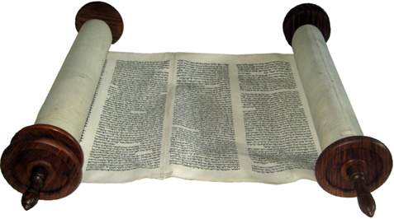  In Old Testament times, Jews copied their Scriptures by hand on scrolls that rolled up. | 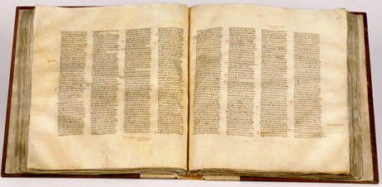  In New Testament times, Christians started making books that they copied by hand.

