Good King Josiah Obeys God's Word
Dear Lord, please help the children to trust and respect Your Word.
Choose learning activities that fit the children’s ages, needs and level of spiritual growth.
Children may like to copy or colour the picture on the last page of this study.
- Teach the story of the boy king Josiah.
Read 2 Chronicles 34:1-21, 29-33 that tells how valuable it is to obey the Bible.
Let an older child tell this story from memory. Then ask these questions.
[Answers appear after each question.]
- What did King Josiah do with the idols and altars of false gods? [See verses 3-4]
- Where did the priest Hilkiah find the Book of the Law of God? [Verse 15]
- What did the king do to show that he was grieved, when he read the Word of God and found out that his people had disobeyed it? [Verse 19]
- What did the people agree to do together after they heard God’s Word? [Verse 32]
- Did the people follow their king’s example of obeying God’s Word? [See verse 33]
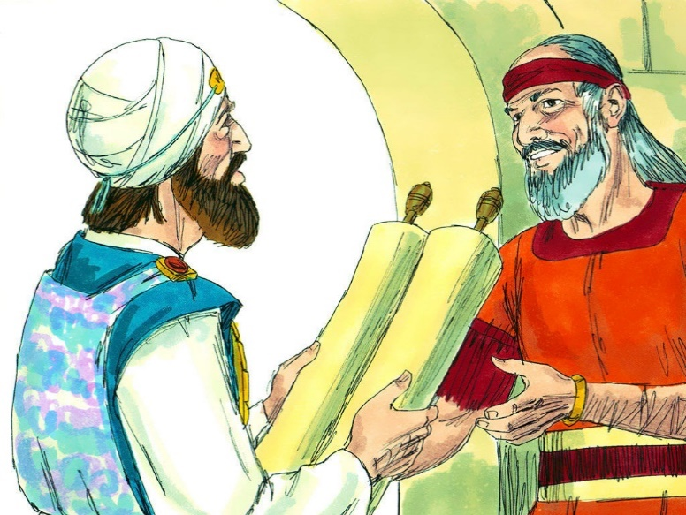
Priest Hilkiah presents to King Josiah a scroll of God’s Law.
- Let younger children …
- Hide a Bible somewhere and have the children find it. Then explain that this was what happened when Josiah was king.
- With older children (if they have Bibles): Say the book, chapter and verse number of a few Bible passages and let the children find them in the Bible as quickly as they can. This will help them to learn where things are found in the Bible.
- Dramatize parts of the story of King Josiah.
- Arrange with the leader of the main congregational worship to have the children present this drama.
- Let the older children help the younger ones to prepare.
- Let older children or adults play the parts of Josiah, Hilkiah, and the Narrator who summarizes the story and helps the children to remember what to say and do.
- Let younger children play the parts of Workers and People. Workers have a book hidden under papers on a table or chair. People have piles of stones for altars, small rocks for coins, and a small box.
Narrator: Tell the first part of the story from 2 Chronicles 34:1-21. Then say,
“Hear what King Josiah says to the people.”
Josiah: “People of Israel, we make the Lord angry with our idols. Let us destroy them!”
People: Knock over the stone altars.
Josiah: “We must repair God’s Temple. Who will give money for this huge work?”
People: Put the ‘coins’ in the box. Say,
“We give our offerings to repair the Temple!”
Workers: Take the money and pretend to build. Find the book and give it to Hilkiah.
Hilkiah: “Look, King Josiah! See what we found in the Temple! It’s God’s Law.
But we have not done what it says. We have disobeyed God!”
Josiah: Look at the book for a moment. Then say,
“Call all the people together! They must hear what God says.
We need to ask God to forgive our disobedience to His law!”
People “You are a good king! We will follow your example!”
Older child or adult: When the drama is over, thank everyone who helped.
- Questions.
If the children dramatize this story for the adults, let them also ask the adults the questions listed above under #1.
- Draw a Bible and let the children copy it.
Older children might want to draw a child holding a bible next to their heart.
- Let the children show their pictures to the adults during the worship time.
- Have the children explain that this illustrates how we love God’s Word and think about it all the time.
- Let the children tell other examples of how God has used His Word to guide His people.
- Let several children each recite one or two verses from Psalm 119: 1-2 and 9-11.
- Let older children write a poem or song about the way God’s Word helps us.
- Let the younger children memorize 2 Timothy 3:16 and the older ones 2 Timothy 3:16-17.
- Let an older child read this prayer: “Father God, Your Word guides us and comforts us. Help us to understand your words so that we can obey them and rejoice in them.”

