King David Broke a Bad Habit
Lord, please use this study about David and Bathsheba to help the children break harmful habits in their lives
- Read in 2 Samuel chapter 11 and 12:1-23 how God broke the power of adultery for David.
Let an older child read or tell the story from memory. Then ask these questions from 2 Samuel 11:1-17. [Answers appear after each question.]
What did the king take that did not belong to him?
[Answer: See verse 4. David became accustomed to taking whatever he wanted, because he was the king. This was a sinful habit. As a result, he committed adultery.]
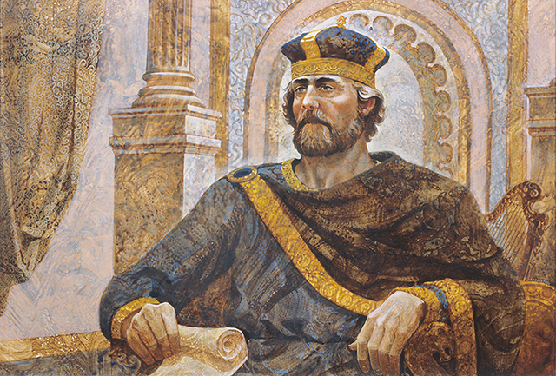
Even a king on his throne can have bad habits that seem to strong to break.

How did King David try to deceive Uriah? [See verse 8.]
How did one sin cause David to commit other sins?
[See verses 13 and 14. Often, when we try to cover up one sin, we do worse sins.
When David tried to cover his sin, he lied and murdered.]
- Questions from 2 Samuel 12:1-14.
What did the prophet Nathan tell David to help him recognize his own sin?
[See verse 1. He told a story. God often uses wise people to help us to recognize our sin, to pray for us, and to help us to accept responsibility for our actions.]
What did David have to do before God broke the power of sin in his life? [Verse 13]
Did God forgive David? [Verse 13]
What was the result of David’s sin? [Verse 14]
- Dramatize parts of the story of David and Bathsheba.
Arrange with the leader of the main congregational worship for the children to present this drama.
- Let the older children help the younger ones to prepare.
- Let older children or adults play the parts of Nathan, David, Bathsheba, Uriah and the Narrator who summarizes the story and helps children to remember what to do.
- Let younger children play the Archer, Rich Man, Poor Man, Pet Lamb and Sheep.
- Try to do this drama with as few words as possible.
- If your group is too small, then omit the sheep (the rich man pretends to count them).
- Players are:
Narrator  David  Bathsheba | Uriah  Archer  Nathan | Pet Lamb  Poor Man  Sheep (Any number)
Narrator: Tell Part 1 of the story from 2 Samuel 11:1-17.
Then say,
“Hear what David says to himself.”
David: Strut around proudly, saying,
“I am the king. I can do anything I like. I can have anything I want.”
Bathsheba: Walk in front of David. Then pretend to wash your arms.
Uriah: Stand near your wife Bathsheba, looking the other way,
not toward her or David.
David: Watch Bathsheba, and then look around to see if anyone is watching.
Then beckon to her with your hand.
Bathsheba: Go to David and walk away with him.
Archer. Go near Uriah and pretend to shoot arrows at him.
Make noises like the ‘twang’ of a bowstring.
Uriah. Grab your chest, scream in pain and fall to the ground, dead.
Narrator: Tell the Part 2 of the story from 2 Samuel 12:1-14. Then say,
“Hear what the Prophet Nathan tells King David.”
Nathan. “King David, please watch. I have a story to show you.”
Pet Lamb. Go to the Poor Man on hands and knees, making sheep noises.
Poor Man. “Nice little lamb!” Pet the lamb fondly.
Sheep. Go like sheep and crowd around the Rich Man.
Rich Man. Count your sheep in a loud voice. Then say, “I want a sheep to eat!”
Point at the Poor Man’s pet lamb and say,
“That one! Why should I kill one of my own sheep?”
Go get it. Pretend to cut its throat with a knife. It falls to the floor.
Nathan. “King, this is what you have done! You took what was not yours. You deserve to die!”
King David. “I repent. May God forgive me! This sin was getting bigger in my life, but now God used you to break its power. I will behave better from now on.”
Nathan. God forgives you, but your sin will bring bad results. Bathsheba’s baby will die.
- If the children dramatize this story for the adults, let them also ask the adults the questions listed above under #1.
- Draw a picture of a thistle among flowers.
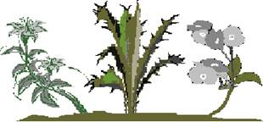
Let the children draw or colour the picture on the last page of this study.
- Let the children show their pictures to the adults during the worship time.
- Let the children explain that this shows how a sin, like a weed in a garden, spread and produces other sins, if we do not remove it. God frees us from the power of sin when we are sorry for our sins and ask Him to forgive us.
- Discussion. Let the children and adults cite other examples of ways that God has broken the hold of bad habits in people’s lives.
- Poem. Let four children each recite a verse from Psalm 51:14-17.
- Let older children write a poem or song that uses words or ideas from Psalm 51.
- Memorize Psalm 51:12. “Restore to me the joy of your salvation and sustain me with a willing spirit.”
- Let an older child read this prayer:
”Lord, sometimes there are sins in our lives that keep getting bigger and bigger. We cannot seem to break their power. Help us to repent of them and find wise people to help us stay away from them. Give us your power to live pure lives, in Jesus’ name.”

