Serving the Lord’s Supper in
a Small Group
Anchor command. “When he had taken some bread and given thanks, he broke it and gave it to them, saying, “This is my body which is given for you; do this in remembrance of me.” Luke 22:19
Anchor story. Jesus establishes the ordinance of the Lord’s Supper. Mark 14:12-26 and
John 13:21-30.
Anchor verse. ”Day by day continuing with one mind in the temple, and breaking bread from house to house, they were taking their meals together with gladness and sincerity of heart.” Acts 2:46
Learning goal. Know how to serve the Lord Supper in a home or other informal surroundings, to a small group.
Growth goal. Value the loving fellowship and meaningful worship that a small group can offer.
Skill goal. Celebrate the Lord’s Table in a way that believers are knit more closely to Christ and to each other.
Outcome goal. All believers receive the Lord’s Supper regularly, and examine themselves in order to receive the bread and cup worthily.
Dear Lord, we thank you for the gift of the Lord’s Supper. Help us celebrated in a way that is worthy of its extreme importance, even though were meeting in a non-formal way.

Basic Study
Jesus establishes the sacred ceremony of the Lord’s Supper, Mark 14:12-26 and John 13:21-30
- While eating the Passover, what did Jesus tell his disciples that grieved them?
Mark 14:18-19
- What did Jesus say the bread was that he blessed and broke? Mark 14:22
- What did Jesus say the cup held that he gave them to drink? Mark 14:23-24
- What did Jesus and his disciples do just before leaving to go to the Mount of Olives?
Mark 14: 6
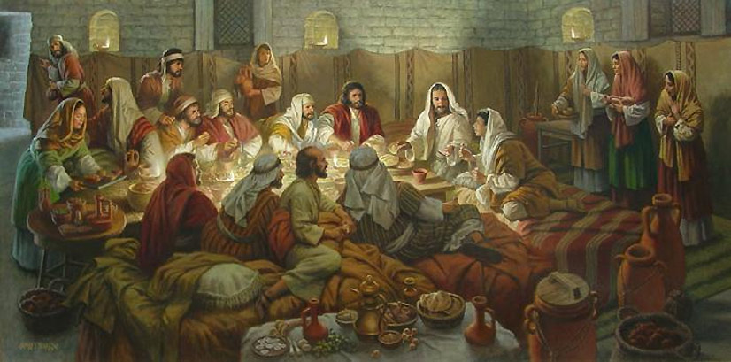
Jesus and his apostles celebrated Passover, transforming it into the Lord’s Supper.
- When the disciples asked Jesus who it was who would betray him, what did he tell them? John 13:26
- Who took control of the traitor Judas after Jesus handed him bread? John 13:26
- Judas left at once after receiving the bread. What time of the day was it? John 13:30
During the week visit any believer who fails to participate in the Lord supper, and any leader of a small group or congregation who is neglecting it, and help them obey Jesus’ command.
During Worship …
- Explain that Christians in the New Testament celebrated the Lord Supper in homes, in small groups
- Relate the account of Jesus’ inaugurating the ordinance of the Lord’s Supper, and ask the same questions as above. Let believers discuss the answers.
- Ask the children to present what they have prepared.
- Memorize Acts 2:42 (which describes activities of the first church in Jerusalem):
“They were continually devoting themselves to the apostles' teaching and to fellowship, to the breaking of bread and to prayer.”

Advanced Study
- Additional facts about the Lord’s Supper.
Background information:
- When Jesus’ followers gathered in the New Testament, they often “broke bread” together. That is, they would celebrate the Lord’s Supper which is also called the “Lord’s Table,” “Communion” and the “Eucharist.”
- For almost 2000 years, the Lord’s Table has been at the center of Christian worship, both in big buildings and in humble home meetings. Your home group can break bread together, too.
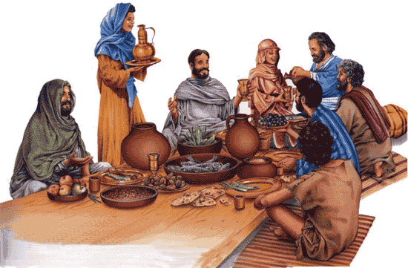
For almost 2000 years, the Lord’s Table has been at the center of Christian worship.
- When we break bread together, with faith in Jesus, several things happen:
- We obey a command of Jesus. Matthew 26:26-27.
- We experience new joy. Acts 2:46.
- We come together. Acts 20:7.
- We participate in the blood and body of Jesus. 1 Corinthians 10:15-17.
- We remember Jesus, his body given for us, his blood, and the new covenant.
1 Cor. 11:23-25.
- We proclaim the Lord’s death. 1 Cor. 11:26.
- We examine ourselves. 1 Cor. 11:28.
- Preparations before starting the worship time.
- To celebrate the Lord’s Table, you only need some kind of bread and some kind of juice. Most churches prefer grape juice: some use wine. If anybody is an alcoholic or believes that alcohol is bad, then provide unfermented juice. If you have a dish, put the bread on it. It is best to put the juice in a cup or glass with a wide brim. To avoid spreading germs, participants can simply dip the bread into the cup.
- In a small group, you can set the bread and cup on a small table with room for people to stand around it. Invite the people to come stand around the table with you. If some non-followers are there, then first tell them politely that you are glad they came, and that the bread and cup are for those who have been baptized and want to obey Jesus.

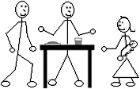
- Before distributing the bread and cup…
- Explain to the small group what they are about to do. Read aloud one more verses from the Bible about Jesus’ death, or ask the people to recall some verses about it. You may choose to read one of these passages:
Isaiah 52:13 - 53:12 Acts 4:8-12
Matthew 26:26-30 Romans 5:6-11
Matthew 20:17-28 1 Corinthians 1:18-2:5
Mark 14:23-26 1 Corinthians 14:23-31
Luke 22:14-20 Ephesians 2:13-18
Luke 24:44-53 Hebrews 9:11-15
John 6:44-58 1 Peter 3:13 - 4:1
Acts 2:22-36 1 John 4:7-17
- Ask the people to thank the Lord in their own words for his death and for how he has forgiven them. Urge them to confess to him any sins. If some people begin weeping, do not try to stop them.
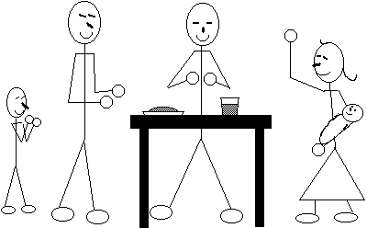
- After a moment, let people recite some verses that tell about forgiveness, or read some verses like Luke 24:45-47 or 1 John 1:5 – 2:2.
- Common ways to serve and partake of the bread and cup in a small group.
- First, read aloud or recite to the group 1 Corinthians 11:26 or a similar passage.
- Take up the bread dish and tear off a small piece of bread. Hold your piece and pass the bread dish to someone while saying, “The body of Jesus.” Each person should do the same, until everyone is served.
- Each one should hold their piece of bread and not eat it yet
- Take up the cup and dip your piece of bread in the juice. Hold your bread and pass the cup to someone while saying, “The blood of Jesus.” Each one should do the same till everyone has dipped their bread in the juice.
- Read aloud or recite to the group 1 Corinthians 11:25 or a similar verse.
Then everyone should eat their bread together.
- While seated or standing, anyone in the group can say a short prayer or lead out with a song of praise to Jesus. Perhaps the group will hold hands with each other while they sing.
- If the people have been standing, then invite them to return to their seats.
- Churches have different ways of serving the bread and cup. Vary the ways, to avoid it becoming simply a perfunctory routine.
- Some small groups make communion part of a potluck dinner. If you do so, be careful not to repeat the error of the Corinthians, which some churches have done, letting the feast overshadow the sacred ceremony.
- Let non-followers watch while you celebrate; they will not be offended.
- Do celebrate the Lord’s Table often.
- Do not preach during the celebration: the Lord’s Table itself is a proclamation.
- Do not hurry it. The Lord’s Table is a form of worship so that people meet with God.
- Do not explain it away. Communion is more than a symbol; it is spiritual and real.
- Test (Choose the better answer to each item.)
1. Communion can be celebrated …
only in a full congregational meeting.
any time and place your church approves.
2. The bread and cup become communion when…
an official ceremony is performed correctly.
they are received with faith in Jesus.
3. Communion can be served …
only by an ordained clergy person.
by ordinary believers one to another.
4. In a Communion service, the cup contains …
real wine like they used in the first century.
any juice that reminds people of Jesus’ blood.
[Answers: the second answer for each question is the better one.]

