OBEDIENCE-ORIENTED EDUCATION

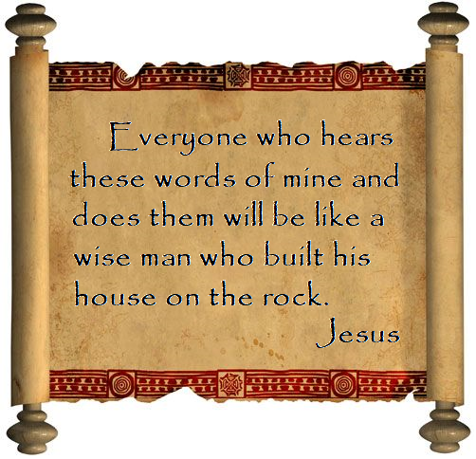

By George Patterson
Copyright © 1976 & 2004 by George Patterson

Permission is given by the author to reproduce freely.

Please cite the source.

INTRODUCTION
Obedience-oriented education originated in Honduras. It grew out of a “TEEE” program, which grew out of a TEE program, which grew out of a TE program. Let us explain these E's
TE means Theological Education, usually in a resident seminary or Bible institute.
TEE means Theological Education by Extension.
TEEE means Theological Education and Evangelism by Extension.
Any of these three types of Theological Education can be obedience-oriented, if it builds the curriculum on the commands of the Lord Jesus Christ (Mat. 28:18-20). Doctrine, Bible, church history, and other such “subjects” do not form the basis for the course of study. Rather, the primary educational objectives are Christ's orders for His universal Church. This priority will quietly revolutionize a seminary or Bible institute.
TEE takes pastoral studies to the student where he is. It reaches men who cannot leave their homes or jobs. It relates their studies to their work with a local congregation in the community, and not in the seclusion of a resident seminary. Self-teaching textbooks permit less time spent in the classroom, but require more private study. TEE aims primarily to educate, not to evangelize nor start new congregations.
TEEE integrates evangelism with TEE. It aims primarily to edify the congregations immediately. We define evangelism not as “soul-winning” but as the birth and growth of congregations, the edification of the Body of Christ. Education and evangelism, combined in one program, powerfully reinforce each other. Pioneer missionaries often use some kind of TEEE, where church planting must be accompanied by a pastoral training program.
How did the Honduras Extension Bible Institute come to apply TEEE? Our TEE program, when integrated with the third E (evangelism) proved to be an efficient tool for planting new congregations and evangelizing the lost. Broadening its scope this way did not weaken its educational capacity as some predicted, but strengthened it. This happy marriage between education and evangelism blossomed as we oriented the education toward obedience. Workers and congregations multiplied in a way unknown to our former TE program (a traditional resident Bible Institute).
The Lord Jesus Christ does not honor any particular educational method. He taught in a variety of ways. God does not bless methods. He blesses loving, faithful obedience. Certain Biblical principles of teaching enable us to make more obedient disciples.
Many congregations emphasize the “body” in which all members of a congregation work together in one Spirit. TEEE applies the same concept on the inter-church level. Sound relations between congregations create an extension chain to reproduce daughter congregations. The “Paul-Timothy” relationship between extension trainers and students edifies the Body locally and regionally, as seen in 2 Tim. 2: 1-2. It enables normal growth of the Body.
George Patterson
OBEDIENCE-ORIENTED EDUCATION
The Honduras Extension Bible Institute has prepared this explanation of the obedience-oriented pastoral course. The principles may be helpful in training pastors and starting churches in other areas. The obedience orientation is not simply a method. It is a way of thinking and acting in obedience to Christ. It applies to the resident seminary, the extension institute, or any church whose pastor trains a “Timothy” in order to multiply his own ministry. If we start with total obedience to Christ and follow through without regard for tradition, we arrive at the some definite requirements for theological education, which make up the basic outline of this document.
I
CHRIST REQUIRES WORK WITH A CONGREGATION
Truly Christian education demands: “Be ye doers of the word and not hearers only, deceiving your 'own selves” (James 1:22). The apostle denounced education that led to passive learning. Many traditional pastoral courses allow such passive learning. A student who is conditioned by three or four years of learning the Word mainly in a passive manner will graduate with an institutional mentality. He will treat his church as if it were a small Bible Institute; the people will sit and learn passively. The church, instead of being the sensitive, creative body which God intended, becomes pastor-centered and passive.
When churches begin multiplying in neglected fields, there is always an urgent need to train many new pastors. This requires a change. Many Christian educational institutions now require much more practical work to supplement the subjects taught. They reinforce doctrine and theory with field assignments in churches. This requires more obedience, but is still a doctrine-oriented curriculum. The doctrinal base comes first; the practical assignments are added to it. Let us go a step farther. Why not start with the practical work, and then add the necessary doctrine to enable a student to do it? Note the reversal. The course is now activity-oriented, but is still not necessarily obedience-oriented. The curriculum is “functionally-ordered” geared to the needs of on-the-training. It serves well to mobilize large numbers of workers in a rapidly expanding field. But we must define it further, to assure that the activities are done in obedience to Christ in a permanent pastoral education program.
Practical work assignments must be done in direct obedience to Christ, not to the professor. This usually solves any problem of lack of motivation. We do not simply hand out Christian service assignments over the weekend, nor assign each student to a church. The practical work is an integral part of the pastoral course. We develop it by starting with the commands of Christ for His churches. We determine the necessary steps to carry out His Final Commission, to make disciples who obey all His commands, in our area of responsibility. His orders form the backbone of our curriculum. The congregational activities necessary to carry them out make up the skeleton for the course.
The flesh appears on our pastoral training course as we apply these activities to specific places, people and responsibilities. If our general objective may be to train men to start new churches; our immediate objective will be to train Carlos to start a new church on Seventh Street this month. Our general objective may be to prepare men to witness; our immediate objective is for student-worker Carlos to help his friends Roger, Juan and Ian to witness this weekend. An obedience-oriented curriculum requires immediate objectives with names, places and dates.
The heart of the course is our love for the Lord Jesus' Christ. Obedience for any other motive is legalism. He said, “If you love me, keep my commandments” (John 14:15). This love needs to be cultivated: we must exhort, encourage and recognize the work of our students continually. The student-worker responds voluntarily in obedient love for Christ and His work. We must not demand obedience to the commands of the Lord with a legalistic spirit. The student does not work for the professor, or grades or a diploma, but because he loves to edify the Body of Christ.
  - Conventional teacher views student
Traditional theological teachers concentrate on the student. Their objective is to educate him. They seldom look beyond the student to see what he does. The student satisfies his teacher with good papers, exams and sermons.
The obedience-oriented trainer, looking beyond his student, is satisfied only with edifying work in the field. It is not enough to teach him the Bible; he must teach it biblically. Education includes the trainer, the student and the congregation in which he works. The educational objective is not just to educate the man but to edify his congregation. The trainer sees his congregation through his student-worker who is God's instrument to help the congregation obey all that the Lord commands. The student-worker may be a pastor or a pastor’s helper.
  - Obedience-oriented trainer views student-worker as part of a church body
We must know Christ's orders for a church in order to obey them. Confusion abounds: one preacher demands that we baptize immediately, another says to wait months; some insist on total abstinence from alcoholic beverages, others say such a demand is unbiblical tyranny; churches divide on issues of dress, food, entertainment and methods of evangelism. Human opinions confuse Christians. We must distinguish between (1) New Testament commands for the Church, (2) apostolic practices (not commanded), and (3) human traditions.
  - THREE LEVELS OF AUTHORITYFOR THE ACTIVITIES
OF A CONGREGATION
1. NEW TESTAMENT COMMANDS
EXAMPLES: faith, repentance, baptism, love, sanctification, Lord's Supper, prayer, giving, evangelism, biblical instruction of believers. We do not include the Old Testament because we are dealing with church activities, not the ancient laws for the covenant with ancient Israel.
AUTHORITY: They are required (Mat 28:18-20). They cannot be prohibited.
2. APOSTOLIC PRACTICES (not commanded)
EXAMPLES: To travel by foot or by boat; to speak in foreign tongues; to baptize immediately; to share all goods in common; etc.
AUTHORITY: They are not to be required. They are not to be prohibited. (Only Christ has the authority to order what we must or must not do in His congregations.
3. HUMAN TRADITIONS
EXAMPLES: Sunday School; choir; pulpits; seminaries; public invitations to ‘go forward’ or ‘raise your hand’ to accept Christ; ‘preaching points’, candles, catechism for baptismal candidates; formal ordination; wearing a tie in the pulpit; not wearing a tie in the pulpit; the pulpit; etc.
AUTHORITY: They are not to be required (Mat.15:1-9). They may be prohibited if they hinder obedience. Most traditions are good. They become bad when they hinder obedience to Christ. Their only God-given authority is the voluntary agreement of a certain congregation to do something (Mat 18:18-20). One congregation should not press its tradition on another. Most traditions are good. Some are diabolical.
These three levels of authority for a congregation provide a basis for determining whether we should require or prohibit a questionable practice.
For example: to celebrate the Lord’s Supper is an obvious, universal commandment (required). To celebrate it frequently in homes was an apostolic practice (not required, nor to be prohibited under similar circumstances). To celebrate it at 10:45 AM in a chapel is a human tradition (to be practiced when agreed upon by a specific church body).
We have an obedience-oriented pastoral course only when immediate educational objectives fulfill the commands of Christ. To guarantee a permanent orientation to obedience we must secure the active cooperation of the congregations in which our students serve.
II
TRAINERS COMMUNICATE WITH SHEPHERDS IN THE FIELD
Ephesians1:17-23 gives us insight into the divine process of theological education: God Himself gives His people (the members of the church in Ephesus, in this case) a spirit of wisdom and revelation to know Him and His plan for His people. The trainer helps his student-worker to participate in this divine educational process. What he studies should correspond to the activities of the congregation where he works. Essential elements of doctrine, Bible and church history are introduced into his course where they best meet the needs of those people for whom he is responsible. We do not give doctrine and Bible a lower place in the obedience-oriented curriculum: they take on a surprisingly new importance when related directly to the life and activities of a growing congregation. This requires constant communication between the trainer and the congregations-the nervous system of the pastoral course.
Compare the two educational methods as they relate to the churches
  - 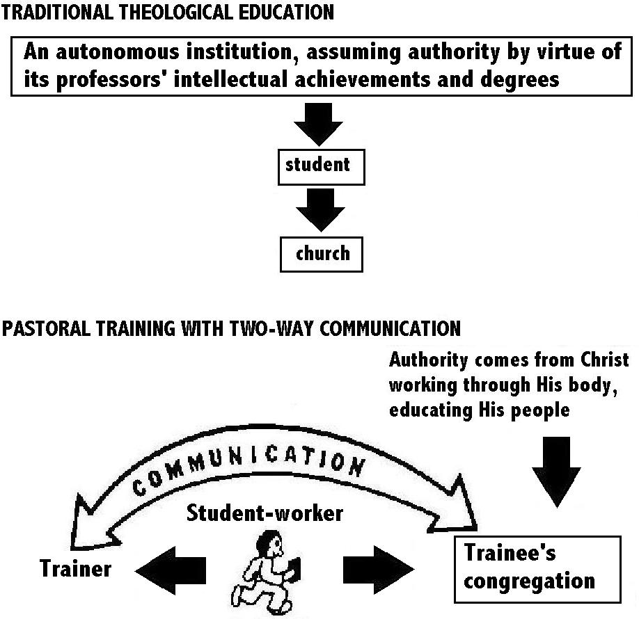
In pastoral training with two-way communication, the student-worker goes back and forth from his congregation to his instructor, who might be a pastor or elder in a mother church, or a trainer in an educational program set up to serve the churches. From his congregation, the student-worker takes progress reports and information about needs and opportunities to serve. From the trainer, who is prepared by these reports, the student-worker takes solutions, materials and instructions back to his congregation for its edification.
Experienced shepherds and church planters in the field should inform the trainers what steps each student ought to take next. The student's own reports also inform the trainer of his changing needs. The educator designs the broad course of study with its general objectives and unchangeable biblical goals. But he allows flexibility for dealing with the changing, immediate objectives, as the new believers in the student's congregation progress. In a new congregation the immediate objectives are more obvious: the congregation simply begins to do the things ordered by Christ, one by one. In an older congregation many needs normally arise; the student should not lack opportunity to apply different studies to them. Sooner or later he will need to apply the whole Word of God, important examples from church history, vital doctrines and pastoral work.
A seminary remaining independent from the congregations can hardly have an obedience-oriented curriculum. The theological institution must place itself in a position of cooperation with the congregations. Each congregation should incubate shepherds in cooperation with a resident or extension seminary. Christ gave the power to the Church - not to an autonomous seminary - to educate His people (Mat. 28: 18-20). The seminary working within this sphere of authority finds the congregation to be its most valuable ‘classroom’. Like a lens focusing sunlight on one sharp point, the Holy Spirit uses the congregation to integrate different elements of study into one program, just as. He coordinates different ministries in one body (Eph.4:1-16).
Seminaries fear control by the congregations, which in turn fear control by the seminaries. The seminary defends its independence in the name of academic freedom, scholarship and intellectual honesty. It may recognize the authority of Scripture but this is not the same as submitting to Christ's authority given to the Congregation, through which God educates His own people theologically. We do not ask for the congregations to control the seminary or vice versa. The mutual suspicion is allayed only when both agree to share in the educational process, appreciating the contribution of the other to, its own ministry. The decisive factor is not the control but communication, to coordinate the student-worker's service in a congregation with his studies.
This two-way communication between shepherd and educator is as vital as that between a military commander and his trainers. During a long campaign the troops are repeatedly briefed and oriented. As they pass from one objective to another they are re-equipped for their next encounter with rubber rafts, snow shoes, gas masks or anti-tank weapons, according to the intelligence reports and commander's directive. The pastoral student may not need to learn how to inflate a rubber raft; but he will need to know how to discipline a disorderly member of a new congregation. For this he needs special equipment. His trainer must know what his work is and relate the theoretical studies to it.
Such teaching is challenging; it spoils us for the conventional classroom. The student-worker also devours his studies with an eagerness seldom found in a traditional institution. He is obeying Christ! As part of a conquering army, he is responsible for his part of the work in some congregation.
A commanding general would not send military units into battle under officers from an autonomous military academy which ignores his orders in the name of intellectual freedom. Military trainers cannot be shielded from the realities of a modern battlefield and design their own curriculum along traditional lines of their own choosing. Rather, they must use information flowing constantly from the combat zone and follow the directions of their commander.
The Christian educator, like a military strategist studying his maps, must interpret communications from the field, from ‘spies’ behind the lines, and from the General Himself, in order to mobilize his ‘troops’ to advance. In both military and missionary operations workers in the field must report continuously to those who are directing, training or mentoring them. Reports of progress and urgent needs clarify our immediate objectives, as we work in obedience to our Supreme Commander's general orders. Immediate educational objectives change from week to week, according to the progress and needs of those for whom the student-worker is responsible.
III
COMBINE DOCTRINE WITH ITS CORRESPONDING DUTIES
The trainer must enable his student to fulfill the practical obligations of every doctrine. We do not tack on an “application” to it: rather, we approach doctrine out of a primary desire to obey Christ. Shepherds should mobilize all the members of the congregation for service; Ephesians 4: 11-16 indicates that shepherds should equip the “saints” for the ministry. The Holy Spirit coordinates their different ministries. Theological truth, properly taught, moves us to serve together as a body. But it cannot when we partition it into specific subjects and teach each one separately. We should relate different theological truths by focusing them on one specific congregational activity. Systematic Theology seeks to relate divine truths logically, but outside of their normal setting. The Spirit of God brings these truths into focus as He coordinates the different ministries within a growing congregation. He integrates different elements of Bible doctrine, history and Christian education, etc. as we apply them to men's lives, struggles with the world, contradicting philosophies, politics and human relationships.
How can our student learn to harmonize apparently opposing interests in his congregation? A shepherding elder with the gift of teaching interests himself in the details of biblical doctrine. Another with the gift of prophecy is more concerned about the long range implications of theological truth for men in today's world: he interprets church history, past present and future, to show us our position and duty before God. Another with the gift of exhortation wants to get the job done; he enjoys books on counseling, evangelism and mission strategy. A deacon with the gift of serving wants better worship and searches for better hymns of praise. Another volunteer works with a boys' group and community projects; his wife takes food to sick neighbors. A shepherd cannot harmonize these different interests and abilities in the classroom or from a pulpit. An experienced shepherd governs with wisdom, unifying these workers as they obey Christ together as a team. The student-worker observes and learns how God's Spirit coordinates different people, interests and truths in the ministry of the body of Christ, harmonized by the Holy Spirit. He discovers a cohesive factor in Spirit-motivated obedience to Christ.
How can we integrate different studies so that they contribute to an activity ordered by Christ? (See diagram on page 14.)
To relate doctrine and duty requires a “vertical” treatment of doctrine. We begin with God as the source of all truth and authority. His attributes find expression in the eternal decrees of God the Father. These decrees are wrought within creation by God the Son, whose work is applied to man by the Holy Spirit. Man responds in simple obedience. We start with God and end with man. The intermediate steps in this vertical application form the content of a doctrinal study. Any systematic study that fails to begin with God or end with man's obedient response falls short of the biblical ideal. It will not really contribute to the activities performed by an obedient congregation.
  - 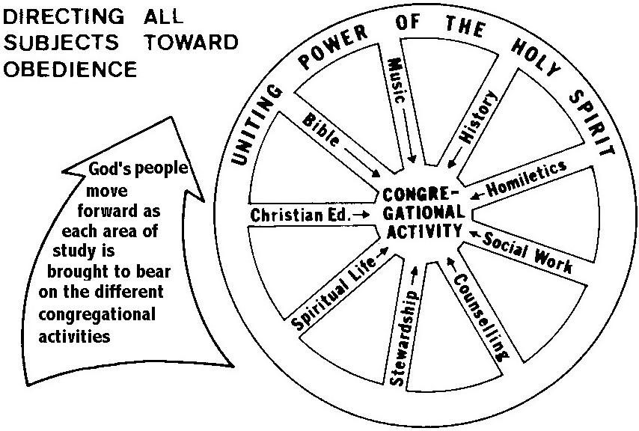
The traditional, analytical approach to doctrine is “horizontal” and seldom begins with God and ends with man's duty. Like medieval scholasticism, it groups doctrinal truths in parallel or horizontal categories, comparing similar ideas. It fails to touch both heaven and earth. The Prophets and Apostles show us how to teach: they presented theological truth which touched men's daily life in a disturbingly practical manner. They never taught doctrine for its own sake.
A resident education program can hardly require every class to have its corresponding practical work. But sessions practical focusing on practical work can gear the student's studies to his congregation's growth. Whoever teaches this practical work can help the other teachers make assignments that helpful for each student's needs.
  - 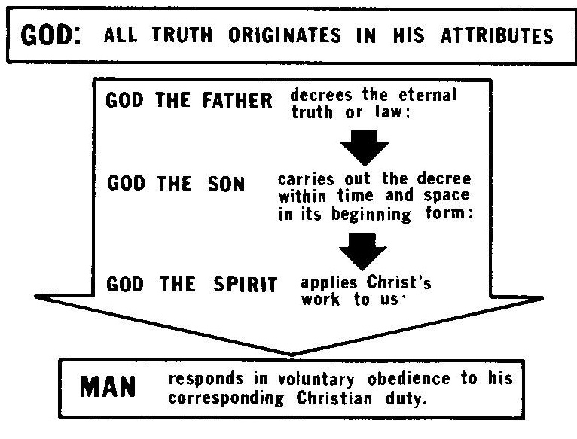
Another way to illustrate the process of integrating different theological subjects is to compare them to the old way that masons constructed buildings (see page 16).
The trainer in an obedience-oriented pastoral course is responsible for his student's weekly progress. He teaches the same general content as the traditional seminary or Bible institute professor, but not in the same order. He gives his student what he needs for his own changing needs as he takes on more and more responsibility with his congregation.
Traditional theological education makes little effort to integrate the different subjects and their practical applications, because of the way curriculum is arranged. Notice the two parallel columns on page 17.
  - 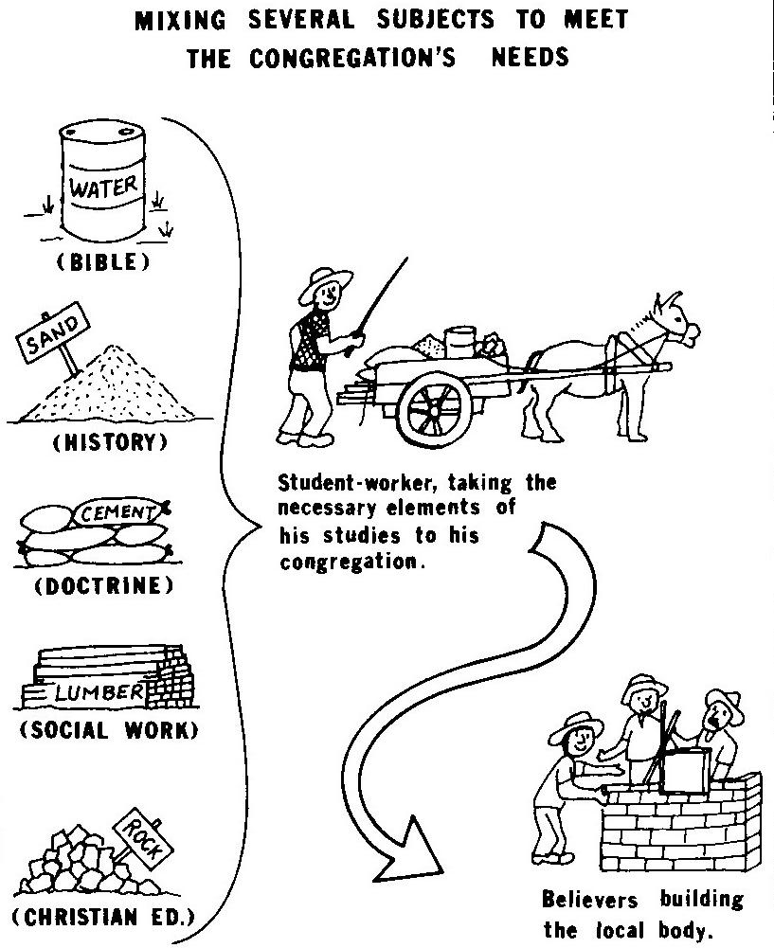

The student-worker does not take his people a several months' supply of water all at once (such as a six months' verse by verse study of Ecclesiastes); he does not dump a whole load of sand in their midst (an intensive study of church history from Paul to the present). He takes them a mixture: just enough of each of the elements to make a solid wall. He keeps them working from week to week. He gives them what they need at each stage of development.
  - 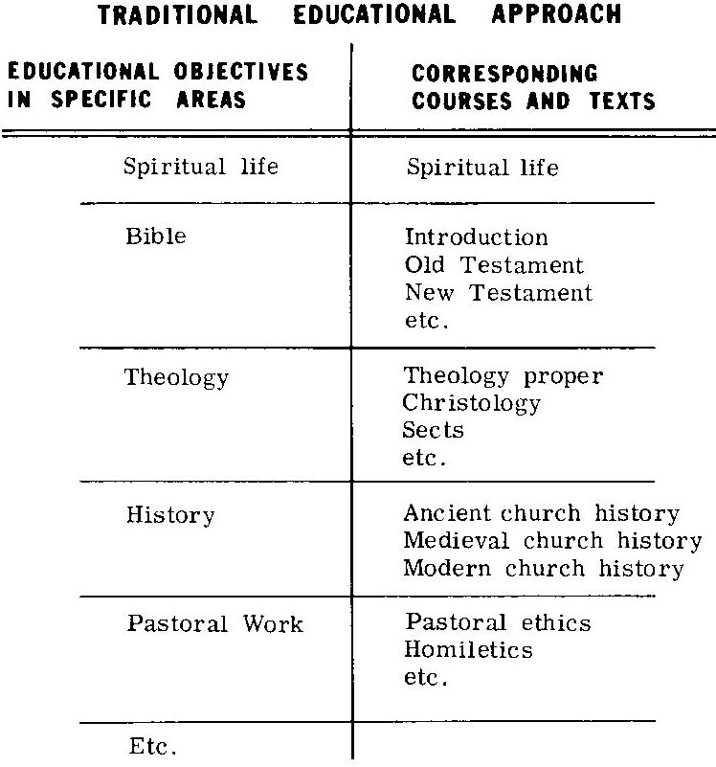\
How can we prepare textbooks which focus different areas of study on a given activity? First of all, we need to detach our list of educational objectives from any corresponding parallel list of subjects and textbooks. If the two lists run parallel, each course or text tends to deal only with objectives in one specific field, Obedience oriented education cannot be diagrammed graphically without some kind of a two-axis graph, to integrate what we learn (content)) and what we do (activities with the people during the week).
If the subjects and textbooks parallel the educational objectives with little integration of different areas of study, we cannot combine subjects and activities for a holistic ministry. We can illustrate proper interrelation better by plotting the two lists (content and activities) on a two-axis graph and restating the subjects in terms of activities required by the New Testament. The following is an example (but too small to be of actual use):
  - 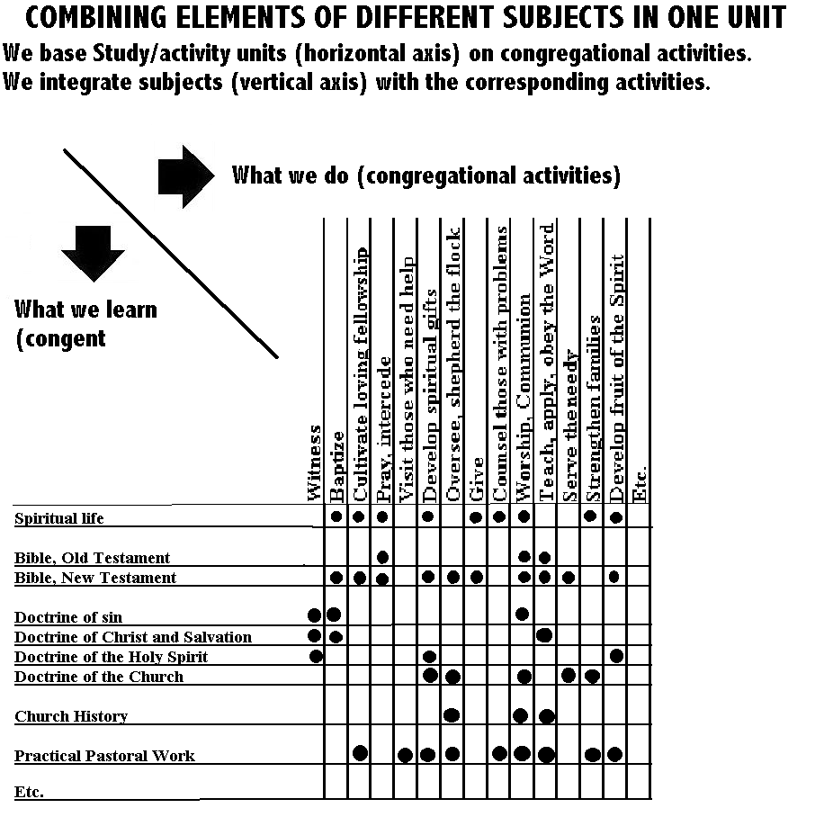
We do not really need such a graph except to visualize the concept integration. An accurate graph demands too many details, constant revisions and additions. We tried to prepare such a graph but it grew to the size of a door and proved to be unwieldy. We can integrate the studies better by continuously filing objectives, needs and studies under their corresponding congregational activities. Such a file, whether on paper or computer, needs a folder for each activity. It can grow and be revised without confusion. If you write curriculum, each such folder might yield a textbook. It almost writes itself it we keep filing the significant information gleaned from students' reports of their congregation’s needs and adding the relevant theory as we discover it.
Teachers sometimes resist such a practical way to study biblical doctrine and practice, especially those conditioned by the traditional academic disciplines. They fail to appreciate the flexibility required unless they have a dedicated shepherd's heart and experience. Sometimes students also resist such a practical, New Testament approach. Resistance commonly comes from younger students who are not yet ready to apply the Word in a practical way to a flock. They prefer to file it away in their memories and notebooks, for some future application. With some happy exceptions, we found that most young men prefer to study or teach theory, neatly separated from any real work with people in the community. When they tried they often found that they lacked the maturity and respect of the community that they needed to do serious pastoral work, especially with mature men. Such young students need instruction, but not in an obedience-oriented course for pastors.
IV
LET CONGREGATIONS GROW AND REPRODUCE IN THE NORMAL WAY
Mark 4:26-29 illustrates how congregations take root, grow and develop their different ministries spontaneously, with a minimum of control on the part of the workers responsible.
We recognize the Lord Jesus Christ's supreme authority over all congregations and theological institutions. Where he reigns, the congregations develop spontaneously. Under His sole command, the Congregation grows and multiplies in a manner natural to itself. A normal, healthy congregation must grow and multiply. That is its very nature, built into it by the Almighty Creator.
We find in living things four principles common to created life, including the corporate life of an obedient congregation:
1) All, even the simplest plants, have the capacity to reproduce after their own kind.
2) All organisms have a sensitivity to react to their environment. In even the viruses a primitive intelligence discerns what foreign particles it can assimilate and what it must repulse. More complex animals learn and reason. Man has the dangerous ability to choose between right and wrong and the blessed capacity to worship God and appreciate His divine attributes.
3) All but the most basic forms of life differentiate their cells into diverse organs that work together in harmony; this specialization enables the plant, animal or person to do increasingly complicated activities.
4) Most organisms bear fruit or provide something useful for others besides themselves: plants yield antibiotics, wood, berries, flowers and feed for the cow, which produces milk, meat and leather; men produce good and evil works.
The Creator works from the simple toward the more complex and useful. He began with plants, then animals, but He did not end with man. Man is not the ultimate creation, but the universal Church. The Lord Jesus Christ arose on the first day of the week as the Head of an entirely new creation (I Cor. 15:20.23, 40-49). This is his Body, the Church.
Like all living creatures, each congregation has within itself the power to grow and multiply after its own kind (Mark 4: 1-20). It develops spontaneously, not like an institution whose progress depends on the initiative of its executives. An active, feeling body, it seethes with potential energy. An obedient congregation has to grow and multiply just as surely as the plants and animals; it is its nature. This assurance moves us to witness and serve in relaxed, voluntary obedience to Christ.
The congregation likewise has an intelligence of its own, a spiritual nervous system: Christ the Head communicates through the Holy Spirit to each member. The congregation, in cooperation with qualified trainers and institutions, educates itself theologically. It discerns what doctrine it should receive or refuse. It selects and trains its own leaders. The professional educator must gear into this divine educational process. He cannot create it; nor should he seek to control it, or he kills its spontaneity.
Like other living creatures, a congregation has the power within itself to differentiate its “cells”. Each member has a gift or specialization for ministering to the needs of the congregation. These gifts provide for ministries which must contribute to building up the whole body (I Cor. 12; Rom. 12:4.8). An active, obedient congregation soon discovers these different ministries which God has distributed among its members. It does not try to manufacture the pastoral gift in a classroom. An active congregation, given the liberty to do so, readily develops the necessary gifts among its members.
Like other living things, the congregation also produces fruit. It has the privilege of bearing fruit of eternal value and duration. It results, inevitably, from any work done in faith and loving obedience to the commands of Christ (John 15: 1.1 0; I Cor. 3: 11.15). This fruit often grows high on the tree; we may fail to see it from earth. It may bear little relation to the amount of effort or money invested. .
We extinguish the spontaneous element of a congregation's development if we make Christ's commands obligatory with a legalistic spirit. We can avoid this danger of legalism in our emphasis on obedience. We must count on the student's voluntary obedience in love (John 14:15). This is a Spirit filled Christian's normal inclination; it is contagious: one's congregation will catch it. A spontaneous movement for Christ is not a revival in the sense of a rare, special outpouring of the Spirit on a dormant congregation. Spontaneous growth is neither rare nor special. It is the normal, daily development and reproduction of any reasonably obedient congregation planted in good soil. It happens as sure as any other harvest: a normal congregation produces more kernels of spiritual grain (witnessing, serving, visiting, giving, etc.) than were originally sown (Mark 4:1.20). A congregation can produce double, triple or a hundredfold. But if a church consumes 100 kernels per week to maintain its own program and produces an average of only fifty among its members, it requires another fifty to survive, provided by an outside worker, missionary or mother church. Such a “sponge” only absorbs spiritual energy and impedes spontaneous growth. New churches are not automatically sponges; they often produce more spiritual energy per member than older churches.
In Honduras we observed the two types of curriculum in a controlled “laboratory” situation. Isolated from most outside influences, village churches were almost entirely dependent for their religious education upon the efforts of our mission. We could control the theological input. We observed churches whose only input came through an obedience-oriented course. Other churches' input came through men of the traditional, doctrinally-oriented course. Some churches received a combination of both influences. The obedience-oriented churches grew and multiplied, maintained discipline, and showed discernment in doctrine. The churches with the traditional, doctrinally-oriented education grew not at all except through the efforts of outside workers. Although they knew more doctrine as such, they suffered more from doctrinal error and lacked initiative. Churches influenced by both orientations did well only when they gave priority to obedience.
A theological institution can release a great power, already latent in the churches, for a spontaneous movement for Christ. It costs less; more men are involved voluntarily in pastoral education. The institution actually gains influence with the students and churches when it surrenders its privileged position of complete control over the educational processes.
For education to contribute to the spontaneous multiplication of churches, the factor of self-multiplication must be part of the curriculum. This is simple. Any pastor can train his “Timothies” if he has materials that follow the New Testament guidelines for training leaders, such as Paul-Timothy Leader Training (www.Paul-Timothy.com). These apprentices, in turn, should quickly begin to train their own Timothies (2 Tim. 2:2). This self-multiplication requires that every student-worker also become a student-teacher without delay. This process results in the multiplication of churches or cells in the city and many small congregations in remote areas where travel is difficult and people lack normal educational opportunities. We have observed that where every pastor becomes an extension teacher, the number of Christian workers and churches multiplies rapidly.
  - Example of an Extension Training Chain
When we applied obedience oriented education to train pastors in Northern Honduras, several ‘training chains’ resulted. In the diagram below the smaller dots depict fifteen new village churches that the students of Armando, an uneducated student-worker, planted and shepherded in Northern Honduras. The process of extension took about five years. (See diagram on page 25.)
Interestingly, the churches with little or no contact with educated pastors or missionaries were invariably the strongest and most trouble-free. They had constant communication with mature trainers, however, through the extension chain. Each student-worker reported to his own trainer; everyone in the chain knew what was happening in his own area of responsibility.
The obedience-oriented curriculum deals with the changing activities of a living, growing, obedient body. Once a theological institution commits itself to release this spontaneous growth and development of Christ's Church through education, its objectives, philosophy and methods of communication will soon improve. We measure this improvement not by the academic criteria of accrediting boards or theological associations, but by pastoral standards which seek above all the immediate edification of the student’s churches. The seminary concerned with both scholarship and the Great Commission should offer two very separate courses: one for professional scholars (every denomination needs them) and another for pastors.
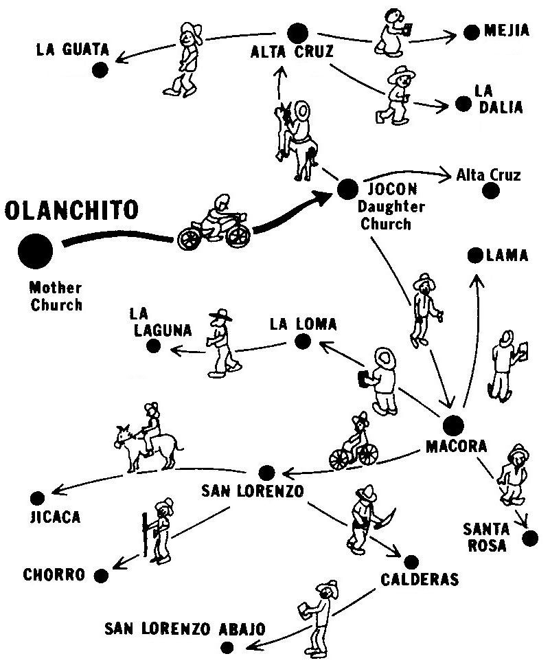
V
EDUCATIONAL OBJECTIVES MUST BE REALISTIC
Our Lord pronounced His Great Commission in Matthew 28: 18.20 in urgent, authoritative military terms: “All authority is given me . . . go therefore and make disciples. . .” It leaves no room for excuses; it demands simple, direct obedience. We should establish realistic objectives for mobilizing obedient disciples from the very beginning of their Christian life. But often we plan institutions and projects which train disciples in the most indirect ways.
We missionary educators are notoriously impractical dreamers. We confuse faith with wishful thinking, vision with ambition. We write educational objectives with stars in our eyes. The prophets of the Bible were also dreamers, but they had a controlling attachment to nature that kept them in balance. They were close to the earth. Shepherds and farmers, they knew the reality of nature. They never entered a great library where one can become lost in a philosopher's world. They were not scholars who specialized more and more in less and less. The problems of pastoral education are of such a nature that, apart from prayer, they yield only to harsh reality. But we begin costly projects justified only by the eloquent presentation of our objectives. Objectives should not be wishes but honest plans. Educational plans must be projected with such clarity that their outcome is clear from the start. Educational problems must be identified and faced honestly. In a world where millions are dying without Christ, we must not waste time and money on impractical educational efforts just because their objectives sound good.
How much money has been spent enlarging Bible schools in unresponsive societies with the naive hope that by the size of our institutions we could increase the number of God's elect? Then, when our project falters, we keep it looking alive by pouring in more money, adding classrooms and printing grand objectives in multicolored brochures. We educators must repent of this commercialism!
An obedience-oriented curriculum does not start with humanly-inspired educational objectives, but with Christ's commands applied to a given field of responsibility. Every professor and student knows his own area of responsibility. He knows exactly what Christ orders His Church to do within that area of responsibility. He knows what specific steps he must take as a Christian worker, to see that the Church fulfills what Christ has ordered.
Each student in the Honduras Extension Bible Institute draws a map of his church's area of responsibility. He helps the congregation to accept its responsibility before God. Then they make workable plans together to do what Christ orders. They study their field of responsibility to determine which towns best serve as strategic centers to reach the remaining areas. Then they raise up daughter churches. These workable plans bring their vision of God's unlimited grace into practical focus. Let us abandon educational or evangelistic projects which have proven impractical, regardless of how much money and time has already been invested! We must start extension centers where God is working. We observe which men are taking on responsibility. What are their needs? What curriculum will enable them, whoever and wherever they are, to guide their churches in doing what Christ has ordered? Maybe these men who present themselves to the church for service have little or no previous education; but they are the men whom God has given us. We mobilize them immediately for whatever God has given them to do, and adapt our course to it. Their educational experience must follow their church experience. Their education orients them intellectually at each step as they take on more responsibility.
It is a crime to commit an unproven man to several years of study for the pastorate when neither he nor the church knows if that is God's gift for him. This gift can be discerned only as one practices it in a local church. To assume that three year's study will automatically make a pastor contradicts the biblical doctrine of gifts. We must provide a graceful way out for the beginning student who finds he cannot apply his studies in a local church situation.
Our educational objectives become more realistic when they go hand in hand with their corresponding pastoral or evangelistic objectives. Evangelism and education, integrated, reinforce each other. Every experienced pastor should participate in the pastoral training course in three ways:
1) Train his own Timothies (perhaps in cooperation with a formal theological institution).
2) Communicate .needs and progress reports from his field to those who are writing texts and training men for his field.
3) Continue his own study to keep his mind sharp and stay ahead of his Timothies.
A professor in a resident institution must share his student's time with his pastor-teacher in the field. The better the communication between the professor and pastor, the easier the student's application of theory will be. Objectives printed in some seminary catalogues have small relationship to the ministry of their students and graduates. How can we be sure that our objectives are met? How can we be assured of the Holy Spirit's guidance as we project new extension centers and new churches? We cannot make plans which will cause a spontaneous movement (or it would not be spontaneous). We cannot say that the Spirit of God will begin working at 7:30 P.M. next Friday as we inaugurate a new education program. But we can make plans which permit a spontaneous movement. Figure 10 shows how strategic plans for a flexible pastoral course permit a spontaneous movement.
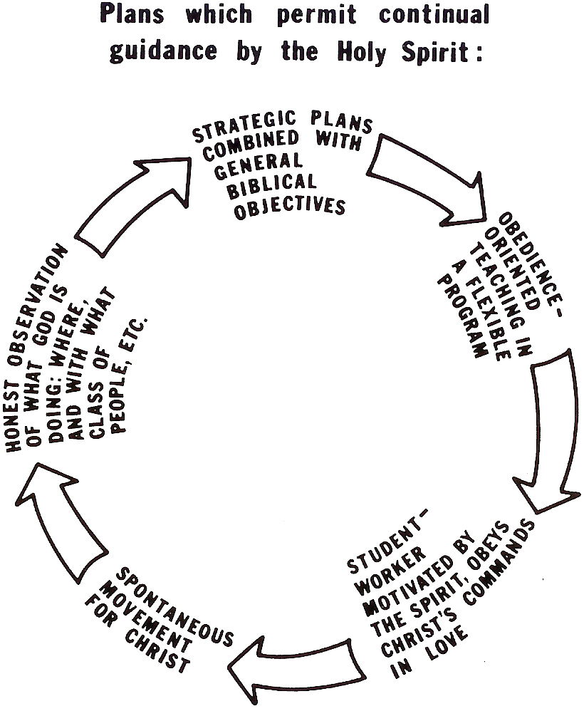
  - VI
  - PERMIT FREE EXTENSION OF TRAINING CHAINS
In 2 Timothy 2:2 we find four links in the chain of extension:
“The things which you have heard from me (Paul)
… pass on (Timothy)
to faithful men
who will teach others also.”
An obedient pastor multiplies his ministry in others: he prepares ‘Timothies’ who imitate him (I Cor. 11:1; Phil. 3:17). Every pastoral student needs to observe and imitate a good pastor. In some churches everything revolves around a poor pastor. Others cannot imitate him because he gives them no responsibility in the work. They listen to him passively, occasionally doing what he says. The training ‘chain’ ends with his teaching. His flock becomes passive and overly dominated by the pastor. It is not Christ-centered but pastor-centered:
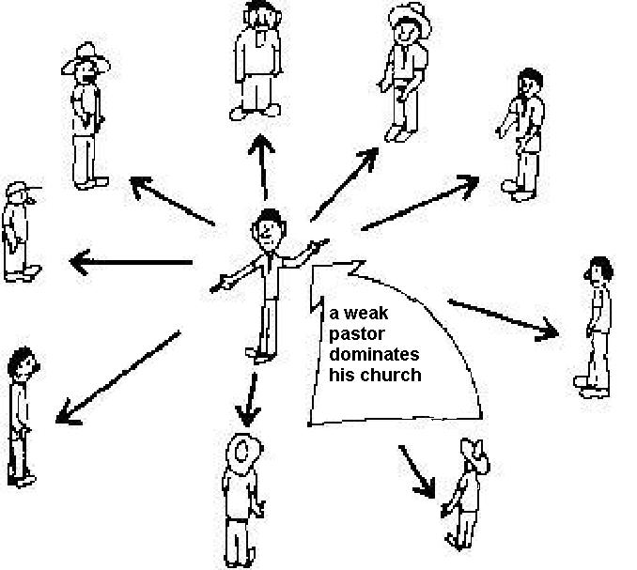
A spontaneous movement of church reproduction requires that the theological curriculum be part of the multiplying process. The students become teachers of others: their assignments aim to develop new leaders in an atmosphere of freedom to work for Christ. Every believer in a congregation should learn to share the ministry in some way; our students must be trained to train them.
  - Interaction in a Dynamic Church
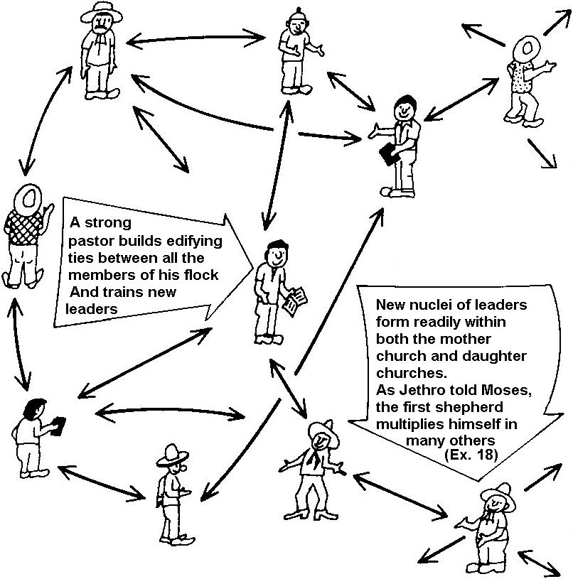
Teaching and serving one another provides links between many active members. They share the pastoral responsibility; the body is alive and reproductive.
To train many new leaders by the extension principle of 2 Tim. 2:2 our student-workers must also mentor others in small, tightly disciplined groups. In the beginning of a new work a trainer from the outside wins a few new believers and establishes the teacher-student relationship, as we see in Paul’s relationship with Timothy. As soon as possible, invite one or more of these men who most nearly meet the biblical standard for an elder, to the leader training sessions. They become student-workers and teach the same things they learn to the other students and the people. From then on the outside teacher teaches only the new student-workers:
  - 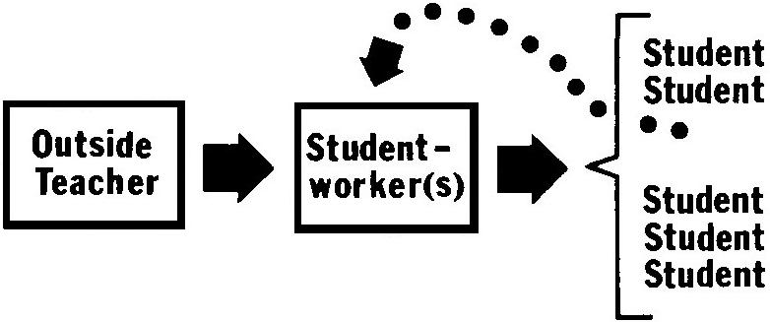
This type of extension training session should be limited to one, two or three students. They are student-workers and teach the others in larger groups. This teaching by the new student-worker has five advantages:
1) The new student-worker quickly becomes a responsible leader.
2) The outside teacher does not weaken the local leaders when he works through them. An outsider weakens the local ministry if he takes over pastoral responsibility with the people, by-passing the local leaders.
3) The outside teacher conserves his time; his students take most of the responsibility for their own churches; he can deal with several churches in the same time that he would otherwise spend with one.
4) The session can deal with details of the work which could not be discussed in a large, unrestricted group that because of its size becomes simply another Sunday school class.
5) The educational structure is already set up for reproduction; they do not need to change a thing to start a daughter church or a new nucleus of leaders within the same church. The student-worker simply repeats the same steps in another area.
In many cultures it is better to train men of different educational or economic levels in separate sessions. Otherwise, the more humble students become passive and fail to take initiative.
A student-worker in an established congregational might not have opportunity to lead the believers, because they already have leaders. He must win new believers and form a new cell or growth group in the congregation.
Pastors and teachers who tend to be dictators, who control others abusively, impede this free extension of the educational process. They do not delegate responsibility nor recognize their own students as colleagues in the educational process. They often enjoy teaching but fail to trust their students to teach the same things to others. We do not enjoy it when others impede the practice of our own spiritual gifts. Ordained pastors, for example, should accept the biblical authority of lay ministers or elders and encourage their participation (Titus 1:5). A shepherd has biblical authority because he is an elder with a God-given gift (2 Pet. 5:1-4; Eph. 4:11.12). The experienced pastor should encourage, train and trust his Timothies.
In order for a 'Timothy' to imitate his 'Paul', as an apprentice, the more experienced workers must use only equipment and methods which are within the trainees’ reach. They should be able to imitate at once all that the teacher models. Christ never ordered his disciples to do anything that they had not observed him doing in a way that they could easily imitate.
  - EXTENSION CENTERS FOR SMALL GROUPS OF
STUDENT-WORKERS
Each new congregation is a training center. Teaching the same things that student-workers have just learned to their own congregations or other student-workers quickly reproduces new centers of leadership.
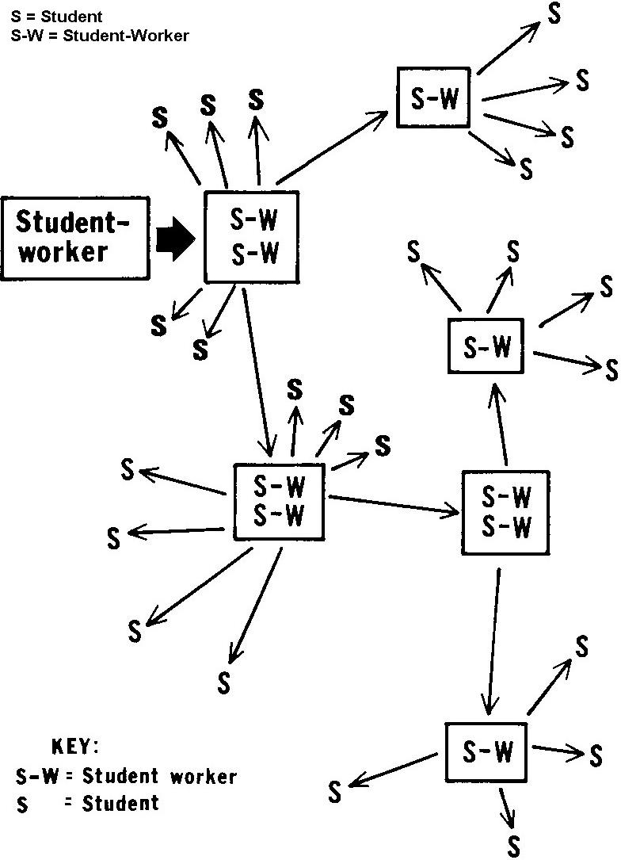
Paul the Apostle left new churches organized under new elders (Acts 14:23). Following his example, a church planter enters a neglected community, wins several men to Christ and, after baptism, enrolls them in extension sessions to let them raise up their own church. New churches result from an education program rather as well as evangelistic efforts. Training and evangelism go hand-in-hand. Such churches are stronger from the beginning and more evangelistic, because the local believers take the responsibility for the Lord’s work. The extension teacher gives them the studies which they need at every step, to keep progressing with their own congregation.
New believers should not preach. Many fast-growing churches have no formal preaching; their new leaders teach simple studies and serve the Lord's Supper; other members participate with hymns, testimonies and Scripture readings.
When daughter and granddaughter churches multiply, the link in the chain of spiritual reproduction is not the individual person who witnesses for Christ or teaches others, but the local church. Reproducing a daughter church requires a team effort. The student-worker goes and witnesses as an arm of the mother church; the Holy Spirit reproduces the church through him. This is why daughter churches resemble their mothers, regardless of the personality of the individual worker.
The free extension of the educational process requires flexibility in the Church. The Old Testament legal system was too rigid to contain the dynamic gospel. The old wineskins lacked elasticity for the new wine. Theological institutions likewise help or hinder the extension of the gospel according to their elasticity. In whatever culture or community the Church grows rapidly, a coordinated educational effort must provide leadership for the expanding work. In neglected fields, church planting normally is tied closely to reproductive pastoral training.
Rigid plans and church traditions replace faith with machinery and institutions. We must educate our people for spiritual liberty. This requires a toughness, a continual struggle with Christians of tradition who impede simple, direct obedience to Christ. Rules and customs have evolved into hundreds of evangelical traditions. Theologians who strive to preserve the original teaching of Christ and His apostles in the Word, often become merely ‘conservative’ and confuse biblical doctrine with evangelical traditions and institutions. If we insist more on the rules of our institution or denomination than on the commandments of Christ, we are not conservative in theology. We have embraced innovations of man. Institutionalism paralyzes spontaneous development of the Church. The desire to control men reinforces educational traditions and the institutional mentality. The obedient educator must detect and correct traditions which deny liberty for the congregations to reproduce in the normal, biblical way.
Traditional textbooks do not lend themselves to a spontaneous movement of church reproduction. For a program of self-extension, each textbook should require practical work related to each week's (or two weeks') study, and be easy for the student to teach at once to other students in another training center.
Traditional entrance requirements for some evangelical training institutions make no allowance for a man's demonstration of the pastoral gift. They deny theological training to anyone who lacks certain education. Many evangelical congregations, as a result, are shepherded by men with little or no formal theological training. They are considered unqualified to be shepherds: they have not finished secondary school. But they are the men who shepherd their congregations. Do we have the authority under God to deny these men, to whom He has given pastoral responsibility, the training they need? We must train men on all academic levels. Some shepherds will work among well educated people; the Church needs scholars and administrators, like the Apostle Paul, with the highest qualifications. But it also needs a much larger army of humble shepherds for the multitudes with limited education.
Tradition also prohibits that some congregations celebrate the Lord's Supper unless an ordained shepherd is present. Do Jesus’ disciples in a remote village need an ordained shepherd in order to be obedient? Preaching causes a new worker to become proud: it requires restrictions. But serving the Lord's Supper requires no special priestly qualifications. The sincere educator must take education to those servants who are in a position to lead their people in obedience.
Traditional patterns of church government often serve as fronts for hidden power structures within a church. Older believers, jealous of their position, tend to deny new believers the liberty to develop their own ministries. A small group of people dominates the congregation; new workers cannot freely exercise their gifts.
Some regional leaders also deny liberty for new congregations to grow and reproduce freely, because they try to govern them in detail from the outside. The more responsibility we give new churches and new leaders, the better they grow and reproduce. If a new congregation is free to draw its leaders from its own community, the less disciplinary problems it will have and the sooner it will reproduce daughter congregations. The church planter must not use his position as extension trainer to control the congregations from the outside. Let us not confuse education with government.
Tradition sometimes cripples spontaneous expansion by limiting evangelism to special meetings or Sunday evening services. Biblically, evangelism is the ordinary, daily work of all members of a congregation. There is nothing “special” about it. But some congregations leave witnessing for professionals with extraordinary preparation. They confuse evangelism with pulpit eloquence. They often make a sacrament out of the public invitation, implying that one cannot be saved without performing some kind of individual decision-making rite, a man-made sacrament.
We must educate our congregations for evangelism; witnessing for Jesus must be a direct result of our teaching. For years the Honduras Extension Bible Institute taught personal evangelism but we observed little connection between classroom studies about personal evangelism and the number of persons won to Christ. But when the trainer took his students with him to witness, in almost every case the congregation won new believers.
Tradition often shackles a new congregation with a ponderous, detailed constitution and by-laws inherited from a well-meaning mother congregation. By-laws do not assure adherence to proper doctrine and practice: only biblical education of the congregation will do this. Bylaws are worthless if not followed It is sometimes worse if we follow them, if they do not apply to a congregation's needs. Constitutions and by-laws should be very brief, avoiding details, with biblical job descriptions for church officers. The best rule is not to require anything unless it is explicitly required by Scripture. These bylaws can be revised as the congregation grows.
Tradition also tempts some educators to foster “preaching points”. They send students somewhere every weekend; the people come listen to them preach the gospel. We have observed that when this happens a few people, mostly women and children, will go through a ritual of raising their hands to “accept” Christ. But no one disciples them the way Jesus said, to obey His commands. Their baptism is neglected. Responsibility for directing the congregation is not given to local leaders of the new congregation because no one is training them. The young preachers often make no distinction between evangelistic services for unbelievers and worship for believers. They neglect the Lord's Supper. They often keep calling the same believers to receive Christ again and again; much confusion results. An unbeliever cannot worship God in spirit and in truth (John 4:24) and the new believers remain passive infants in Christ. Christ wants obedient congregations, not ‘preaching points.’ Our Lord demands that new converts be baptized and trained to do his commands (Mat. 28: 18-20; Acts 2:38-42).
Traditional training to preach in an artificial, artistic manner also hinders the free development of the prophetic gift. Often the best preachers are those whose preaching has developed gradually. They begin witnessing humbly to their friends; then they teach simple Bible studies already prepared for them; later they prepare their own Bible studies; finally, they find themselves preaching the Word of God to people for whom God has made them responsible. We must train shepherds who care, not mere preachers. Graduates from seminaries frequently fail in their first church, not in the pulpit but in their role as a compassionate shepherd.
Another evangelical custom, segregation by age, hinders normal development of young Christians by depriving them of loving relationships with people of different ages. Closely graded school systems isolate young people in age groups. Young people, segregated by age during their secondary and university education, develop an artificial society separated from little children and the elderly. Often they are unable to adjust to normal society. Some traditional churches' Sunday school and youth programs continue this segregation over the weekend. They keep teenagers sealed off from their families when they most need them. Young people normally seek friends of their own age; but it is abnormal when they can no longer communicate with people of other ages. An obedient congregation must help its young people to develop normal relationships with their families, their government and society at large. A resident seminary that fails to require a young pastoral trainee’s deep involvement with a congregation, with both young and old, may prolong his segregation from normal society. He will find it hard to adjust to truly biblical ‘elders.’
  - Segregated by Age
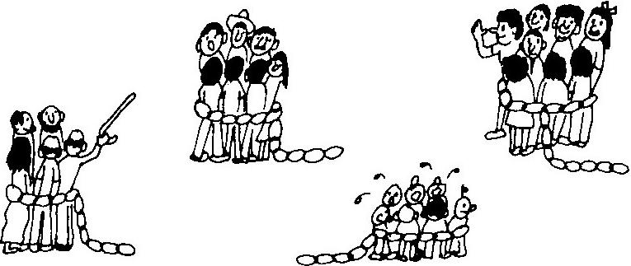
  - VII
  - SESSIONS WITH STUDENT-WORKERS DEAL WITH THEIR
PRACTICAL WORK
A theological institution, resident or extension, formal or informal, must deal regularly with the student's practical work, in order to train shepherds the way the New Testament requires. The pastoral student must continually orient himself in sessions which deal with his reports and plans. His trainer supervises his activities and enables him to apply everything he learns. Everything taught should contribute to the student's present ministry. No professor is teaching well unless his student is active in a ministry that is edifying other people. The practical work does not merely train the man for the future; it relates his training to a present pastoral experience.
An effective practical work session will begin with detailed reports by each student, of his work. This limits the session to a very few students, in order to deal with the work of each one. If many others wish to study, they may do so in a separate session taught by one of the student-workers. Only mature adults should be enrolled in serious pastoral work session, because we are training ‘elders’ (I Tim. 3:1-7). The trainer gives each student studies and counsel to meet the needs that he has reported. Whoever teaches the practical work should keep a record of the needs reported from the field. These records serve to prepare new studies and foresee problems.
In a resident institution every professor should keep in touch with the needs of the congregations of the student-workers and relate his classroom studies to them. But many professors lack the qualifications for teaching the practical work; only experienced shepherds should attempt it. Time may not allow the few qualified professors to hold many small practical work sessions. The students, however, can form teams, each with a captain who is an advanced student. The professor instructs these team leaders in the practical work; they in turn train their teams. Experienced pastors of churches should also train these student-workers.
Trainers should have a checklist for each student's required activities. Both extension and resident theological institutions must verify each student's progress in his practical activities. A checklist or register of his progress should depict each activity that he must do to raise up and develop a congregation, edify its members and deal with the problems that every shepherd faces. This register is not simply a list of pastoral skills: it is a guide for helping a congregation to grow. Our aim is to edify the congregation. The register or checklist tracks a congregation as it grows from infancy to maturity. It lists congregational activities: duties of parents, deacons, Bible teachers, services for special occasions, visiting, missionary projects and community development. The new student-worker, not yet an official pastor, wins a group of people to Christ and leads them through all these activities into maturity. He starts with personal witnessing and takes on more and more responsibility until at graduation he is, in fact, a shepherding elder. The student who begins a new congregation and brings it to spiritual maturity (or does the same for a small group within an older congregation) deserves his diploma. He has dealt with those needs which truly test the theory of his pastoral course: he has related his studies to a real, dynamic situation. The Honduras Extension Bible Institute offers both large group workshops for older and newer leaders, and practical work sessions mainly for new leaders.
Student-workers do almost all their reading and studying during their own time, at home or wherever they can open a book. Each student keeps some kind of a Register of Progress for the congregation with which he is working. The example shown below lists 35 activities, each of which requires several weekly studies. Each weekly study combines theory with a practical assignment in a small textbook. We recommend using pocket-size books, to carry and read during the week. Avoid long-term courses in Bible, history or doctrine. The units for each activity should combine relevant elements from these different general subjects. Some units are strictly biblical studies; others combine elements of history, theology and homiletics all in one brief study. Some weekly study booklets treat definite needs of the congregation that may arise any time. Over the years the same needs reoccur. Although every congregation's path differs, a general pattern emerges which enables us to foresee most of the needs in some kind of progress chart. Here is an example:
  - CONGREGATIONAL PROGRESS CHART OF ACTIVITIES AND
CORRESPONDING STUDIES
Tic activities when your congregation is practicing them well.
  - NEW CONGREGATIONS
1. WITNESS FOR CHRIST - Evangelism; Person and Work of Christ
2. CONFIRM REPENTANCE WITH PRAYER, BAPTISM - Doctrine of Sin and Salvation
3. CELEBRATE THE LORD'S SUPPER - History of Doctrine of Sacraments; Gospels
4. ENROLL NEW PASTORAL STUDENTS - Christian Education; Pastoral Epistles
5. PRAY - Spiritual Life; Sermon on the Mount
6. GIVE CHEERFULLY - Stewardship
7. LOVE GOD, MEN, NEIGHBOR, ENEMY - Human Relations; Spiritual Life; Character
8. RAISE UP DAUGHTER CONGREGATIONS - Extension Principles
9. HAVE FAMILY WORSH1P IN HOMES - God's Rules - or the Family; Genesis
  - DEVELOPING CONGREGATIONS
10. LET THE CONGREGATION GROW SPONTANEOUSLY - Church Growth Principles; Kingdom of God
11. ASSURE NEW BELIEVERS OF THEIR SALVATION - God’s Sovereignty; Election; Grace; The Reformation
12. ELECT DEACONS AND ELDERS - Proper Business Meeting Procedure; Church Government
13. TRAIN DEACONS FOR THEIR DIFFERENT MINISTRIES - Deacons, Mercy Ministry
14. TRAIN ELDERS FOR DIFFERENT MINISTRIES - Ecclesiology; Pastoral Theology; Historical Examples
15. DEVELOP STEWARDSHIP, PROVIDE FOR NEEDY - Material Obligations
16. APPLY GOD’S WORD TO PERSONAL NEEDS - Homiletics; Vigilance; the Shepherd's Heart
17. HELP EACH MEMBER TO HAVE A MINISTRY - Gifts of the Spirit; Congregational Body; Ephesians
18. COMMISSION NEW SHEPHERDS OR SHEPHERDING ELDERS - Pastoral Duties, Requirements and Call
19. PRACTICE CHRISTIAN LIBERTY - Galatians, Romans; Church History; Exodus
20. COUNSEL MEMBERS WITH PROBLEMS, SICKNESS, ETC. - Pastoral Counseling
21. DISCIPLINE UNRULY MEMBERS - Church Discipline, Ethics; I Corinthians; Numbers
  - MATURING CONGREGATIONS
22. COOPERATE WITH OTHER CONGREGATIONS - The Church Universal; Pastoral Ethics
23. ORGANIZE AND TRAIN THE YOUTH - Youth Work; Proverbs
24. ORGANIZE AND TRAIN THE WOMEN - Women's Work
25. CULTIVATE THE FRUIT OF THE SPIRIT - Doctrine of the Holy Spirit
26. INTERPRET THE BIBLE PROPERLY – Methods of interpretation, Bible Survey; Revelation; Inspiration
27. SEND AND SUPPORT MISSIONARIES - Mission Strategy, Stewardship; History of Missions
28. REORGANIZE FOR NEW GROWTH IN A GROWING CONGREGATION - Administration
29. RECEIVE NEW BELIEVERS WITH A LOVING SPIRIT - Christian Life; Philippians; Philemon
30. PRODUCE WORSHIPFUL MUSIC – Sacred Music; Psalms
32. ANALYZE AND DEAL WITH COMMUNITY NEEDS - Christian Social Obligations; Prophets
33. DEVELOP CHRISTIAN EDUCATION – Teaching aims and methods; James
35. VERIFY CONTINUED PROGRESS IN ALL ACTIVITIES
36. OTHER NEEDED ACTIVITIES:
The instructor for the practical work shares the responsibility for the effective weekly ministry of his student. If his student fails, he fails; if his student succeeds, he succeeds. The proof of effective teaching is in the spontaneous growth and development of the student's congregation. The student's progress is measured primarily by his congregation’s progress in developing and maintaining the activities that God requires for every church in the New Testament.

  - STEPS TO DEVELOP OBEDIENCE-ORIENTED EDUCATION
  - FIVE STEPS FOR A COORDINATOR
1) Verify your qualifications. To coordinate the program requires a shepherd's heart and experience. If you lack these, work closely with someone else who has these qualifications.
2) Arrange the first Paul-Timothy links in the training chain. Meet at least every two weeks with one, two or three student-workers. Enroll only adult men who are serving their local congregation.
3) Let the local congregation approve and assist with this training. They can pray for it, provide food and housing for visiting teachers, and recommend workers who should be trained. The main shepherd of the congregation, if experienced, should cooperate in the training. The congregation should also define its area of responsibility, affirm Christ's orders for its work in this area, and agree on a workable plan to carry them out.
4) Break the plan down into short, simple steps for both the student-workers and the congregation. Explain each step carefully to all involved.
5) Continually cultivate love and mutual confidence between all trainers and students. The two-way communication needed for edifying the student's congregation requires a warm bond of mutual respect, interest and sharing. Each worker must also give regular reports to his own congregation so the believers will appreciate what he is doing.
  - SIX PARTS OF AN OBEDIENCE-ORIENTED TRAINING SESSION
1) Prayer. Ask God to guide your session.
2) Reports. Each student-worker reports his congregation's progress and needs. Check to see if his report reflects what he planned to do during the previous session. He may also report his own students' progress, needs and plans for their congregations. An obedient, biblical trainer is responsible for his student's effective ministry, and his student's students' ministries. Record the progress on the Congregation Progress Chart. Constant evaluation of a congregation’s progress enables both believers and leaders to progress at their own speed toward spiritual maturity.
3) Plans. Help each student-worker to plan the next steps, for both his congregation and the congregations that his students are leading.
4) Review. Each student-worker gives a brief about what he has studied. If possible, help him improve his explanation before he teaches it to his congregation.
5) Reading assignments. Assign study materials which facilitate your student's practical work assignment. Limit it to your student's available time and capacity for study. Assignments may include a small book that you sell him, chapters from a conventional textbook, Scripture or outlines that meet some pressing need. Use materials written for the educational level of the people your student leads (not your student's level, but his flock's). Most leadership training programs teach with words and methods unfamiliar to the common Christian.
6) Prayer. Participants pray for one another and for the plans they have made. Pray at any time during the session when faced with a difficult decision.
  - FIVE STEPS TO START DAUGHTER CONGREGATIONS
  - Or small shepherding groups of new believers in an established congregation
1) Show your student-worker what to do. He must observe and imitate you (I Cor. 11:1; Philip. 3:7).
2) Witness to heads of households first, if possible. Go first where your student already has friends or relatives. Baptize the new believers, with their families when possible, as soon as they repent and believe in Christ. Hold no public worship until a local leader (not an outsider) can lead it.
Outsiders, however, can lead public evangelistic meetings or small gatherings for worship for believers, until local leaders are ready to lead them. Distinguish carefully between worship for believers, which would include the Lord's Supper, and evangelism for non-believers.
3) Organize the sober, adult men among them as provisional shepherds (Acts 14:23). Give these men the responsibility for further growth and edification of their group. When they are shepherding well, commission them with the laying on of hands, to serve as shepherding elders.
4) Enroll the new leaders in training sessions, as student-workers. Your student may teach them, just as you have taught him. He shows them everything they must do; they take on more and more responsibility as they study and complete their practical work assignments. If more than three or four want to study, train one or two of the most respected men and let them teach the same things to the others in separate sessions.
Often it is wise to invite the public to serious worship services only when these new student-workers can lead them. They do not “preach” at first; they may serve the Lord's Supper, give testimonies, read Scripture, exhort, sing, pray and .direct the others in congregational activities. Outside teacher should not preach or direct these public meetings. He should do nothing that these new leaders are training to do, except to briefly model new skills for them, or he weakens their ministry. Let them do what you are training them to do! This way the mother congregation, or parent growth group, does not lose its leaders to the daughter group and both grow faster.
  - FOUR STEPS TO KEEP REPRODUCING GRANDDAUGHTER CONGREGATIONS (Or cells, in the same congregation)
1) Encourage each new group or daughter congregation to start at once to reproduce daughter groups or congregations. Do not let the enthusiasm cool.
2) Instruct each new student-worker, as part of his regular assignments, to imitate his own trainer, repeating the same steps. He, too, will soon have his own students who can form new groups or daughter congregations.
3) Promote the student-worker to be a trainer as well, when he has won men to Christ who can be trained to be shepherding elders. Let him keep a Congregation Progress Chart for each of his students’ congregations.
4) As he reports their progress and needs, keep providing studies for his students' congregation's needs, and for the needs of all the newer congregations farther down the training ‘chain’.

