Train New Leaders in the Way Jesus Did
Anchor command. “Be imitators of me, just as I also am of Christ.” 1 Corinthians 11:1
Anchor story. Jesus calls twelve disciples to do God’s work and be with him. Mark 13:19.
Anchor verse. “The things which you have heard from me in the presence of many witnesses, entrust these to faithful men who will be able to teach others also.” 2 Timothy 2:2
Learning goal. Discover how Christ and Paul trained new leaders.
Growth goal. Appreciate why Jesus prepared leaders on the job, and not in a classroom.
Skill goal. Train leaders effectively and quickly, the same way Jesus and Paul did.
Outcome goal. Congregations multiply and grow in Christ as many new leaders receive training.

Heavenly Father, your Son Jesus trained new leaders and showed us how to do so. His apostle, Paul, also showed us how to do so. Please, give us strength and ability to train up many new leaders to serve new congregations.

Basic Study
Jesus appoints and empowers twelve disciples, Mark 3:13-19.
- Where did Jesus appoint his main disciples? Verse 13
- For what two purposes did Jesus appoint the twelve? 14-15
(Clarification: To “preach” in the New Testament means to proclaim God’s message in any way, not just by monologue, and to any number of persons, even just one.)
- Jesus gave some of his disciples a new name that reflected their personality. What was Peter’s original name? 16
- What did Jesus call James and John? 17
- Besides Peter, another was called Simon. How was he described? 18
- Which one would betray Jesus a few years later? 19
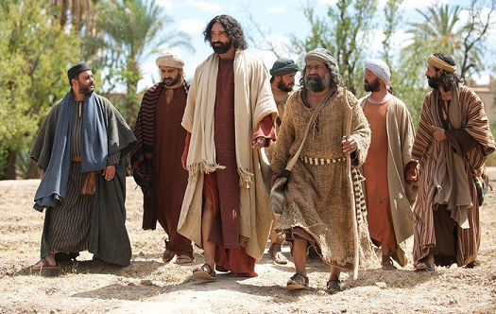
Jesus chose and called twelves disciples whom he appointed and trained as apostles.
During the week visit heads of families and start training them to shepherd their families with prayer and worship.
During worship
- Tell the account of Jesus calling the twelve disciples, and ask the same questions as above. Let believers discuss the answers.
- Ask the children to present what they have prepared.
- Memorize a teacher’s rule: “Be imitators of me, just as I also am of Christ” 1 Corinthians. 11:1

Advanced Study
- Learn from Jesus’ example how to train novice leaders.
Find in Mark 6: 1–6 what happened when Jesus taught a big group of people:
- How did most people respond to Jesus’ words? [They listened with surprise, verse 2.]
- How did some respond after hearing Jesus? [With offence, verse 3, unbelief, verse 6]
Find in Mark 6: 7–13 how Jesus trained new leaders in small groups.
- How big were the training groups? [Twelve total, small groups of two, verse 7.]
- What did Jesus do while together with his trainees? [He gave to them authority to do their work, verse 7, and he instructed them in how to do their work, verse 8.]
- How soon did Jesus’ trainees start to shepherd others? [Immediately, verse 12]
- What kinds of work did Jesus’ trainees do on that first trip? [Evangelism and healing]
- Did Jesus give trainees financial help? [No, he said to take no provisions, verse 8.]
- Where did Jesus’ trainees practice what they learned? [In villages and homes]
Find in Mark 6: 30–32 what happened when Jesus’ trainees came back to him.
- What did Jesus’ trainees report to Him? [All they had done and taught]
- Where did they go after Jesus listened to them? [To a secluded place to rest.]
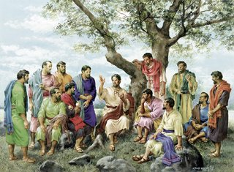
Jesus would instruct his apostle, send them out, and hear their reports afterwards.
- Five principles from Jesus’ training methods.
- Teaching big groups is not enough; you must also train in groups small enough to listen to each trainee report on what his flock is doing.
- Train folks who apply their learning at once in active work.
- Give your trainees authority to do their work, instructing them how and where to do it.
- After they do some work, listen to them report on what they did and said.
- Organize occasional retreats with workers where they can rest and learn more.
- Learn more about training leaders from Paul’s example.
- Find in Timothy 2: 1–2 who should train whom:
Describe Paul’s relationship with Timothy.
[It was like that of a father who trains his son.]
Whom did Paul train?
[Timothy and many others, including Silas and Titus.]
Whom was Timothy to train?
[Faithful workers.]
Whom were the faithful workers to train?
[Others, also]
How many ‘links’ were in the training “chain”?
[Four: Paul, Timothy, faithful men, and others also.]
- Find in Colossians 1:1–9 and 4: 15–18 how Paul equipped many new leaders:
Who was Paul’s main trainee? [Timothy, verse 1]
Whom did Paul and Timothy train as a co-worker? [Epaphras, verse 7]
Who taught the believers at Colosse? [Epaphras, verse 7. He reported the Colossians’ growth and needs to Timothy and Paul.]
How did Paul and Timothy serve the Colossians besides by writing to them?
[They prayed for them.]
Timothy followed Paul’s model, training others who trained yet others, in turn.
- Six Principles from Paul’s training methods
- There should be a kind of father-son relationship between trainers and novice leaders. What would you call such a relationship in your culture?
- More experienced leaders should train novice leaders in their congregations and in new congregations.
- Those who receive training can train other novice workers, in turn, immediately.
- The main qualification of trainees is to prove faithful by putting their training into practice.
- Trainers hear reports about their learners’ congregations and pray for them.
- Trainers write training materials to meet needs of the congregations and their leaders.

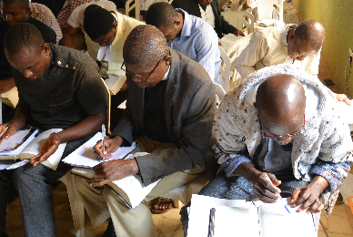
Important pastors who coach workers, also provide occasional training workshops.

- Plan with your co-workers additional activities for the coming week.
- Arrange for your trainees to train newer leaders. Provide them with copies of this study.
- Discuss together where the gospel is spreading, and identify who can lead house groups.
- Ask about needs of your trainees’ groups, and find or write short studies to help them.
- Store the studies where you can find them quickly, and share them with other workers.
- Plan with your co-workers additional, optional activities for the next worship.
- Explain how Jesus trained new leaders (use the Bible verses and questions above).
- Explain how Paul and Timothy trained new leaders; discuss how you will do so.
- Let workers who have been training new leaders report on their progress and needs.
- To introduce the Lord’s Supper read Numbers 9:1-2 and explain:
  - A year after God freed His people from slavery, new shepherds led them in celebrating Passover, remembering how a lamb’s blood had saved their firstborn.
  - Jesus gave new meaning to this feast. He is our Passover Lamb.
- Meet in groups of two, three and four to pray and plan to train shepherds and evangelize other towns.
- Those who teach children should read study #103 for children.

