Jesus Trained Leaders by Humbly
Serving Them
Dear Lord, please help the children to serve others humbly, like Jesus did when He washed His disciples’ feet as an example to them.
Choose any of these activities that fit the children’s ages and needs.
- An older child or teacher reads, or tells by memory, how Jesus trained His disciples to serve others humbly, John 13:1-17.
Explain these facts:
- Jesus trained his disciples by his example.
- Jesus served them as a humble servant, to show them how to serve others.
Pose these queries [An answer follows each question]:
- For how long did Jesus love his disciples? [See John 13:1]
- How did Jesus serve his disciples? [Verse 5]
- Did Jesus know that Judas would soon betray him? [Verse 11]
- In what way did Jesus train leaders to serve one another with humility? [Verse 15]
- What will God do for those who serve others with humility? [Verse 17]
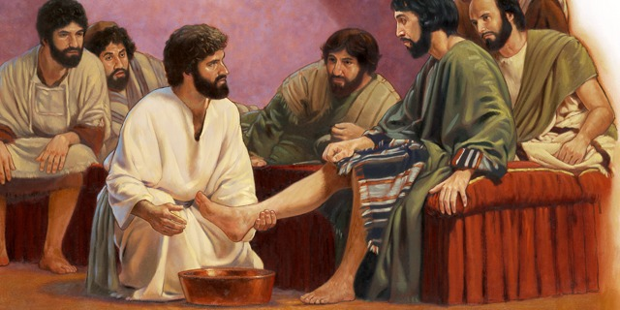
A few hour before Jesus would be arrested, he gathered his disciples and washed their feet.
- Dramatize the story of Jesus washing others’ feet (John 13:1-17).
Arrange for the children to present this drama to the adults.
You do not have to use all the parts.
Use your teaching time with the children to prepare.
Older children help younger ones prepare.
- Older children or adults play these parts: Jesus. Hold a towel and bowl. Narrator.
Younger children play these parts: Peter, Judas, Disciples.

Narrator Tell the 1st part of the story of Jesus washing others’ feet, John 13:1-7. Then say,
“Hear what Jesus says.”
Jesus Stand and wrap the towel around your waist.
Then kneel in front of Peter and pretend to wash his feet. Say,
“I have loved you all very much.
Soon I will leave this world and go back to my Father in heaven.”
Disciples (Some shout) “No!”
(Others shout) “You cannot leave us!”
(Others shout) “Do not go away!”
Jesus “I have something to teach you.”
Disciples (One asks) “Why does Jesus wash our feet like a slave?”
(Another says) “He is our master!”
(Another says) “He is not our servant!”
(Others shout) “He should not do this!”
Narrator “Hear what Peter says.”
Peter “Jesus, stop! Why are you washing my feet?
You are my master!”
Jesus “I always serve those that I love.
You need me to clean you.”
Narrator Tell the 2nd part of the story, John 13:8-17. Then say,
“Hear what Peter says.”
Peter “Then wash my hands and my head, too!”
Jesus “No, I have done all that you need.
However, not all of you are clean.
One of you has a heart that is not clean.”
Disciples (Some say) “Who does He mean?”
(Others. Ask) “Who has an unclean heart?”
Narrator “Hear what Judas is thinking in his heart.”
Judas Walk toward the listeners and say to them,
“Jesus is not freeing us from Roman political control like I expected.
I will sell Him to His enemies.” (Leave.)
Jesus “I am your teacher and Lord, yet I have washed your feet like a servant.
You must do the same for one another.
You must serve one another humbly. Then, I will bless you.”
Peter “You teach so well by your good example that we will never forget.”
Narrator Thank everyone who helped with the drama.

- If the children dramatize this story for the adults, then let them also pose to the adults the queries listed under #1 above.
- Memorize 1 Peter 5:5. “Young men, obey your elders; and clothe yourselves with humility toward one another, for God opposes the proud but gives grace to the humble.”
- Have children give examples of ways that we can serve people with humility.
- Explain that Jesus let a sinful woman wash His feet with her tears and dry them with her hair.
A religious man, in whose house this occurred, rebuked Jesus for letting her do it.
Jesus answered that those who have been forgiven much love much,
and He forgave her all her sins (Luke 7:37-48).
- Draw a picture of feet and have the children copy it.
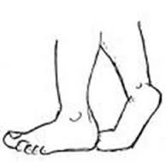
Older children might copy the larger picture under #6 above. Let the children show their pictures to the adults during worship and explain:
- This illustrates how we serve one another with humility.
- Just as Jesus washed His disciples’ feet,
so he wants to cleanse us, too.
Some children might like to colour the picture found at the end of this lesson.
- Let five children each recite a verse from Philippians 2:3-8.
- Have an older child pray:
“Jesus, you are our Lord and Teacher. We praise you because you served others humbly. Help us to follow your example. Help us also to serve others in the same way.

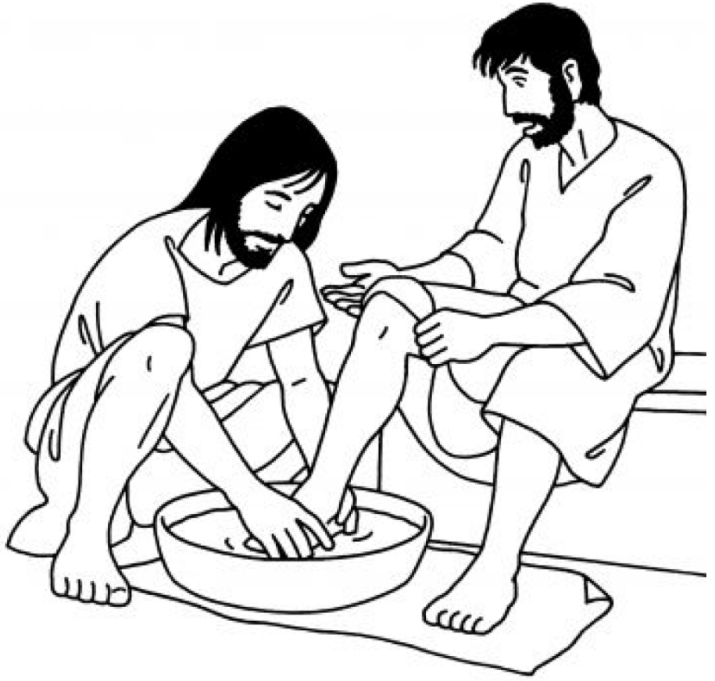
Peter and others were surprised when Jesus wanted to wash their feet. By doing so, he showed that we all need Jesus to cleanse us from sin.

