Take Instruction to Where the People Are
Anchor command. “Go … behold, I send you out as lambs in the midst of wolves.” Luke 10:3
Anchor story. King Jehoshaphat takes God’s word to where the people live. 2 Chronicles 17:3-9
Anchor verse. “In the third year of his reign (King Jehoshaphat) sent his officials … to teach in the cities of Judah.” 2 Chronicles 17:7
Learning goal. Find how God taught the Israelites outside of temples and synagogues.
Growth goal. Grasp the need to take God’s word to those who need it, wherever they are.
Skill goal. Take effective, Christian teaching to those who do not attend your worship services.
Outcome goal. Believers take God’s truth to many who need to hear it.
Basic Study

Dear God, help us take your Word to the people where they live.
Learn from the story of King Jehoshaphat’s teachers. 2 Chronicles 17:3-9
- Describe the character of King Jehoshaphat. Verses 3-4
- Why did King Jehoshaphat send several officials, Levites and priests to the cities? 7-8
- In how many of the cities of Judah did these men teach? 9
King Jehoshaphat formed a group of teachers who took God's Word to towns that lacked it. They took the instruction to the people where they lived, rather than bringing the people to a central institution. This type of training works effectively today also, to win many to Christ and multiply many congregations of believers.
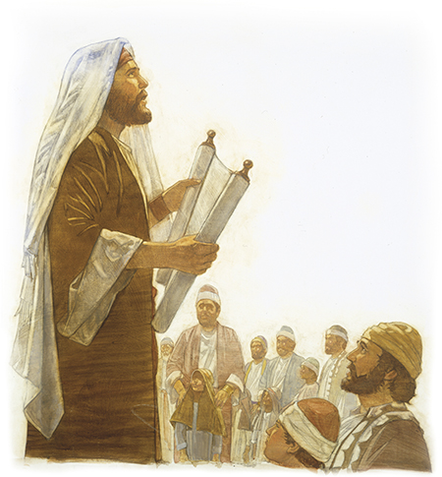
Israelite teachers taught the Word of God in neglected towns.
During the week, you and coworkers go teach God’s word to folk who do not attend your worship services.
During worship, tell the story of King Jehoshaphat and his teachers. Ask the same questions as above. Urge the believers to discuss the answers.
Ask the children to present what they have prepared.
Memorize All Scripture is inspired by God and profitable for teaching, for reproof, for correction, for training in righteousness. 2 Tim 3:16
Advanced Study
- Listen!
- To take teaching to others is also called “extension education.” A good extension teacher listens to those he is teaching, to find out what they need to learn.
- A wise mentor of new pastors listens to his trainees reports, in order to learn what their congregations need.
- After finding out the need, a mentor brings out things old and new from his storehouse; as Matthew 13:52 says. A trainer of pastors to provide different pastoral studies that fit the different current needs of each one of the trainee’s flocks.
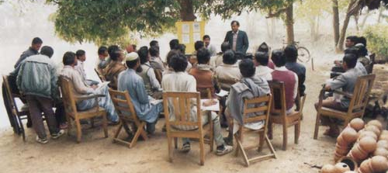
One of a shepherd’s main tasks remains the teaching of the Word of God.
- Prepare Your Heart And Mind with God's Word.
- Find in Titus 1:5 what Paul wanted Titus to do in Crete.
[Answer: Titus dealt with what was lacking in each town by appointing elders to take care of the congregations. Paul had mentored Titus before he left him in Crete, so that Titus would be prepared to train shepherding elders.]
- In modern times teachers educate new Christian leaders in two different ways:
1) By teaching by imparting information to large groups in traditional classrooms.
2) By making disciples and mentoring in small groups, in the way Jesus and His apostles did, in caring relationships.
- Traditional classroom teaching can be effective with mature workers and well-established churches that do not have urgent needs requiring immediate attention.
- Making disciples and mentoring apprentices the way Jesus and the Apostles did is more effective for dealing with the urgent needs of believers, new churches and cells that do not yet have experienced believers and leaders.
- New congregations and leaders are like newly-born babies who have urgent needs. They need someone with more experience who will listen to them, will find out what they still lack, and will teach them accordingly.
- Find in 2 Timothy 2:2 the four links in Paul’s mentoring ‘chain.’
The four links are:
1) Paul who wrote these instructions. He was sent by the church in Antioch (Acts 13:1-3).
2) Timothy who received these instructions and stayed in Ephesus to train others
(1 Tim. 1:1-5).
3) Faithful persons who received training from Timothy in Ephesus and surrounding towns. One of these was Epaphras who shepherded the new flock in Colosse (Colossians 4:12-13).
4) ‘Others also’ such as those whom Epaphras mentored in Hierapolis (Col. 4:15-17).
- To sustain this kind of multiplication, follow these New Testament guidelines:
- Congregations send their ‘apostles’ to start daughter congregations. These apostles are the ‘sent ones’ that God promises in Ephesians 4:11-12 to give to each congregation.
- Shepherds train newer shepherds without delay, as Paul wrote in 2 Timothy 2:2.
- Trainers and disciple makers require their trainees to put into practice immediately with their flock what they learn, and not wait for some vague future opportunity (James 1:22; 2 Tim. 2:16-7).
- Leaders require only what the New Testament requires, for a person to become a shepherding elder, without adding man-made requirements that exclude some of those whom God has gifted to shepherd a flock (Titus 1:5-9).
- Trainees (pastoral students) do immediately with their flocks what they have planned plan with their mentors to do. Trainees also begin at once to mentor newer trainees, to sustain the reproduction of new congregations.
- Those who plant churches do not have to quit their flock in order to start a new one. Like Paul and Barnabas, in Acts chapters 13 & 14, they can return to their own congregation.
- Plan with co-workers additional activities that the congregation will do during the week.
- Verify which congregations near where you live need shepherding, and help them. Titus named and mentored shepherding elders to care for the needs of each congregation.
- If no one is training new leaders yet for those flocks, then prayerfully decide who should do so.
- Talk with people whom you or other workers might train as leaders.
- Help new trainees to begin at once to shepherd their own families and close friends.
- Additional, optional activities to do during worship
- Form groups of two or three people, to pray, confirm activity plans and encourage one another.
- To introduce Communion read 1 Corinthians 11: 34.
Explain that When the Corinthians celebrated the Lord’s Supper, they ate regular meals that sometimes got more attention than did the spiritual aspect. Paul told them to eat at home. We must respect Jesus’ presence in this most sacred celebration.
- Invite the believers to share testimonies of how they were mentored in the way Paul did mentored.
- Those who teach children should first read study #102 for children.

