Jesus Sent Out Seventy-Two Evangelists
Teach the importance going to other places to make disciples.
Lord, help us to take the gospel to places where people do not know yet that Jesus can forgive their sins and bring joy into their lives.
Choose children's learning activities that fit their needs and ages.
- An older child or teacher reads or tells by memory how Jesus sent out seventy-two of His disciples to announce the Kingdom of God, Luke 10:1-20.
It shows how Jesus trained them in small groups to carry on his ministry,
so that the gospel would reach all the nations of the world.
Ask these questions. [Verse numbers for answers follow each question.]
- How many workers went in each group? [Verse 1. He sent them two by two.]
- For what did they pray first? [2]
- Did they go meekly, or with a fighting spirit? [3]
- How much equipment did they take? [4. Jesus wanted them to take as little as possible, relying on God rather than on material things.]
- Did they stop and visit with friends along the way? [4]
- Did they continue to lodge with a person who welcomed them peacefully? [5-8]
- What two activities did they do as they visited the people? [9]
- What did Jesus say to do where people rejected the good news? [10-11]
- What happened to Satan’s power when the disciples obeyed Christ? [18]
- What did Jesus say was more important than binding demons? [20]
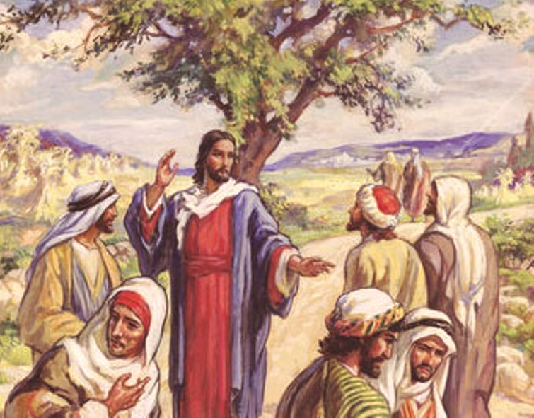
Jesus sent 72 of his followers to tell others about him.
- Dramatize parts of the story of the Seventy Evangelists.
- Arrange for the children to present this drama to the adults.
Older children help younger ones prepare.
This drama requires some rehearsal
- Older children or adults play these parts:
Jesus, Enemy (preferable an adult), Narrator.
Younger children play these parts:
Evangelists, People
Narrator Tell the first part of the story, from Luke 10:1-16. Then say,
“Hear what Jesus tells His disciples after they asked God to send out workers.”
Jesus “Go in groups of two. Be careful like lambs among wolves.
Tell the Good News. Heal the sick.
Tell each town that I am coming soon. The Kingdom of God is near.”
Disciples “What shall we take with us?”
Jesus “Take as little as possible. Hurry! Do not visit on the way;
the message is urgent!”
Disciples “Where shall we stay?”
Jesus “Find a man of peace. Lodge with him while you are in that town,
and eat his food.”
Disciples “What shall we do if the people reject us?”
Jesus “If you have made the message clear and they still reject you,
then go elsewhere.”
Disciples (Go about the room in pairs)
(One says) “Hear the Good News! It changed our lives.”
(Another shouts) “Be healed in the name of Jesus!”
(Another shouts) ”Receive God’s forgiveness in the name of our Lord Jesus Christ!”
(Others shout) “Praise the Name of Jesus!”
Enemy “My name is Enemy! I hate all men!”
(Follow the disciples and say the following things in your own words.
Pause after each one to let Disciples reply.)
“Do not go in groups of two. Stay together in bigger groups'; it is safer!”
“Take a lot of equipment with you. It will impress people!”
“Take plenty of food with you!”
“Visit your friends along the way!”
“Do not lodge only in one house. Find where the food is better!”
“If they reject your message, do not give up. Keep pushing them to accept it!”
“It is unfair for anyone to hear the gospel twice
before everyone has heard it once, so simply leave a gospel tract
at every door in the town. Nothing more.”
Disciples (As Enemy says the things above, mention Jesus’ opposite instructions,
in your own words.)
Narrator Tell the Second Part of the story, from Luke 10:17-23. Then say,
“Hear what the disciples tell Jesus when they return.”
Disciples (One says) “Lord Jesus, we are joyful!
(Another shouts) Your name is powerful!
(Another shouts) We used your authority to heal people!
(Another shouts) Thank you for passing on your power to us!
(Others shout) We even bound demons!”
Jesus “Do not rejoice about having power, but that your names are written in heaven.”
“Father in heaven, I praise you for working through men who are weak.
I have passed on my power and truth to them as you told me to do.”
Narrator Thank everyone who helped with the drama.
- If the children dramatize this story for the adults, then let them also ask the adults the questions under #1 above.
- Draw a simple picture of two people walking on a road, and let the children copy it.
Let the children show their pictures to the adults during the next worship time
and explain that it illustrates how believers take the Good News about Jesus
to people in other places.
Some children might like to colour the picture found at the end of this lesson.
- Have children give examples of how to teach people to obey Jesus.
- Let two children each recite a verse from Isaiah 52:7-8,
or let four children each recite a verse from Isaiah 52:7-10.
- Older children write a poem or song using Jesus’ words from Luke 10:2.
- Memorize together Mark 1:15:
“The time is fulfilled, and the kingdom of God is at hand;
repent and believe the gospel.”
- Have an older child pray:
“Father, help us to carry the good news about Jesus to other people. Keep us from getting distracted by the things of this world. Help us follow the example of Jesus’ disciples. Let us bring glory to your name like they did.”

A more detail drama: Jesus, equips and sends harvesters to announce his kingdom throughout Israel:

http://biblestoryskits.com/015a-jesus-equips-harvesters-to-announce-his-kingdom/

