One Prophet Showed Another
How to Serve God
Heavenly Father, please use this study to prepare the children to help other children to be follow Jesus better.
Choose activities that fit the children’s current needs and local customs.
- An older child or adult tells from memory or reads from 2 Kings 2:1-15.the story of the Prophet Elijah passing on his power to Elisha.
Explain first that the story shows how Elijah passed on his job to a younger prophet, and that children, likewise, should pass on what they learn about God to other children.
Ask (Tell the answer only if the children cannot answer it correctly):
- How much did Elisha care about what happened to his teacher?
[Elisha would not let his older teacher go on alone.]
- Did Elisha know that his master was leaving him? [See verse 3]
- What was Elijah’s final question that he asked his disciple? [Verse 9]
- What did Elisha want to receive from Elijah? [9]
- In what way did Elijah go up into heaven? [11]
- How did Elisha feel when his master left him? [12.]
- Elisha was very sad. In ancient Israel people tore their clothes to show that they felt bad.
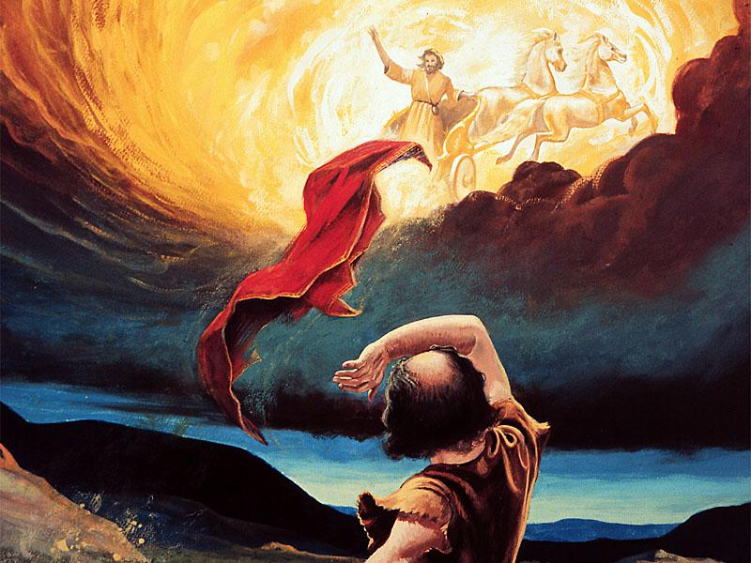
Elisha saw Elijah go up in a fiery chariot.
- Draw a large but simple drawing of a chariot with flames streaming from it.
Let the children draw or copy the picture and, if convenient, color it.
Let older children help the younger.
Some children might like to copy or colour the picture found at the end of this lesson.
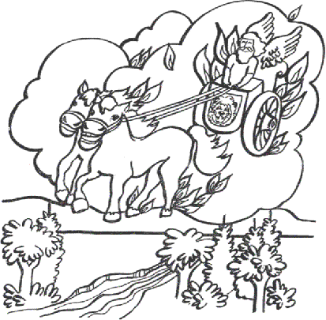
- Dramatize the story of Elijah and Elisha, or parts of it, for the adults.
- Arrange with worship leaders to have the children present the drama to the adults.
Prepare a robe, or cloak, for Elijah (a large cloth worn over his shoulders).
Let the rehearsal be a time for learning.
- Older children play these parts: Elijah, Elisha
Younger children play these parts: Disciples, Elijah
Narrator Tell the first part of story, 2 Kings 2:1-7. Then say,
“Hear what Elijah says to his disciple, Elisha.”
Elijah Walk with Elisha and say,
“Elisha, it is time for me to leave. You stay here.”
Elisha “No, I will stay with you until the end.”
Disciples of Elijah Stand to one side of Elijah.
Elisha “We are prophets, and we know that I, your master,
will go to heaven today!
Who will continue my work?”
Narrator Tell the second part of the story, 2 Kings 2:8-14. Then say,
“Hear what Elijah says to Elisha.”
Elijah Hit the ground with your robe. Then say,
“God parted the river. Let us cross.”
(Walk with Elisha.)
“Now. What can I do for you before I leave?”
Elisha “I want to receive God’s power to carry on your good work
after you have left.”
Elijah “If you see me go up to heaven, then God will help you continue the work.” (Throw the robe on the ground, then climb up on a chair and raise your hands toward heaven.)
Elisha “My father, I see you going up in a chariot of fire!”
Look up, then take the robe and walk toward the group of prophets.
Hit the ground with the robe.
Disciples of Elijah (One shouts) “Look! He parted the waters of the river!”
(Another shouts) “God has given him the same power that Elijah had!”
(Others shout) “Elisha is now our leader!”
Narrator Thank everyone who helped with the drama.
- If the children present this drama to the adults, then let them ask the adults questions under #1 above, about Elijah and Elisha.
- Explain that a long time ago, before Jesus came as a man,
Elijah made disciples by teaching them to obey God.
Now Jesus tells us to make disciples who obey Him. Ask…
- In what ways can we help other children to obey Jesus?
- Do you have a brother, sister or friends whom you can help to learn about Jesus and to serve Him?
- Pass on the robe of power to others.
- Draw a picture of a robe for the children
- Ask a child to be Elijah, another Elisha.
- Hand to ‘Elijah’ the picture of the robe, and explain that it represents God’s power.
Say, “You now have power from God to tell others about Jesus and to serve them.”
- Explain, “We are not selfish with God’s power. We make disciples,
which means that we pass on God’s power and Word to other children.”
- Then, ask the child who is ‘Elijah’ to pass the picture of the cape on to ‘Elisha’.
- Let the children draw a picture of the robe, to show to the adults at the next worship time,
and explain that Elijah gave his robe to his disciple Elijah,
which illustrates how we pass on to others God’s power and goodness.
- Memorize John 20:21:
“Jesus said to them, “Peace be with you; as the Father has sent Me, I also send you.”
- Three children each recite a verse from Psalm 39, verses 4, 5 and 7.
- Have an older child pray:
“Lord, you told us to make disciples who obey everything you commanded. You gave us your Word and your Spirit to help us obey. Help us to be good disciples. Help us to tell others about Jesus so they can be good disciples, also.”
A more detailed drama about Elijah defeating false prophets on Mt. Carmel:
http://biblestoryskits.com/005-elijah-defeats-baals-prophets-on-mt-carmel-2/

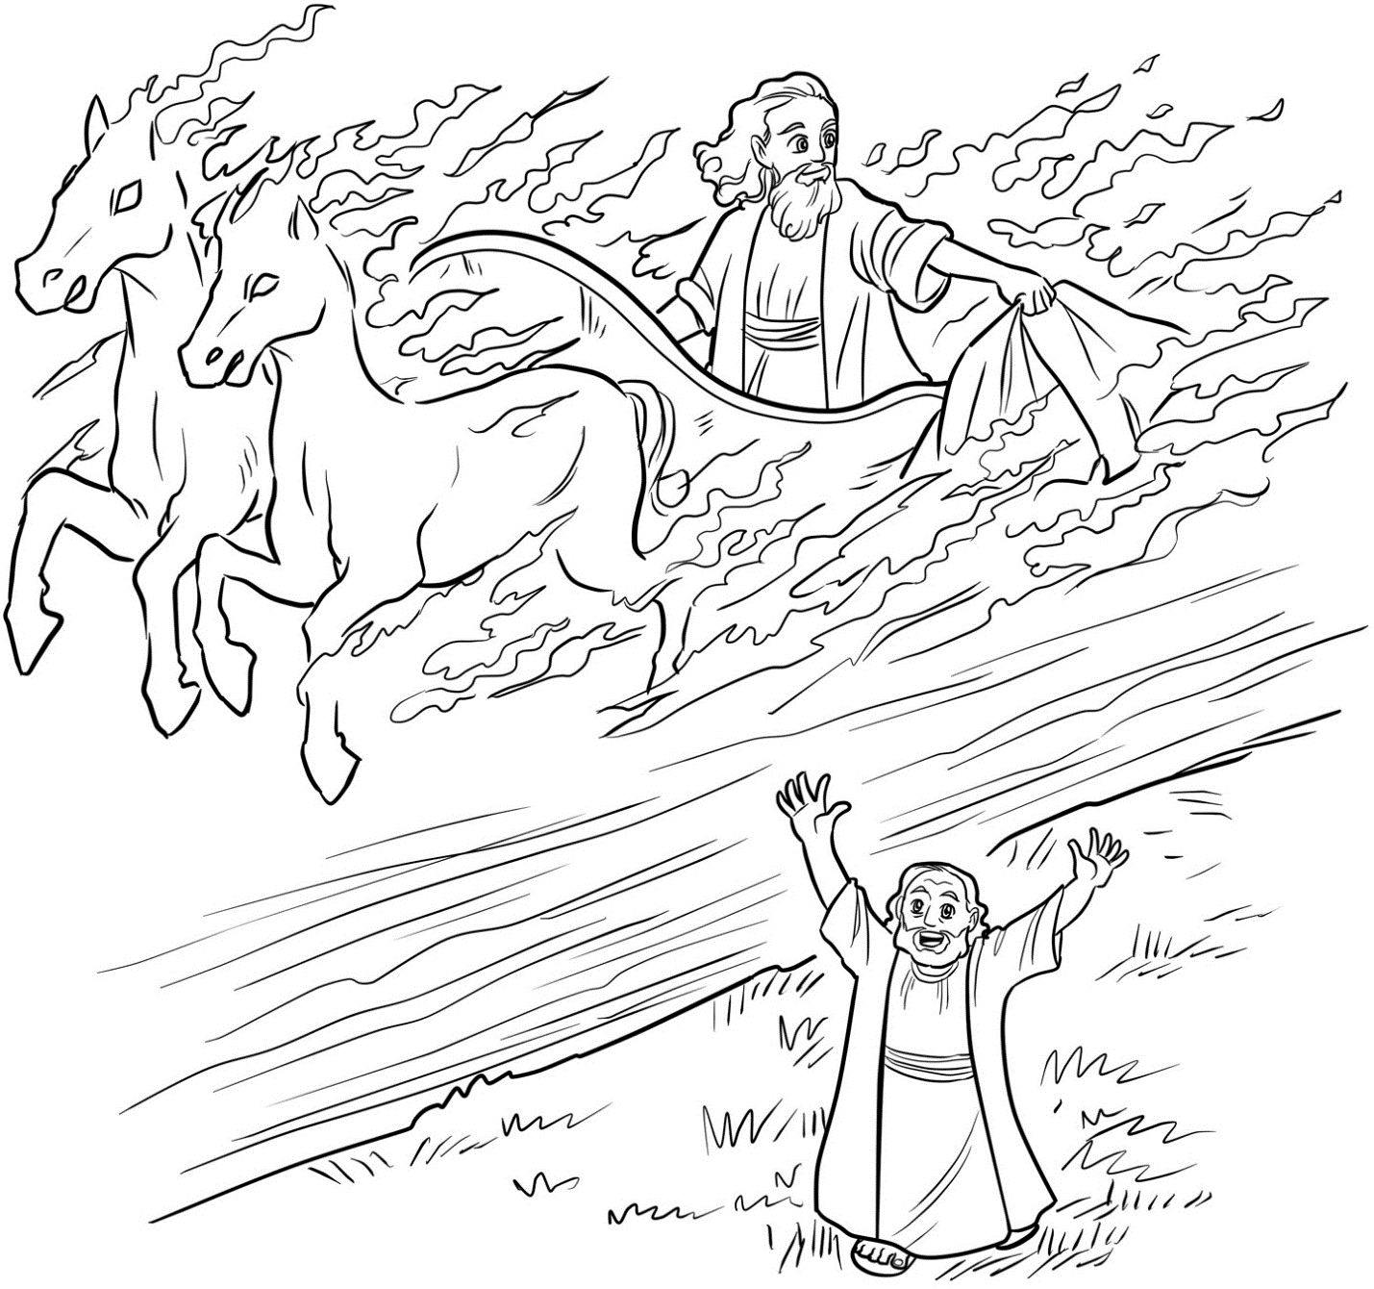
Elisha saw Elijah go up in a fiery chariot.

