Guidelines for Deacons, Deaconesses,|
Small Group Leaders, and those who
Lead Activities during the Week
Prayer: “Lord, please, help our congregation to develop ministries with the same power you gave to the congregations in Acts, and enable us to serve as they did.”
Believers often meet during the week to serve one another and to help members of the community. They pray for people, make disciples, and carry out many different ministries. Sometimes men or women meet as a group. Large families, or two or three families, may gather for family worship. Deacons and deaconesses sometimes lead these meetings and oversee activities done during the week. Deacons often lead groups that serve the needy.

Appoint deacons or deaconesses, who will lead the work of caring for the needy, and help the believers to do other activities during the week.
- Find the requirements for being named as a deacon or deaconess in 1 Timothy 3:8-13.
- Lay hands on deacons as the apostles did. Ask the Holy Spirit to anoint them.
- Find out which believers have urgent needs. Do the same for folks outside your congregation.
- Ask the believers to offer money, time, help or materials that will help meet those needs.
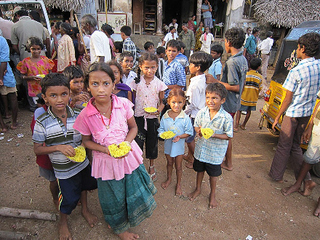
Distribute to the needy.

Read Acts 6:1-7 to find what deacons did in Jerusalem.
- What was the need that moved the new congregation to name deacons?
- What were the requirements one had to meet to be named as a deacon and to serve the widows in need?
- What happened as a result of naming persons full of wisdom and of the Holy Spirit,? (Find the answer in verse 7.)
- Romans 16:1 reveals that a woman, Phoebe, was also called a ‘deaconess’, a servant of the congregation.
- The word ‘deacon’ in the Bible means ‘appointed servant.’

Make plans for what you and those you work with will do next week
New Shepherd’s studies offer helps for doing the work that corresponds to the week’s topic that is taught during worship. These aids are found in the second part of each New Shepherd’s study, under the title “Plan with Coworkers Activities to do During the Week” or similar words.
Each study lists activities that you and your helpers might do. Choose any that fit the believers’ needs. Disregard the other activities.
Plan these activities with those you work with, some time before the next main worship service, so you can explain to the people during worship what needs to be done.
Write your plans on paper, and discuss them with the shepherd of your congregation. Do this planning together with him and other leaders when you gather to plan the next week’s worship and other activities. Arrange with them to announce your plans at the next congregational worship meeting. During this meeting, complete the plans by agreeing on who will do what, where and when. Be very specific. Plans might include activities to do any of the following:
- Serve one another within the Body of Christ, as Galatians. 6:10 requires.
- Serve our families, as Ephesians 5:21 through 6:4 instructs us.
- Cooperate with other congregations, as Paul did in Acts 15:40-41.
- Serve our friends, neighbors, enemies and the community around us, as Jesus commands in Matthew 5:13-14; 25:31-46.
- Prepare others to serve along with you, as Paul told Timothy to do, in 2 Timothy 2:2.
- Plan any other things that need to be done.
Pray for the sick.

